**Vivekananda Institute of Professional Studies** - **Technical Campus**

**(Affiliated to GGSIP University, Delhi, Recognized by AICTE)**

**Vivekananda School of Information Technology**

|  |  |
| --- | --- |
|  |  |

MASTERS OF COMPUTER APPLICATIONS

2023-2025

**MCA - 106**

**PRACTICAL FILE**

**OF**

**Python Programming**

|  |  |
| --- | --- |
| **Submitted To:** | **Submitted By:** |
| **Dr. Mamta Madan** | **Muhammed Raihan P. S.** |
| **Professor** | **13017704423** |
| **VSIT, VIPS** | **MCA 2C** |

**INDEX**

|  |  |  |  |
| --- | --- | --- | --- |
| **S No** | **Topic** | **Date** | **Sign** |
| **1** | Any number is input through keyboard. WAP ti find it is an odd or an even number |  |  |
| **2** | WAP to check if the year is a leap year |  |  |
| **3** | WAP to check if a triangle is valid or not. When the three angle is entered through keyboard |  |  |
| **4** | WAP to print the absolute value of a number entered through the keyboard |  |  |
| **5** | Calculate the area of Circle and a Rectangle |  |  |
| **6** | WAP that recieves 3 sets of p, n, r and calculates the simple interest. |  |  |
| **7** | WAP that prints the number from 1 to 10 all on the same line. |  |  |
| **8** | WAP to calculate the factorial of any number. |  |  |
| **9** | WAP to print the prime number from 1 to 300. |  |  |
| **10** | WAP to print the multiplication table of any number entered by the user |  |  |
| **11** | Calculate the salary of the person by asking various salary components like DA, HRA, TA |  |  |
| **12** | WAP to input three integers from the keyboard and get their sum and product calculated |  |  |
| **13** | Define a function leap and implement it |  |  |
| **14** | WAP to calculate the largest among the three numbers |  |  |
| **15** | WAP to calculate the LCM of few numbers |  |  |
| **16** | WAP to check if the number is odd or even |  |  |
| **S No** | **Topic** | **Date** | **Sign** |
| **17** | WAP a recursive function for factorial |  |  |
| **18** | Practice use of global variables |  |  |
| **19** | Apply recursion in one more problem fibonacci series |  |  |
| **20** | WAP to print the digit at one's place of a number |  |  |
| **21** | WAP to calculate the bill amount for an item given in quantity sold, value, discount and tax (use default argument function, with default value of discount and tax) |  |  |
| **22** | WAP to calculate students results based on two examination, one sports event and three activities conducted. The weightage of activities = 30%, sports = 20% and examination = 50% |  |  |
| **23** | WAP to print the ASCII value of character (ord('a'), char(65)) |  |  |
| **24** | WAP to read a character in uppercase and then print it in lowercase using lower() and upper() string methods |  |  |
| **25** | Income Tax for individual is computer on slab rates as follows |  |  |
| **26** | WAP to check a number entered is perfect or not |  |  |
| **27** | WAP to check a number entered is circular or not (prime or not) |  |  |
| **28** | WAP to check a number entered is palindrome or not |  |  |
| **29** | Check a number for Armstrong number eg: 153 is an Armstrong number (1x1x1+5x5x5+3x3x3 = 153) |  |  |
| **30** | WAP to swap two numbers entered by the user. You are not allowed to use a third variable |  |  |
| **S No** | **Topic** | **Date** | **Sign** |
| **31** | WAP that has a user defined function to accept the coefficient of quadratic equation in variable and calculate its determinant |  |  |
| **32** | Make a calculator.py file and import various functions into another file |  |  |
| **33** | Implement command line arguments (display all the arguments) |  |  |
| **34** | Implement command line arguments (add all the numbers passed on command line) |  |  |
| **35** | Implement a calculator using command line arguments using parser |  |  |
| **36** | From the string “Bamboozled”. WAP to obtain the following output |  |  |
| **37** | Find all the occurrence of 'T' int the string 'The Terrible Tiger Tore The Towel'. Count them and print also replace them with 't' |  |  |
| **38** | WAP to reverse a string |  |  |
| **39** | WAP to check if the string is palindrome |  |  |
| **40** | WAP to calculate the length of the string |  |  |
| **41** | WAP to count the number of characters (character frequency) in a string |  |  |
| **42** | WAP to get a single string from two strings separated by a space and swap the first two characters of each string |  |  |
| **43** | WAP to accept a string and count the total number of vowels |  |  |
| **44** | WAP to search a character in the string |  |  |
| **45** | WAP to read the email id of the person in the format expected |  |  |

|  |  |  |  |
| --- | --- | --- | --- |
| **S No** | **Topic** | **Date** | **Sign** |
| **46** | WAP to perform following on the list |  |  |
| **47** | WAP to implement stack data structure which is LIFO |  |  |
| **48** | Suppose a list has 20 numbers. WAP that removes all duplicates from the list |  |  |
| **49** | WAP to obtain the median value of the list of numbers, without disturbing the order of numbers in the list |  |  |
| **50** | WAP to count the occurrence of each character entered by the user and store them in a dictionary |  |  |
| **51** | WAP to create two dictionaries, concatenate them and create a third dictionary |  |  |
| **52** | WAP to check weather a given key exists in the dictionary |  |  |
| **53** | WAP to remove a particular key from the dictionary |  |  |
| **54** | WAP to display the minimum and maximum in a dictionary |  |  |
| **55** | WAP to reverse a tuple |  |  |
| **56** | WAP to calculate the product by multiplying all the numbers of a tuple |  |  |
| **57** | WAP to check if the number exists in the tuple |  |  |
| **58** | WAP to check if two sets have any elements in common. if yes display the common elements |  |  |
| **59** | Update set1 by adding items from set2, except common elements |  |  |
| **60** | Remove items from set1 that are not common to both set1 and set2 |  |  |
| **61** | WAP to print tuples which are not empty |  |  |

|  |  |  |  |
| --- | --- | --- | --- |
| **S No** | **Topic** | **Date** | **Sign** |
| **62** | WAP to open a file try.txt, add some text into it and close it |  |  |
| **63** | WAP to read the above file and print that on the screen |  |  |
| **64** | WAP that writes four integers to a file called numbers Go to the following position and return  a) 10 positions from the beginning  b) 2 position to the right of current position  c) 10 position to the left from the end |  |  |
| **65** | WAP to implement inheritance using shape class and also make rectangle as a derived class. declare a function area to calculate the area of rectangle and also show the colour of the rectangle. Also make required constructor |  |  |
| **66** | WAP to implement Multiple Inheritance using the example of employee class, waged employee and salaried employee. Write Appropriate constructors and functions to calculate pay. |  |  |
| **67** | Implement operator overloading for + operator |  |  |
| **68** | Implement operator overloading for less than equal to operator for user defined class |  |  |
| **69** | Implement operator overloading for - operator |  |  |
| **70** | Implement operator overloading for unary operator ++ and -- operator |  |  |
| **71** | Implement exception handling for divide by 0 exception |  |  |
| **72** | Implement exception handling using raise statement |  |  |
| **73** | Implement threading |  |  |
| **S No** | **Topic** | **Date** | **Sign** |
| **74** | WAP to construct a 3d array of dimension 4x2x3. Initialize the array to some value. Find the maximum along each axis (k,413) |  |  |
| **75** | Create a program to achieve the following  Create an array of size 10 with each element of it set to a value 3  Find the memory size of this array and its individual element  Create an array b of size 10 with values ranging from 0 to 90 evenly spaced.  Reverse elements of array b  Add arrays a and b and store the result in c |  |  |
| **76** | Declare a matrix o 3x3 and calculate its transpose |  |  |
| **77** | Write a menu driven program to perform all the matrix operation |  |  |
| **78** | WAP to count all the odd numbers in 1d array |  |  |
| **79** | WAP to check if none of the elements is zero in the array |  |  |
| **80** | WAP to extract all the prime numbers from an array |  |  |
| **81** | Pre-process and perform different operations on data using Numpy and Pandas library |  |  |
| **82** | Analyze the sales data and visualize it using different plots |  |  |

**1) Any number is input through keyboard. WAP ti find it is an odd or an even number**

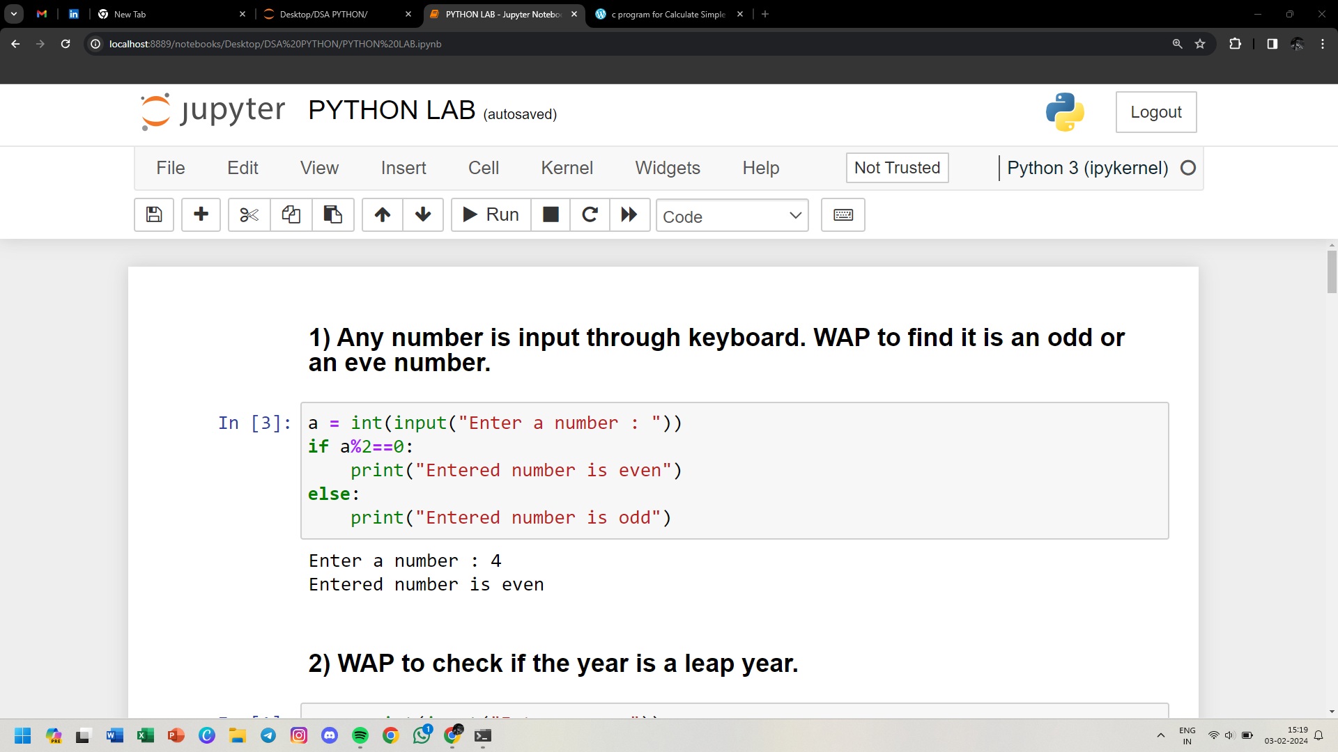

**2) WAP to check if the year is a leap year**

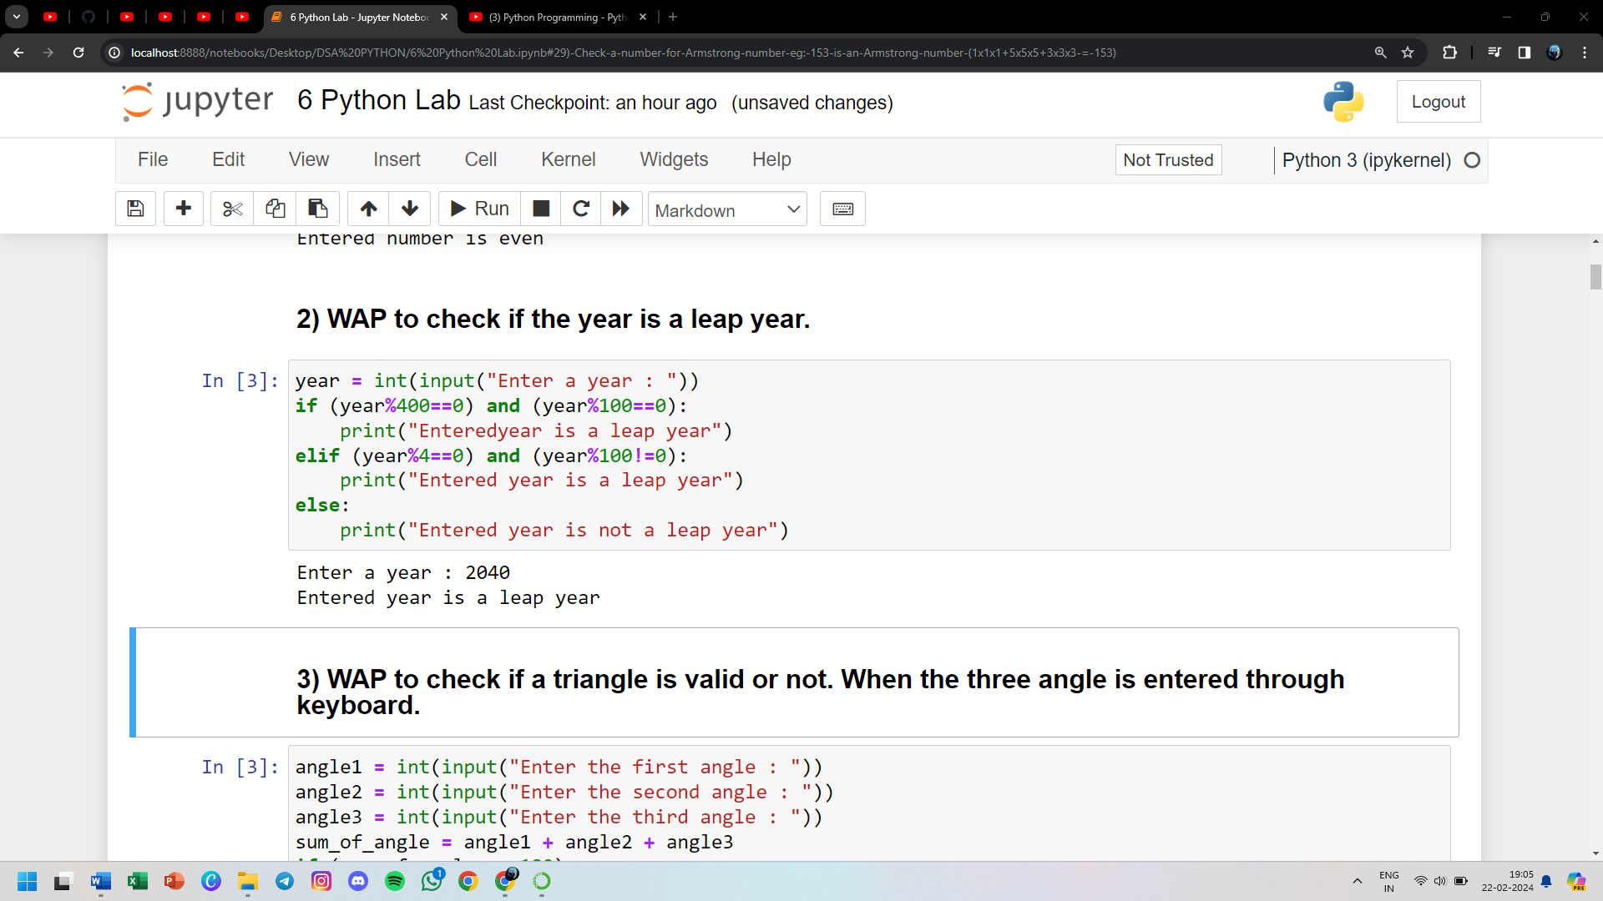

**3) WAP to check if a triangle is valid or not. When the three angle is entered through keyboard**

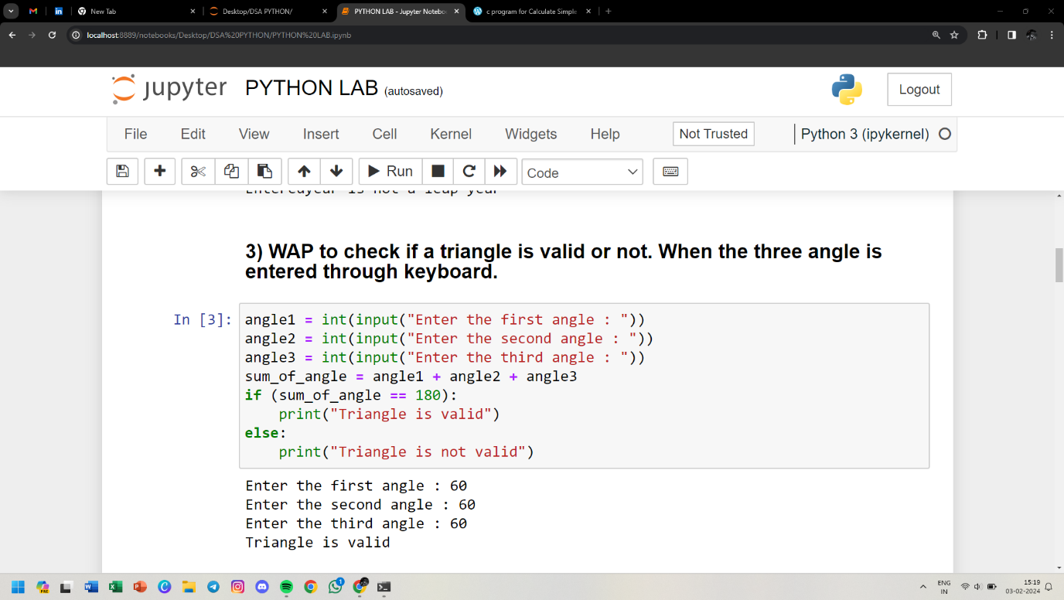

**4) WAP to print the absolute value of a number entered through the keyboard**

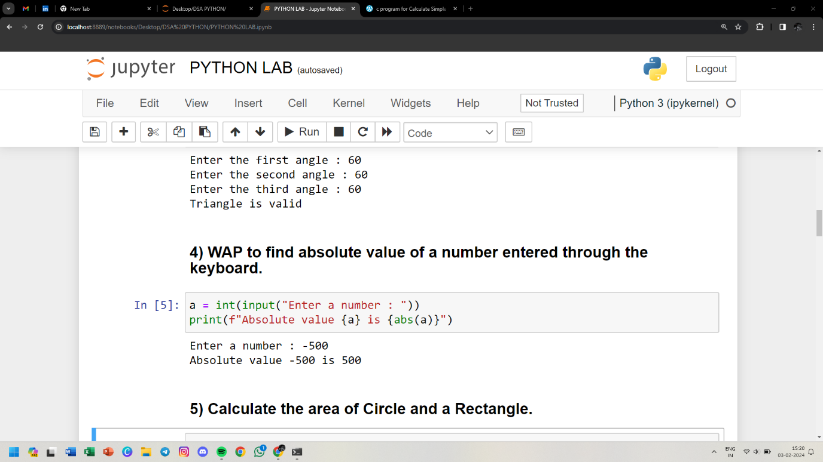

**5) Calculate the area of Circle and a Rectangle**

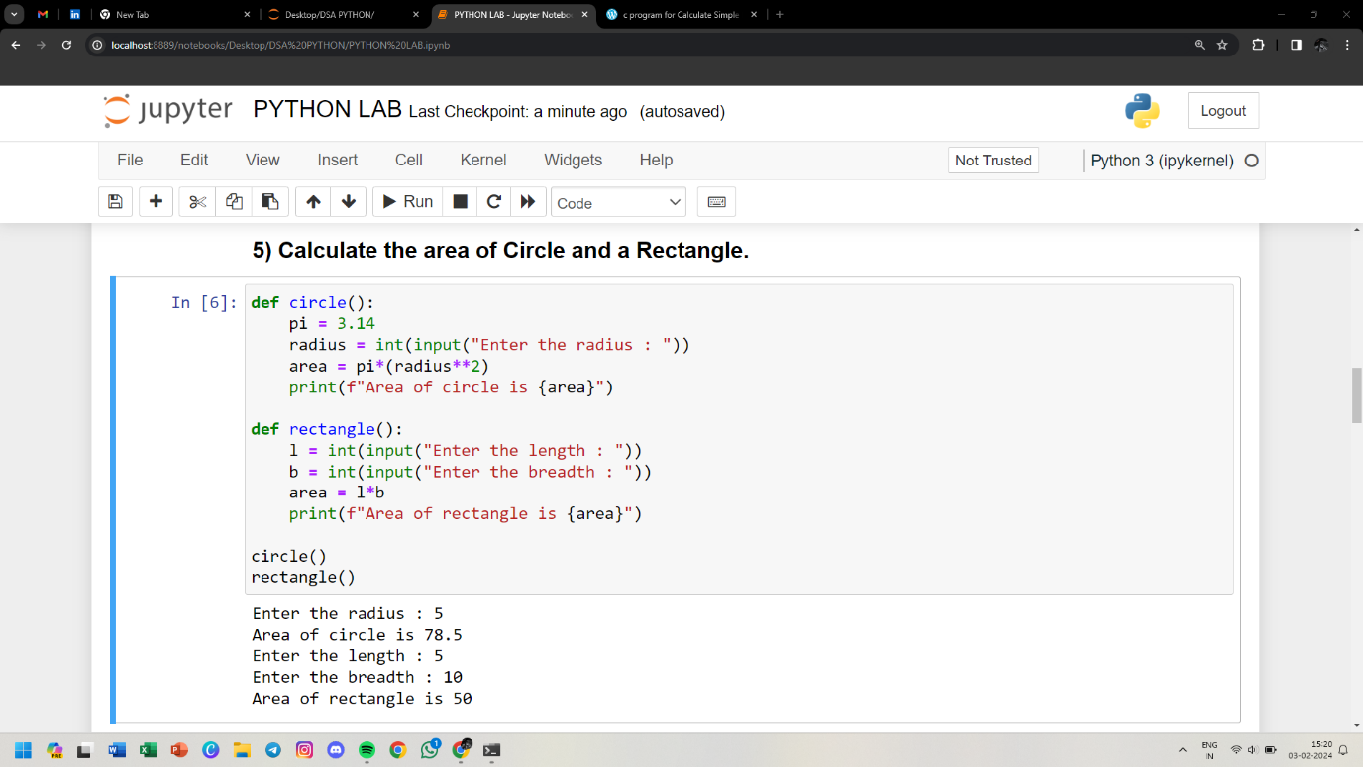

**6) WAP that recieves 3 sets of p, n, r and calculates the simple interest.**

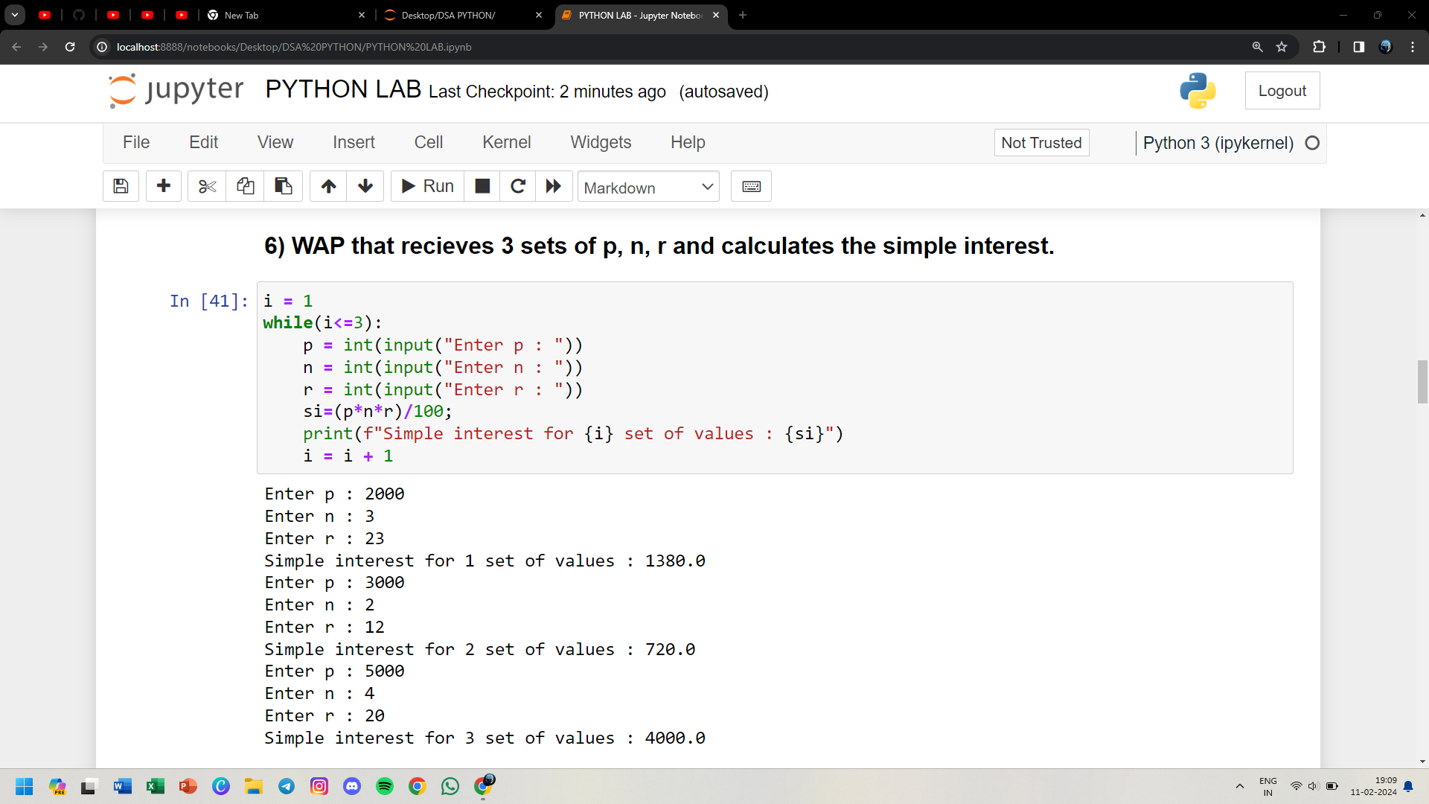

**7) WAP that prints the number from 1 to 10 all on the same line.**

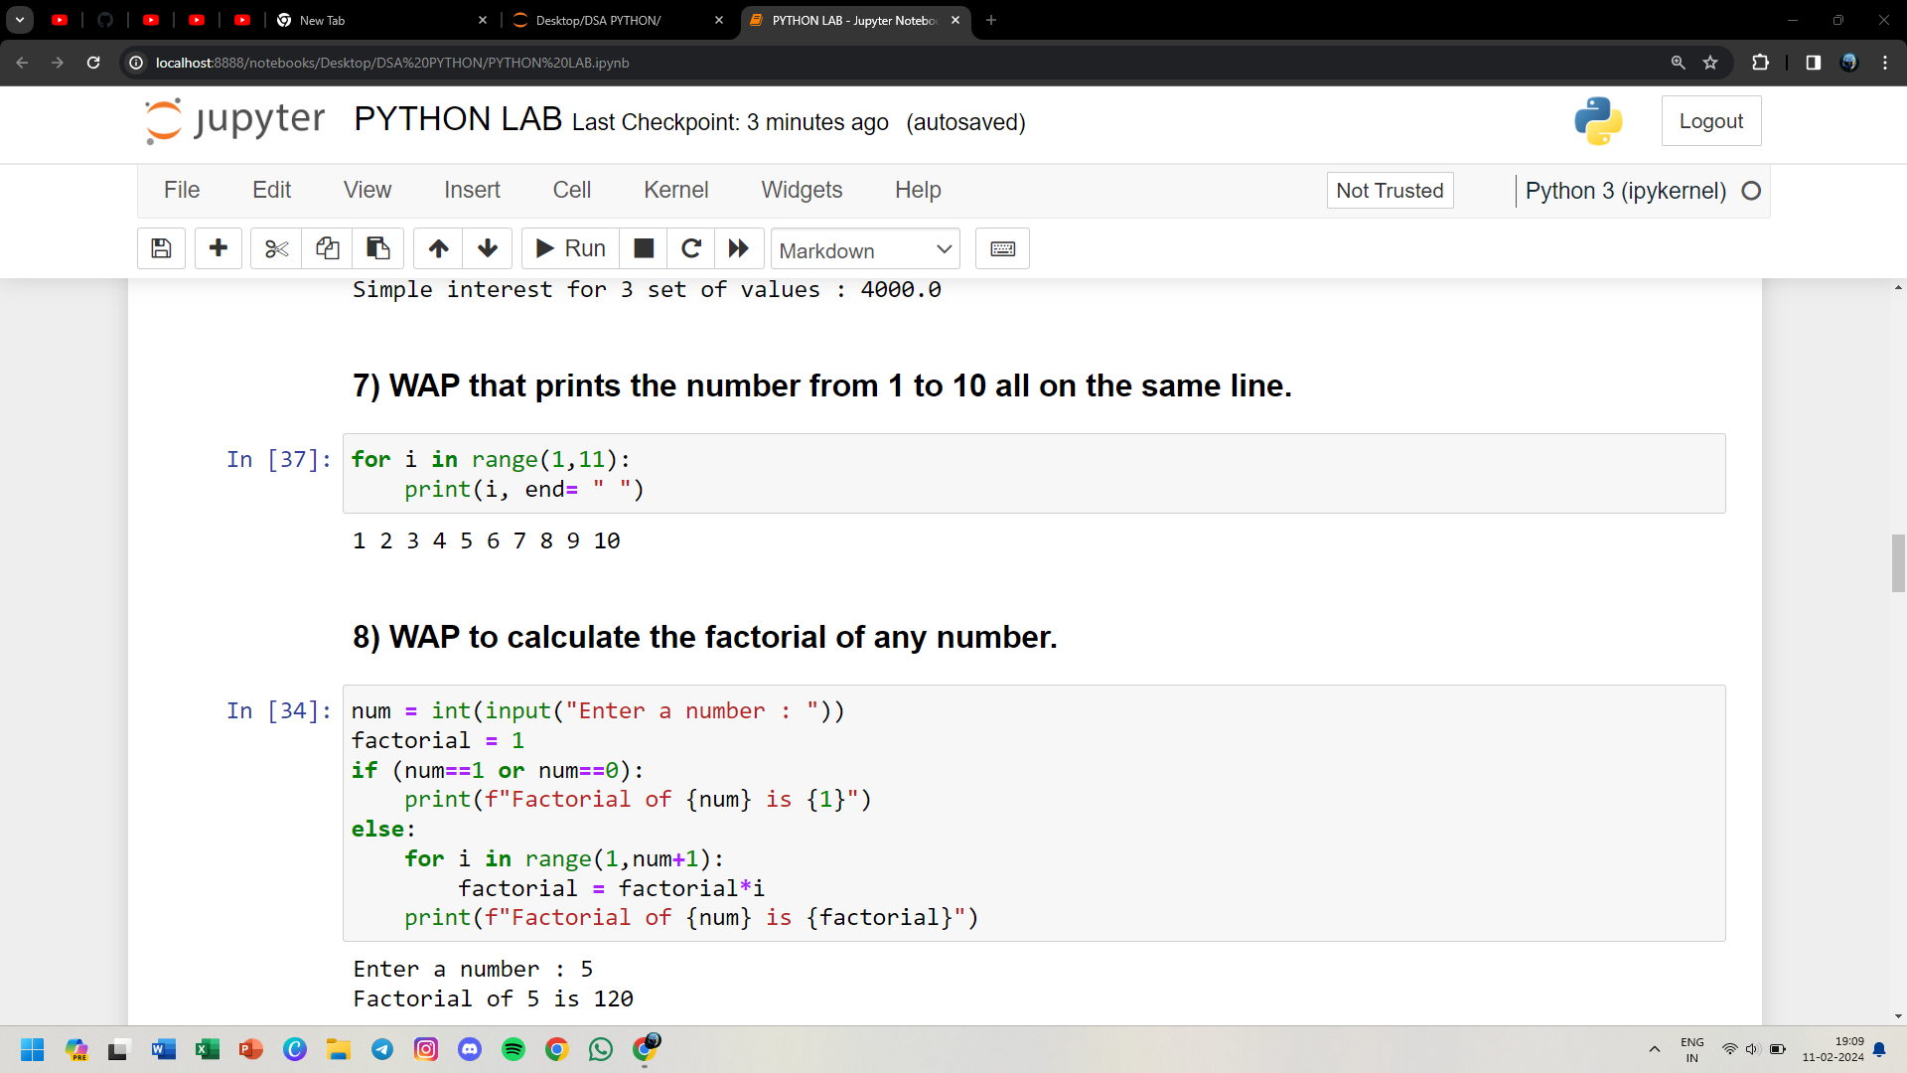

**8) WAP to calculate the factorial of any number.**



**9) WAP to print the prime number from 1 to 300.**

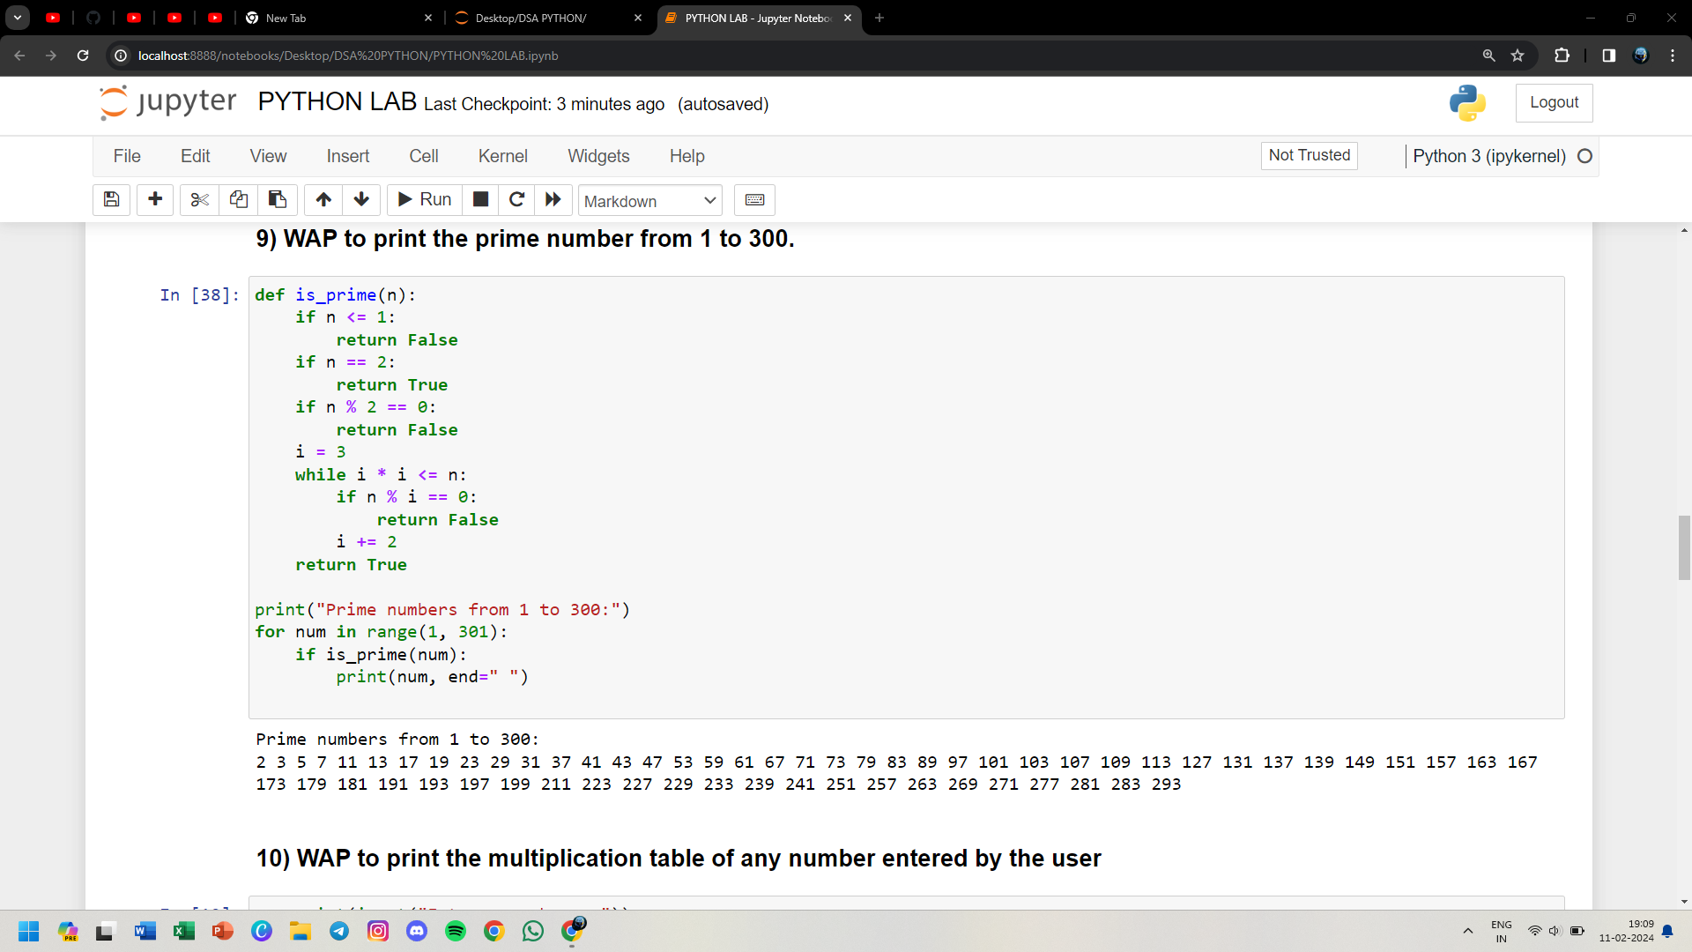

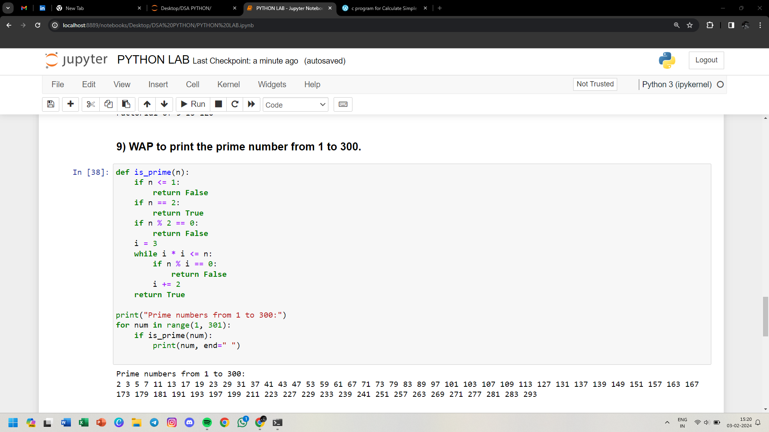

**10) WAP to print the multiplication table of any number entered by the user**

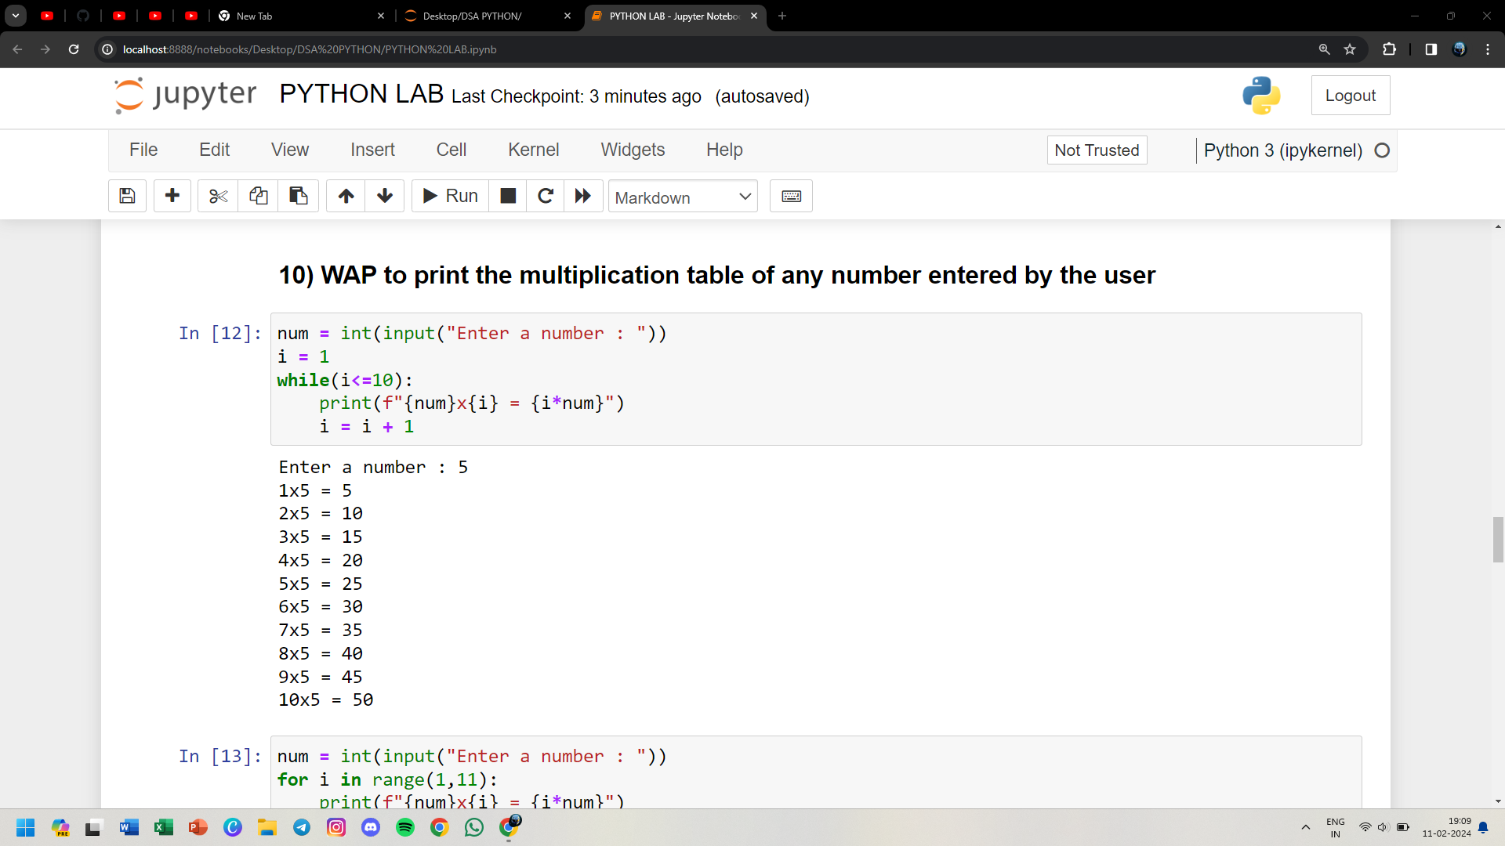

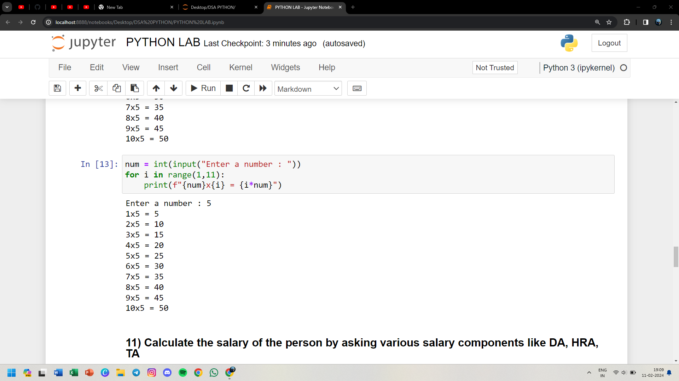

**11) Calculate the salary of the person by asking various salary components like DA, HRA, TA**

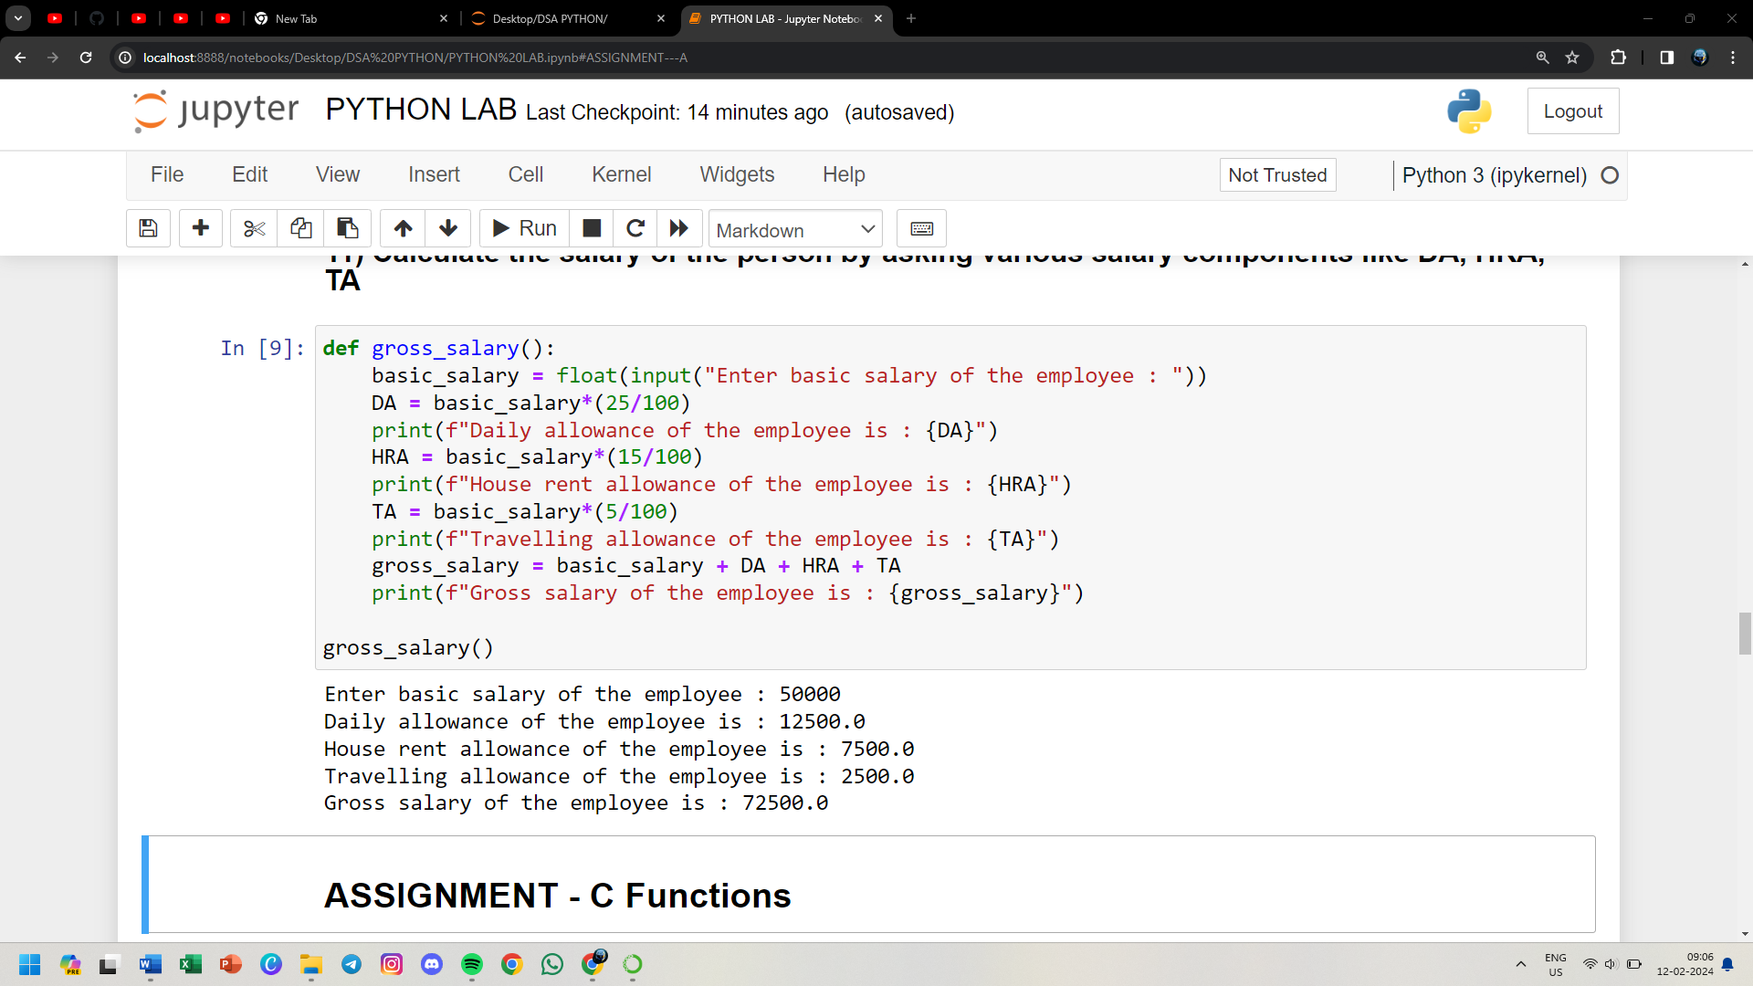

**12) WAP to input three integers from the keyboard and get their sum and product calculated**

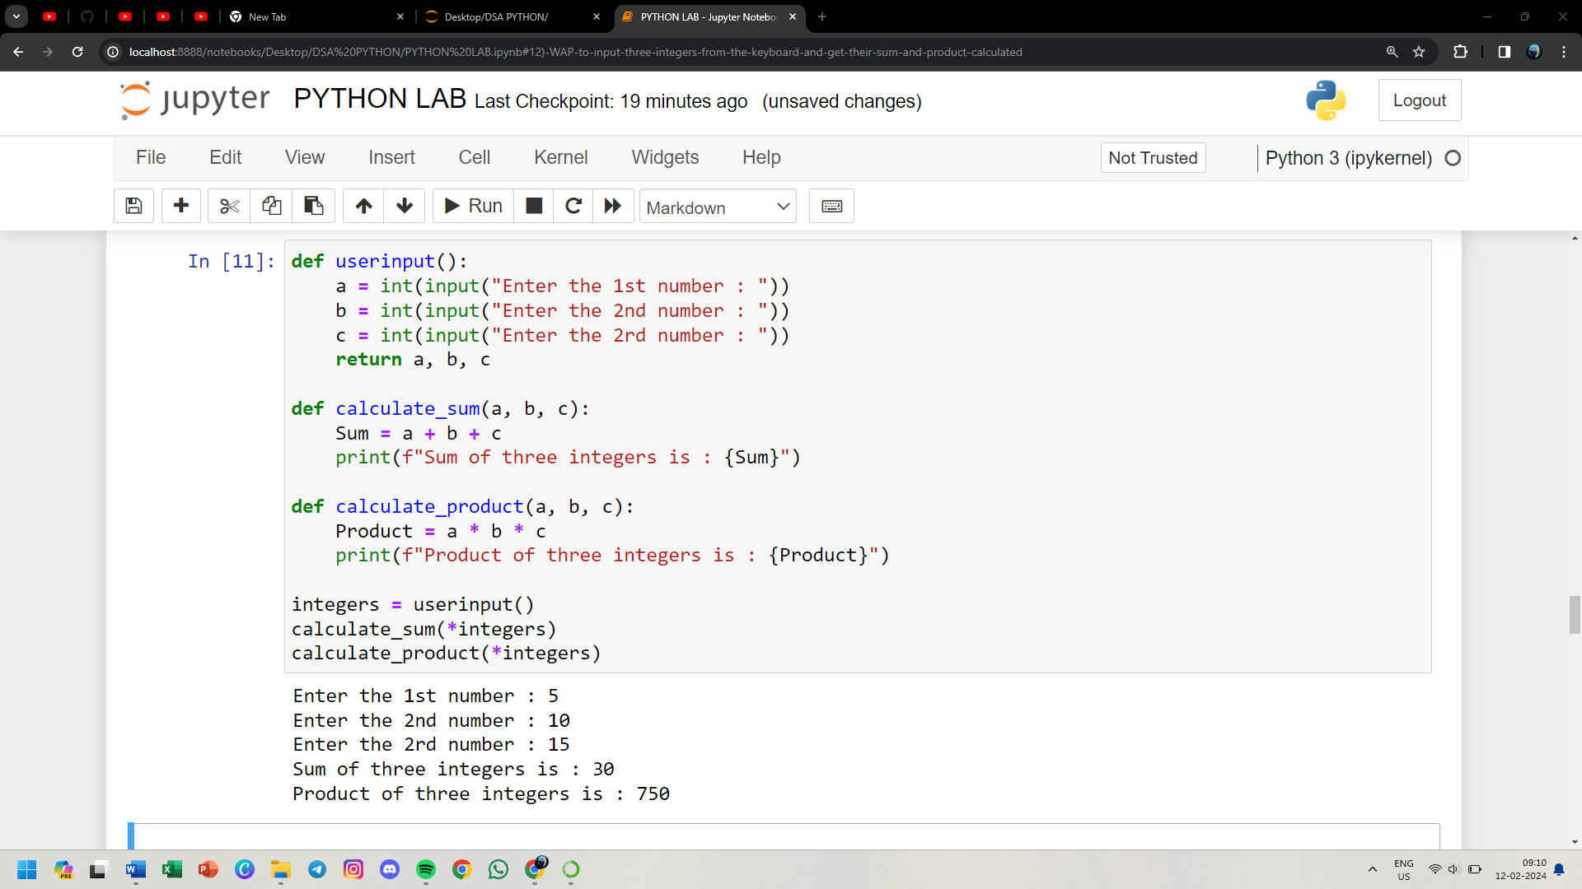

**13) Define a function leap and implement it**

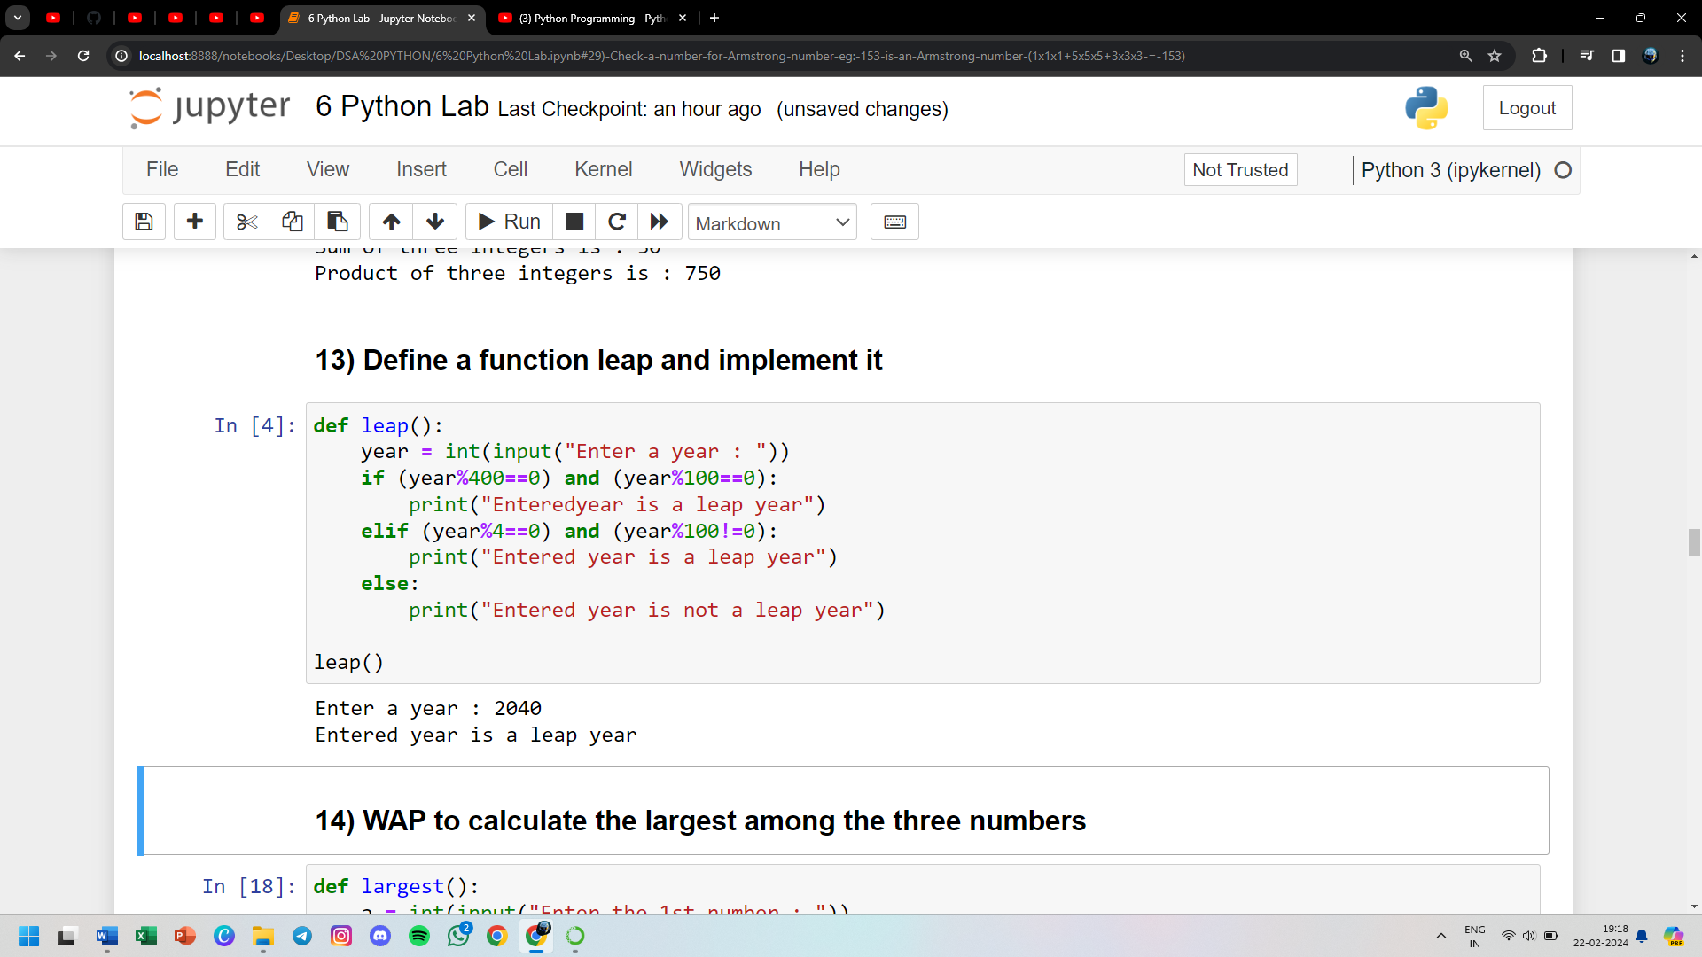

**14) WAP to calculate the largest among the three numbers**

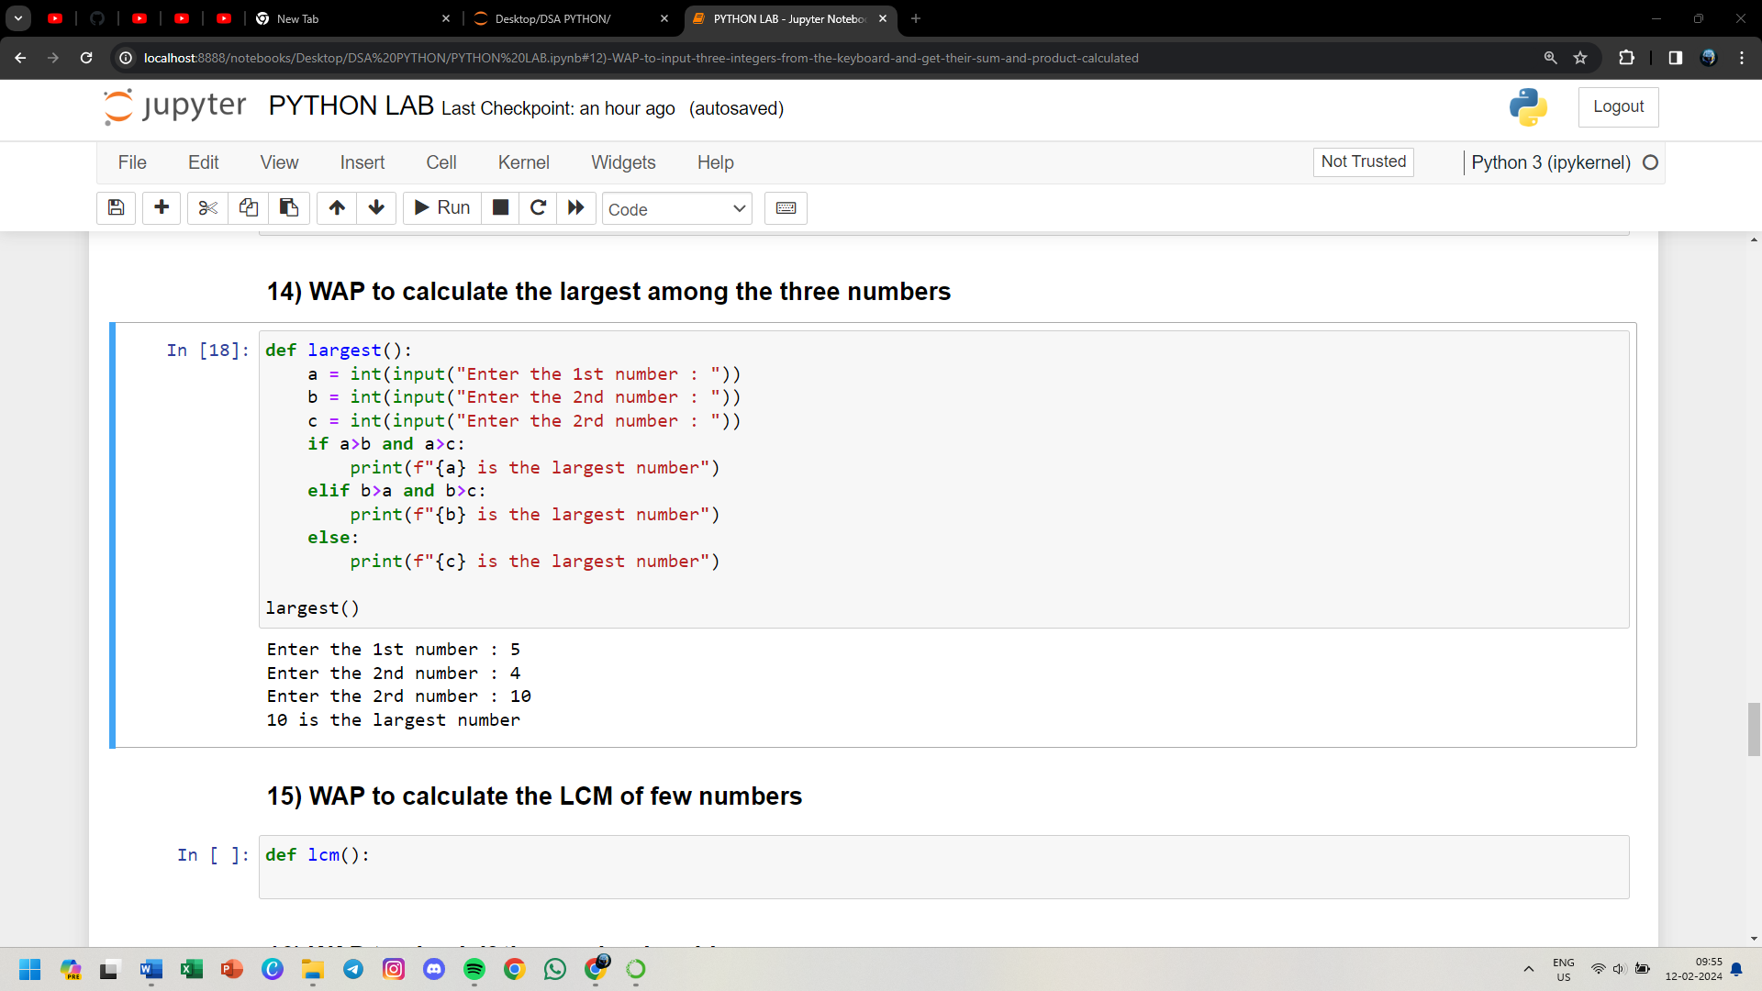

**15) WAP to calculate the LCM of few numbers**

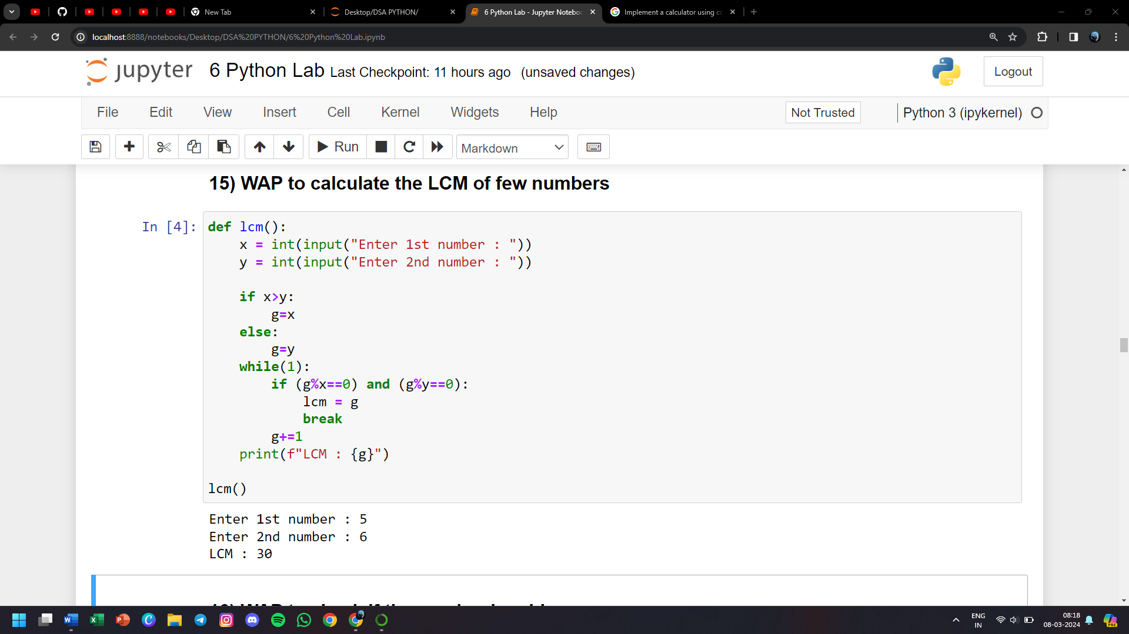

**16) WAP to check if the number is odd or even**

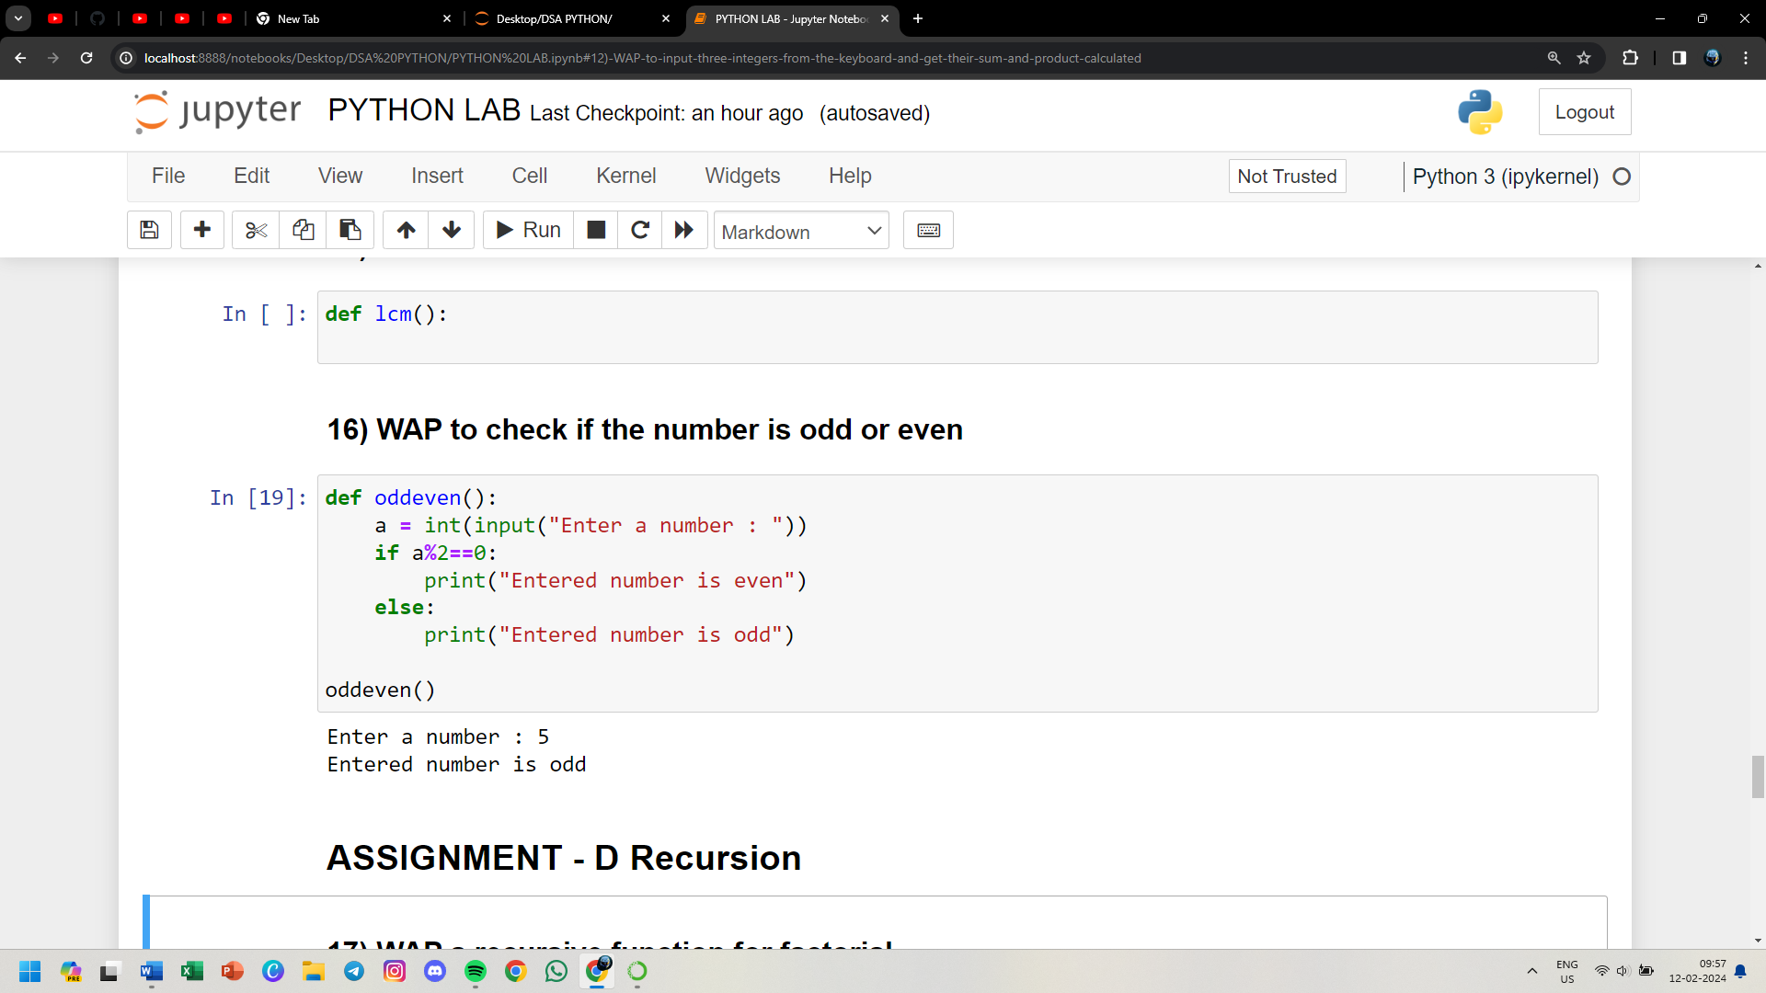

**17) WAP a recursive function for factorial**

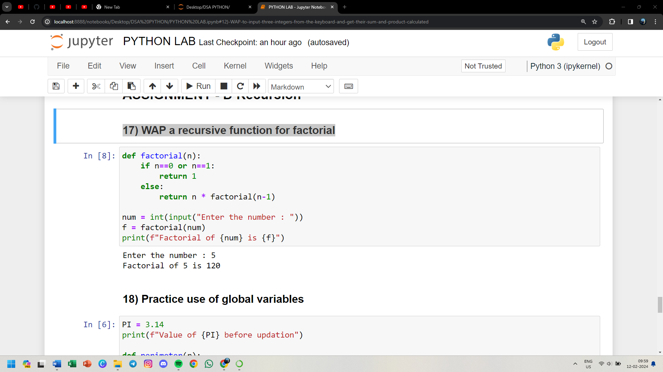

**18) Practice use of global variables**

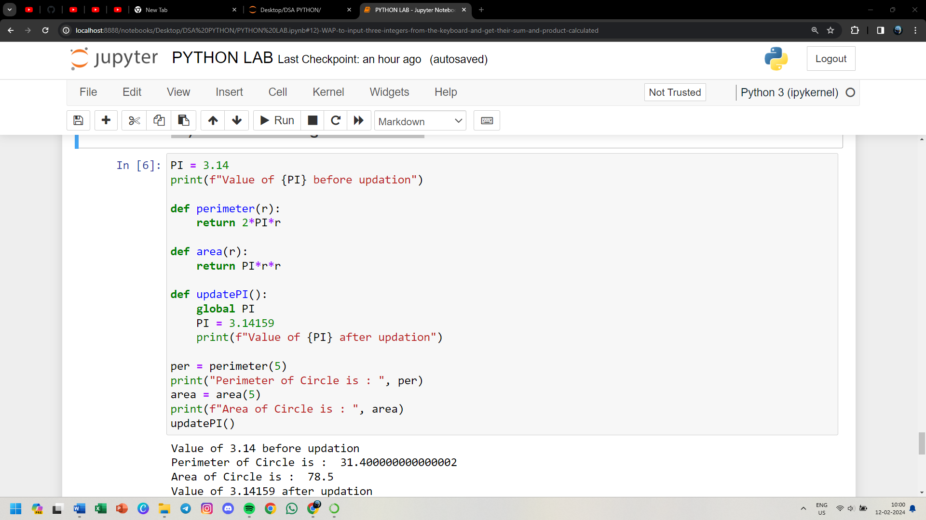

**19) Apply recursion in one more problem fibonacci series**

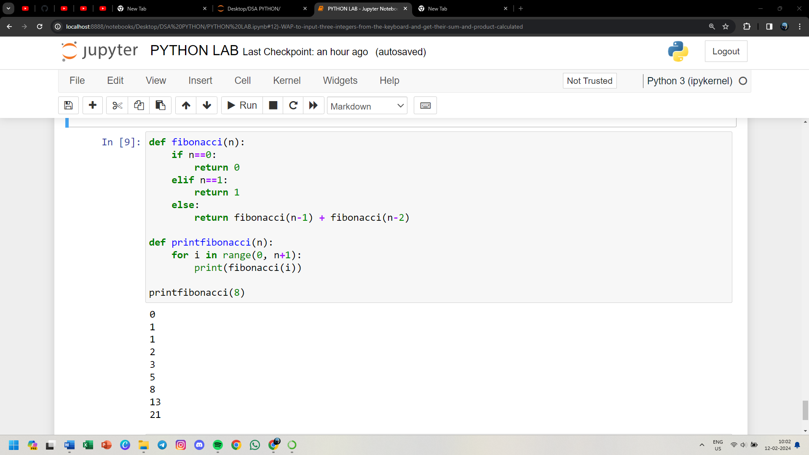

**20) WAP to print the digit at one's place of a number**

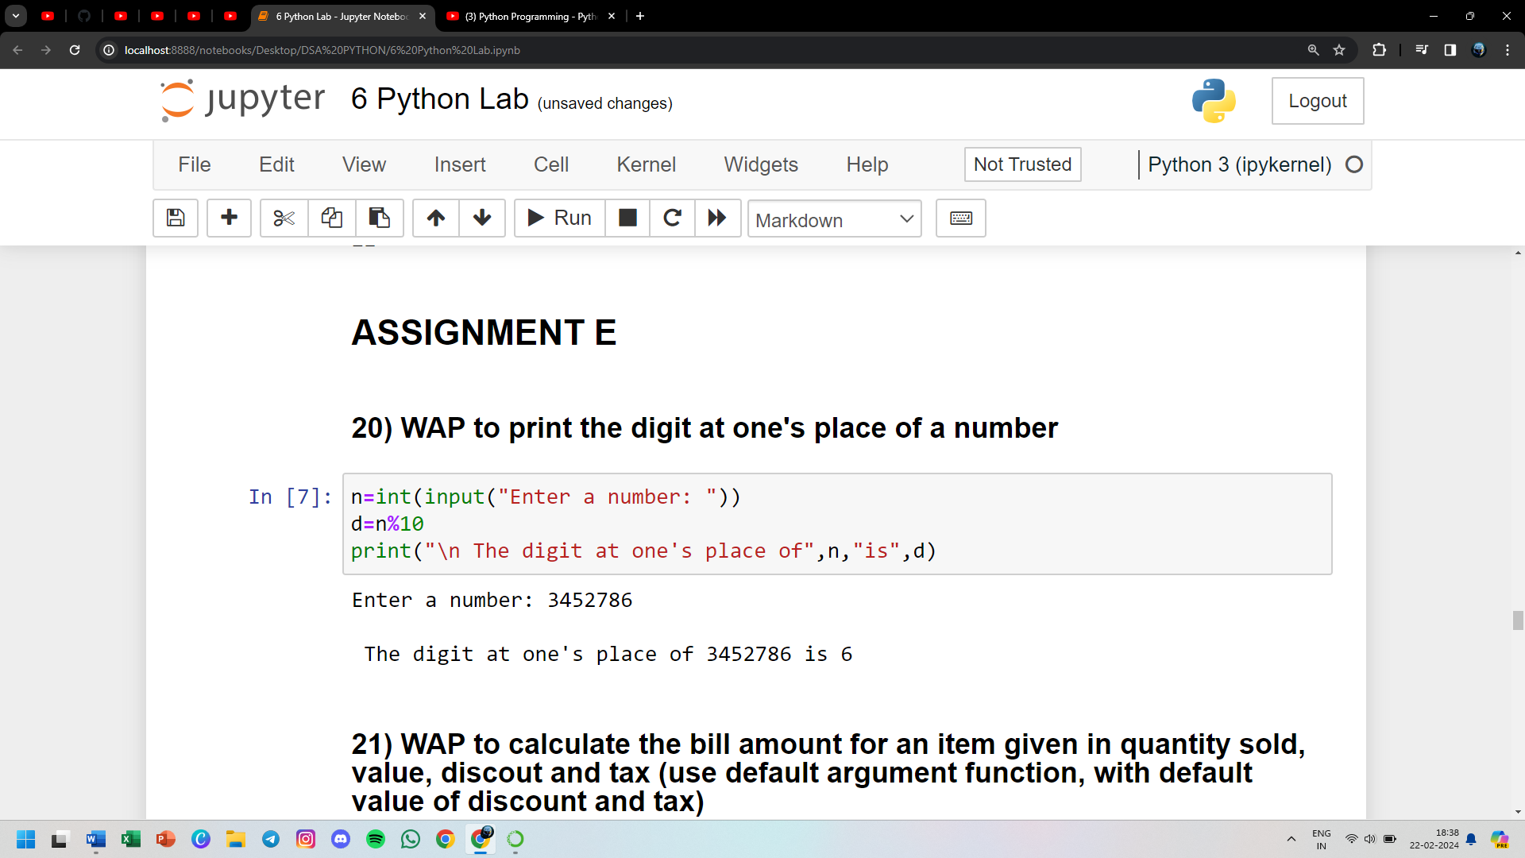

**21) WAP to calculate the bill amount for an item given in quantity sold, value, discout and tax (use default argument function, with default value of discount and tax)**

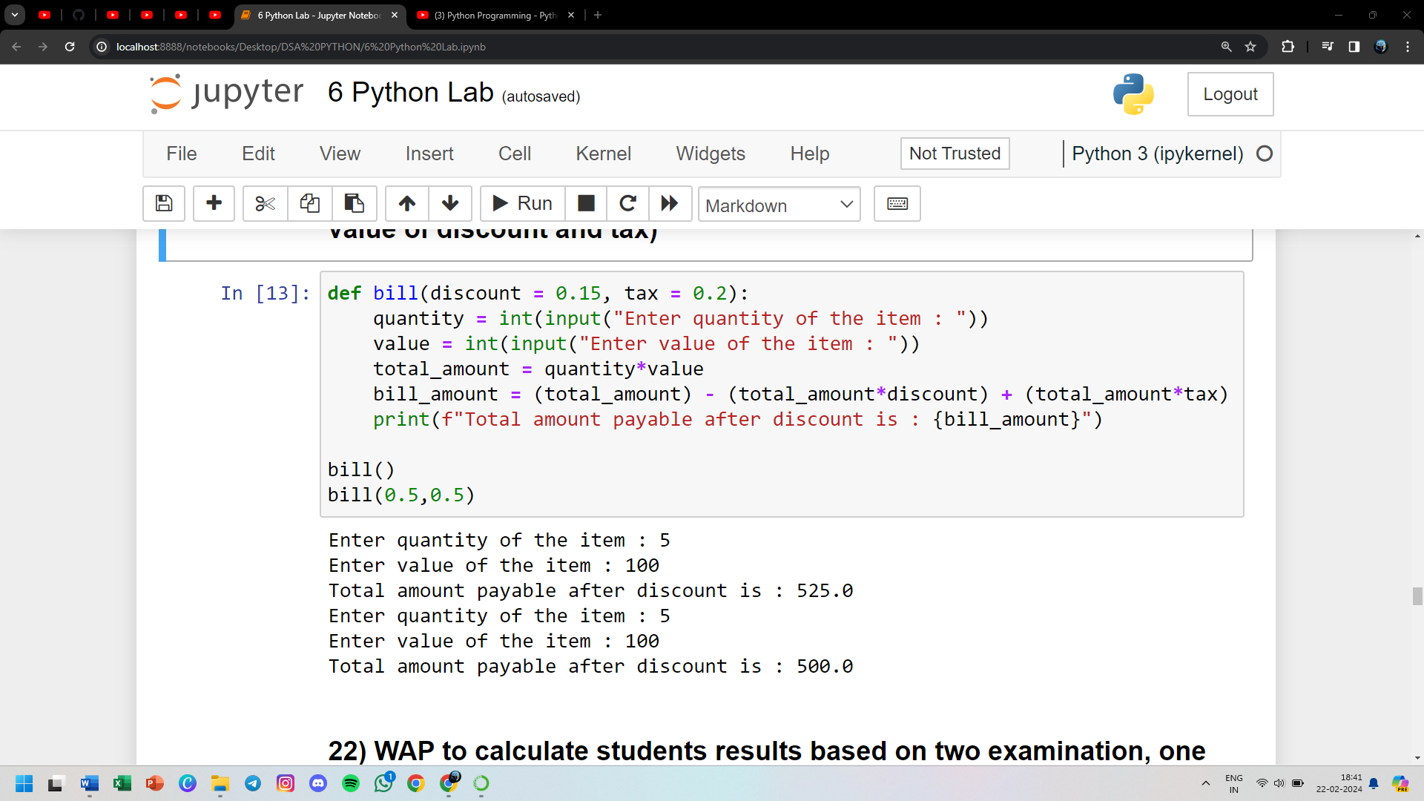

**22) WAP to calculate students results based on two examination, one sports event and three activities conducted. The weightage of activities = 30%, sports = 20% and examination = 50%**

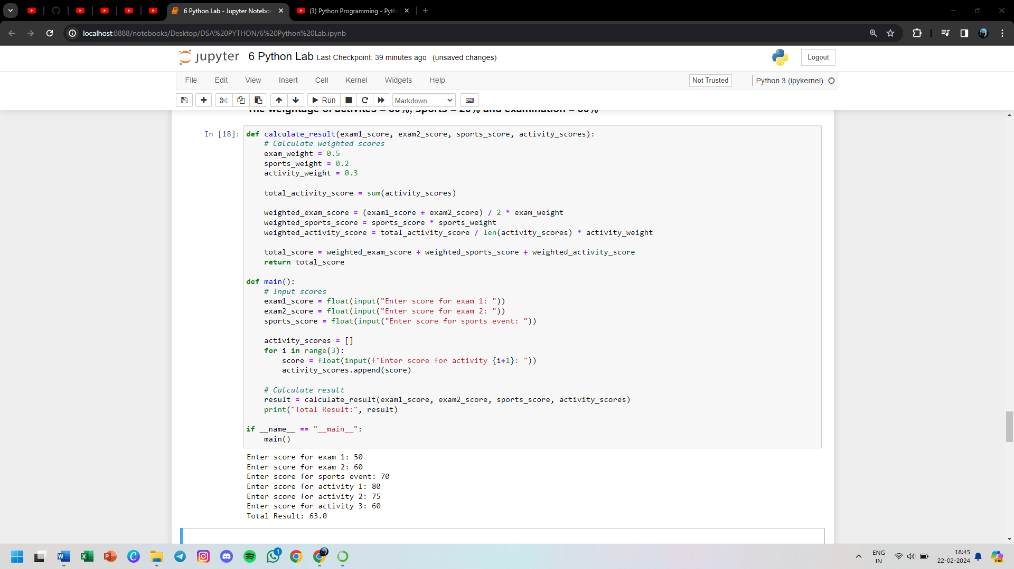

**23) WAP to print the ASCII value of character (ord('a'), char(65))**

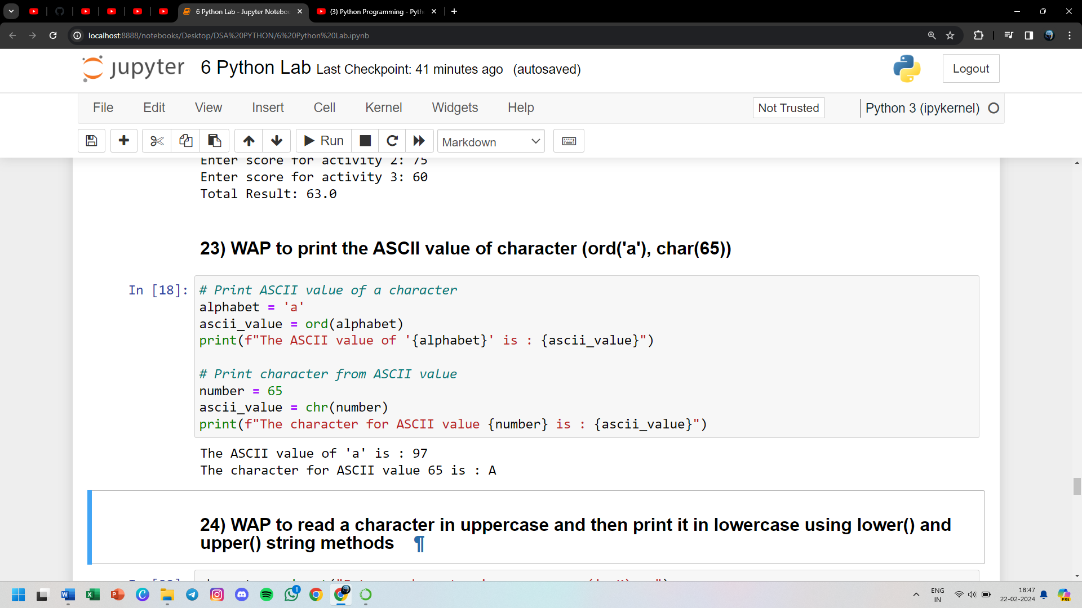

**24) WAP to read a character in uppercase and then print it in lowercase using lower() and upper() string methods**

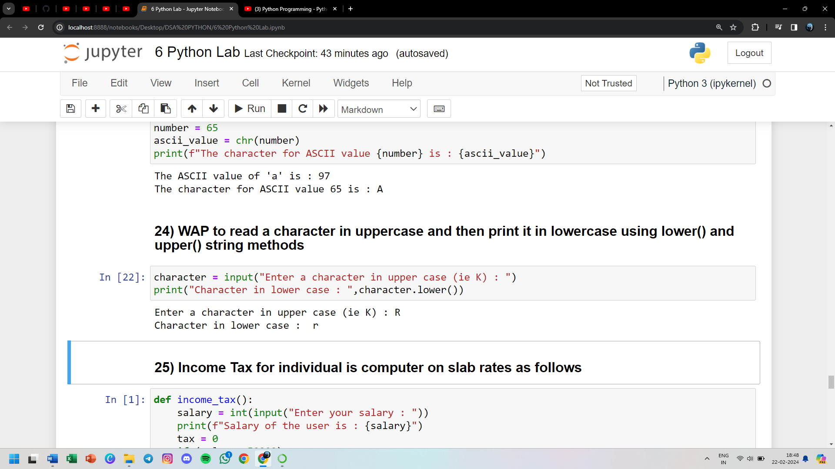

**25) Income Tax for individual is computer on slab rates as follows**

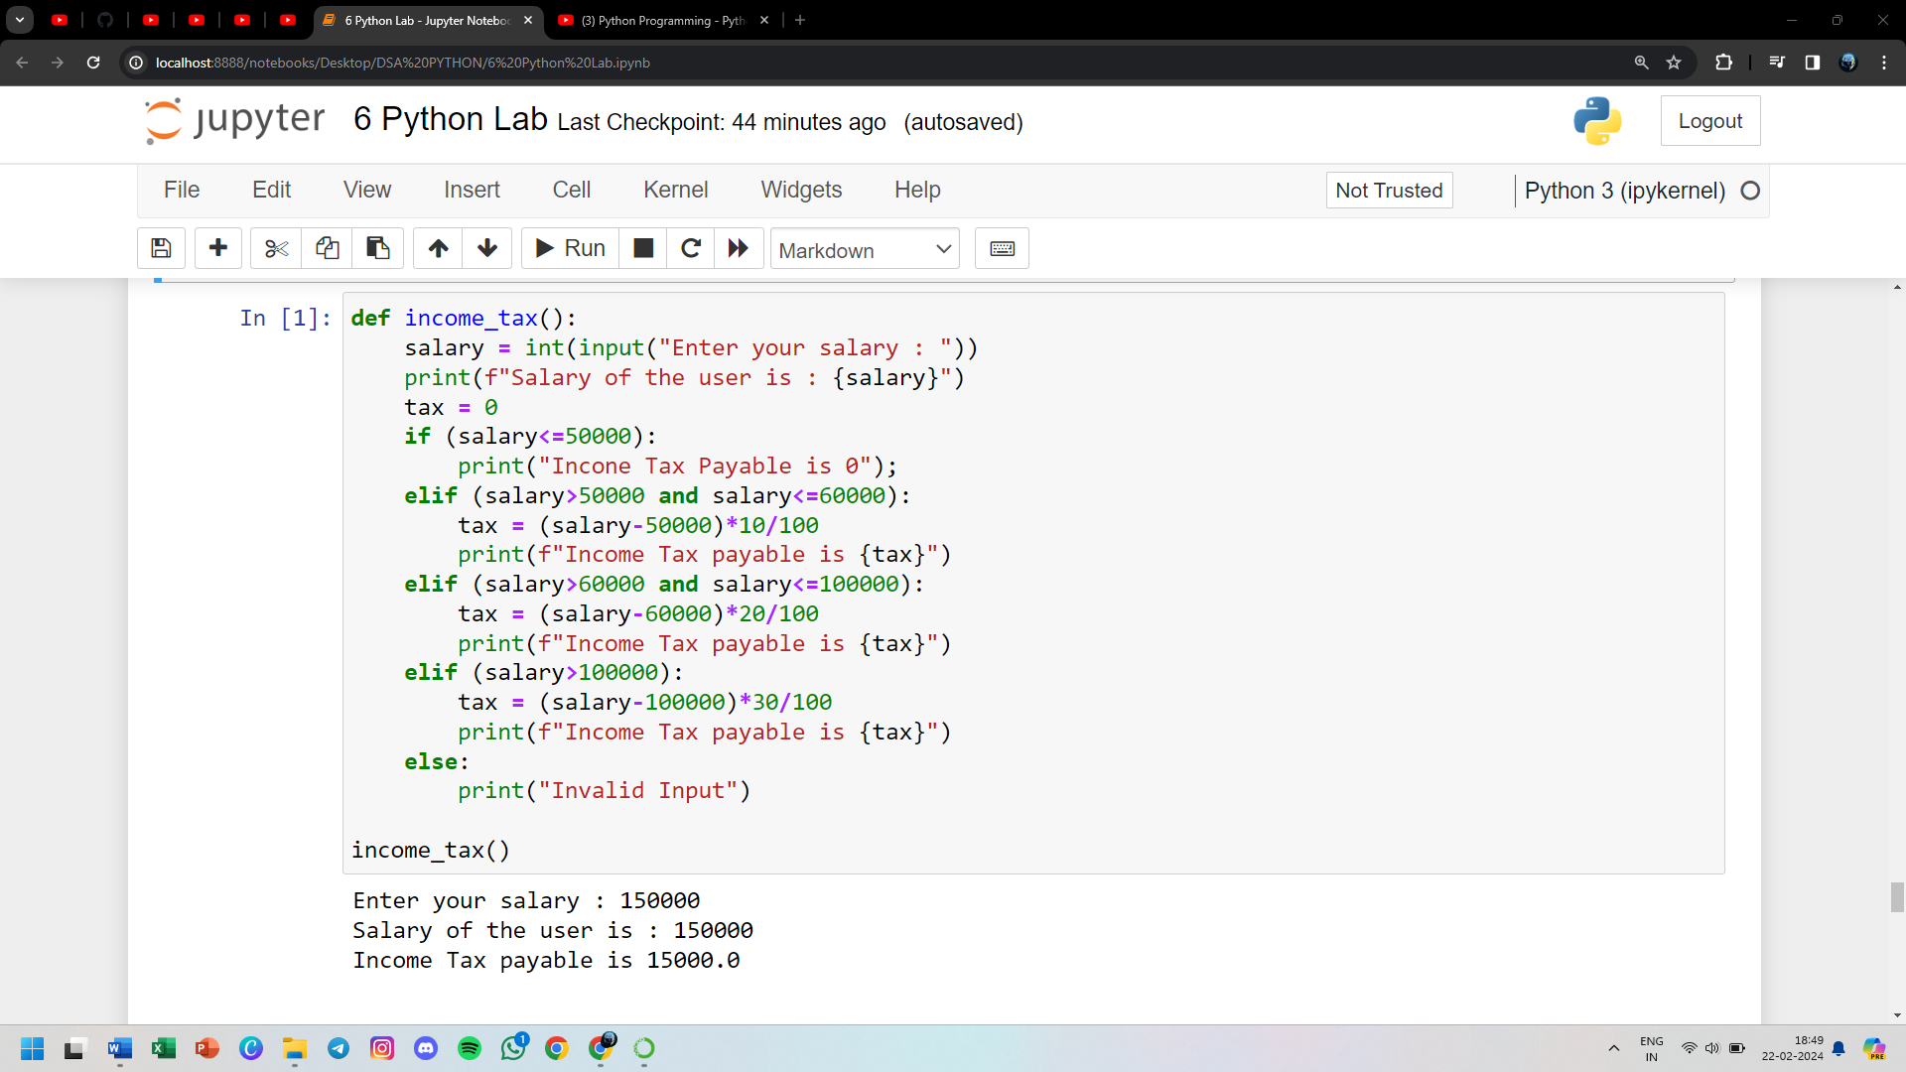

**26) WAP to check a number entered is perfect or not**

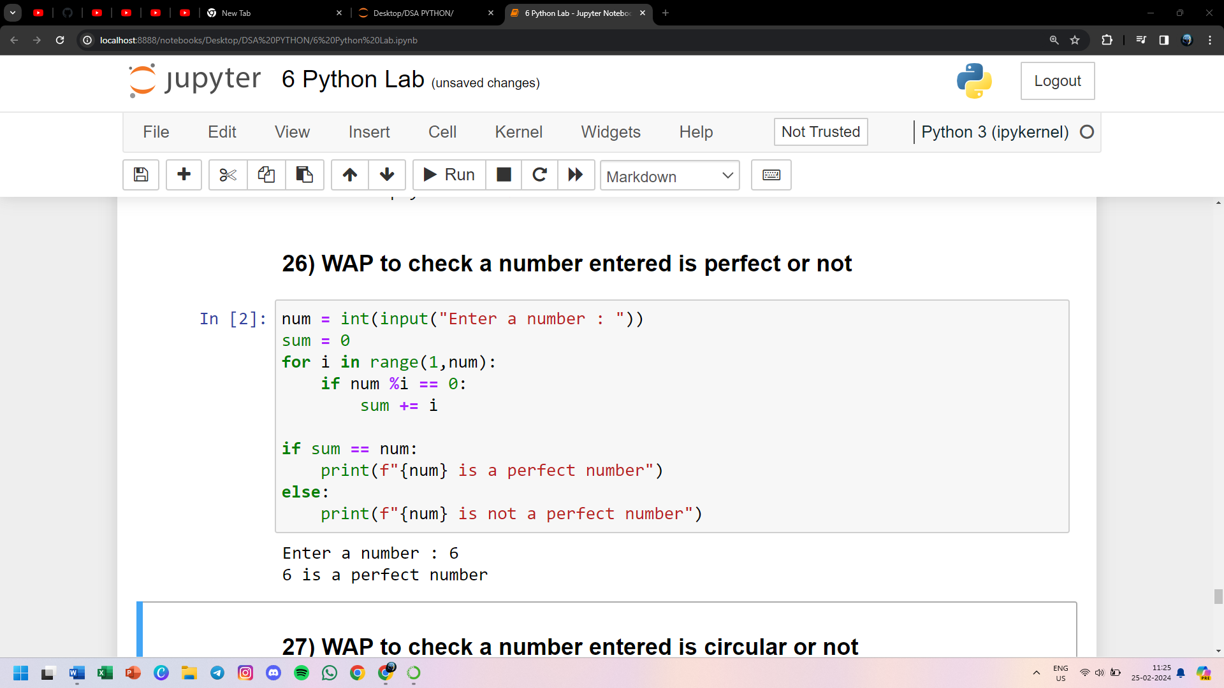

**27) WAP to check a number entered is circular or not**

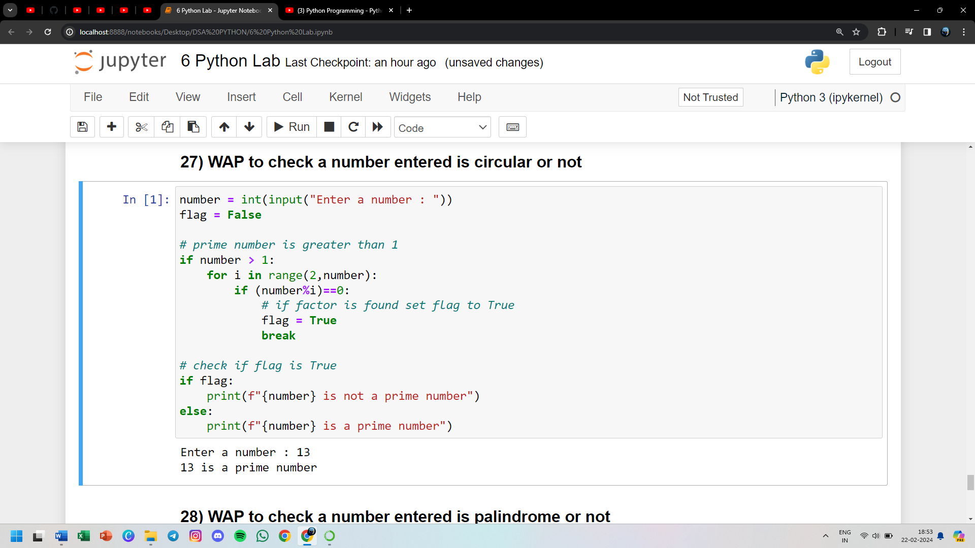

**28) WAP to check a number entered is palindrome or not**

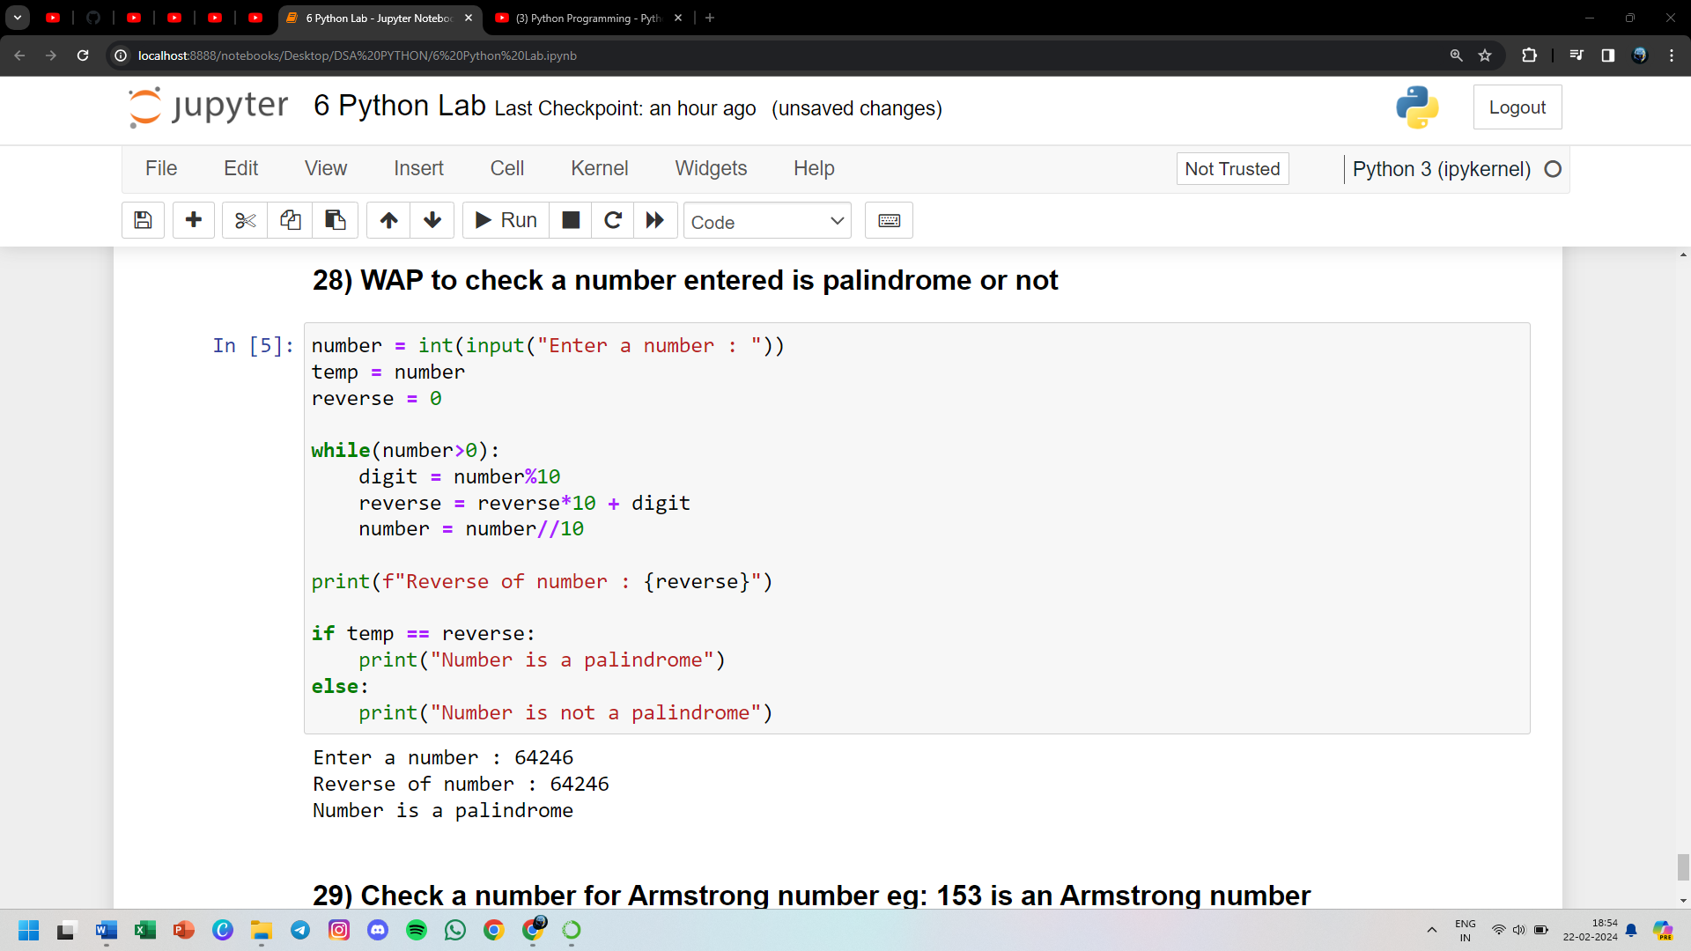

**29) Check a number for Armstrong number eg: 153 is an Armstrong number (1x1x1+5x5x5+3x3x3 = 153)**

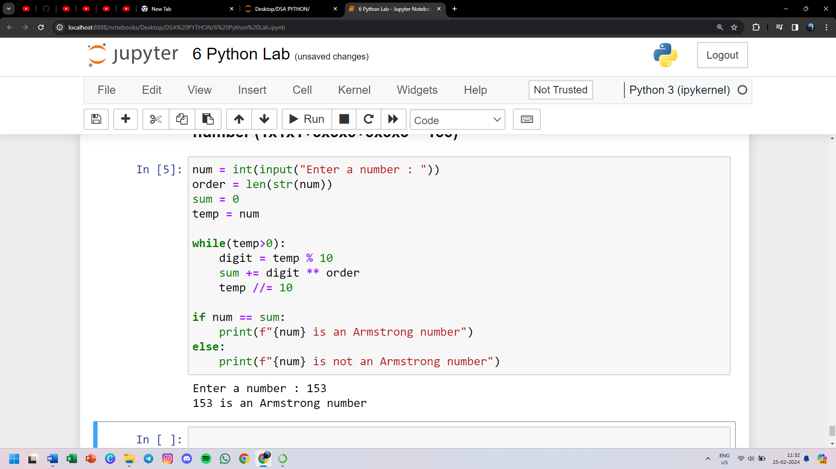

**30) WAP to swap two numbers entered by the user. You are not allowed to use a third variable**

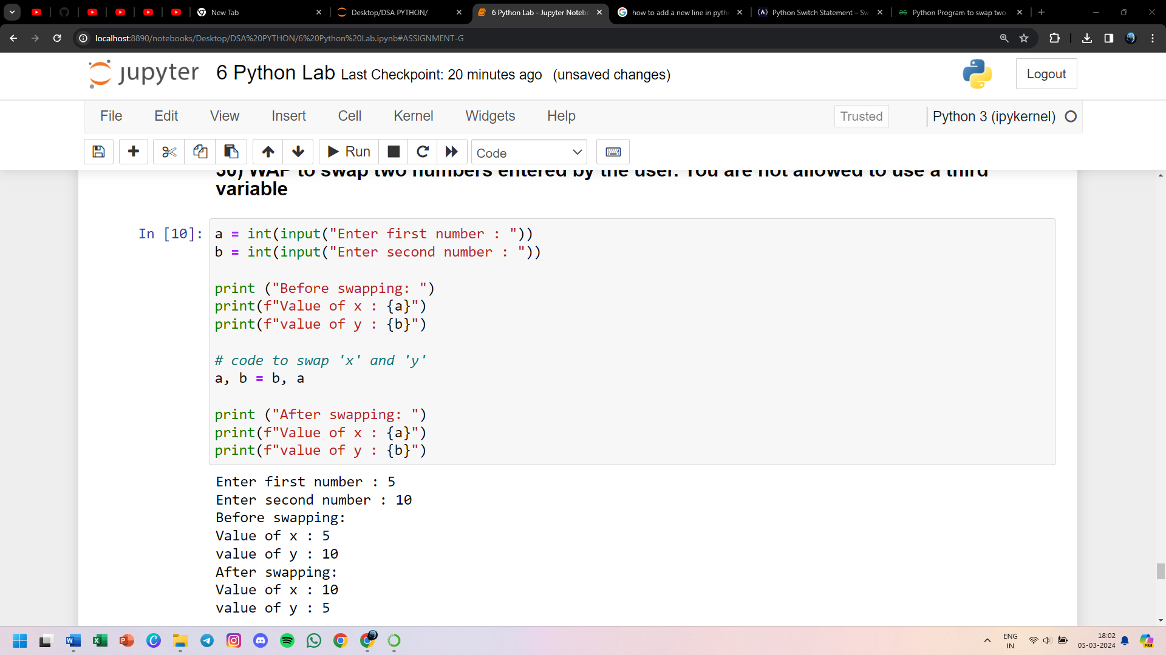

**31) WAP that has a user defined function to accept the coefficient of quadratic equation in variable and calculate its determinant**

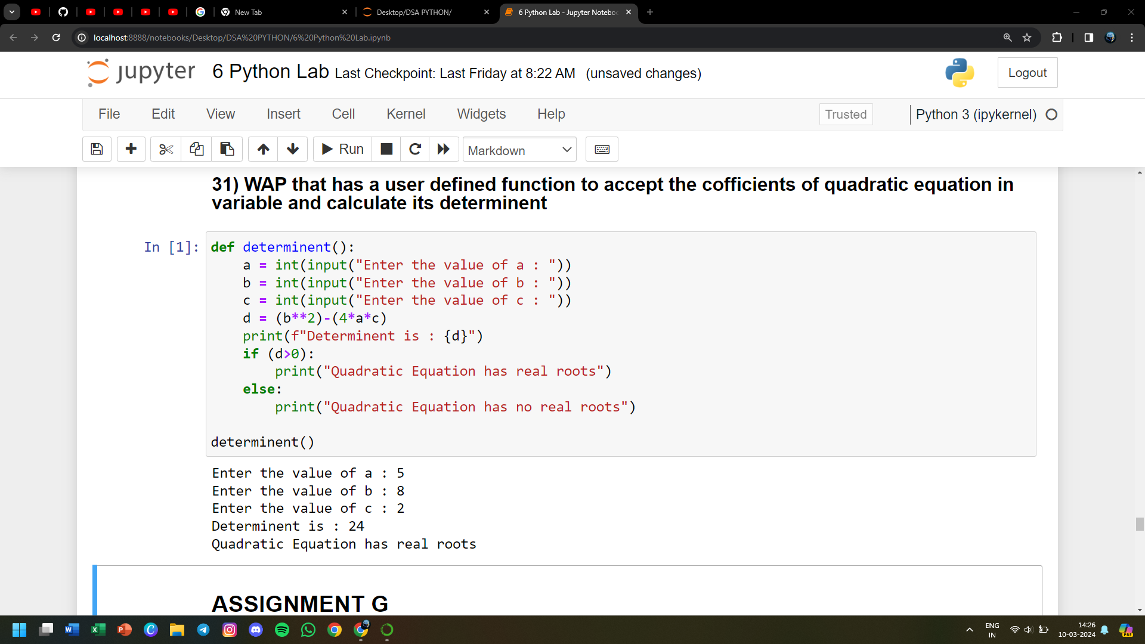

**32) Make a calculator.py file and import various functions into another file**

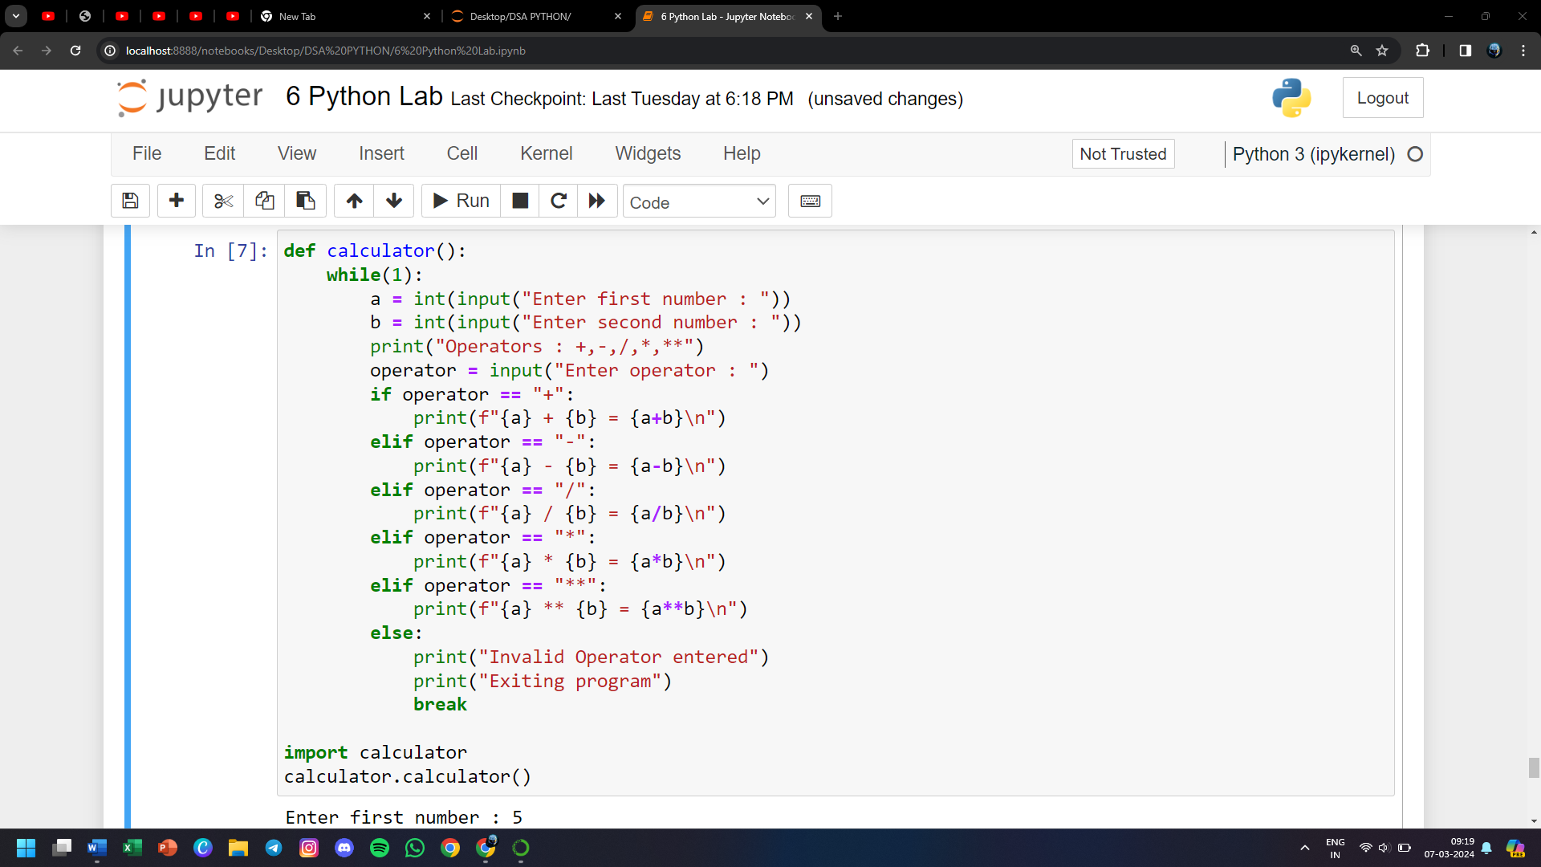

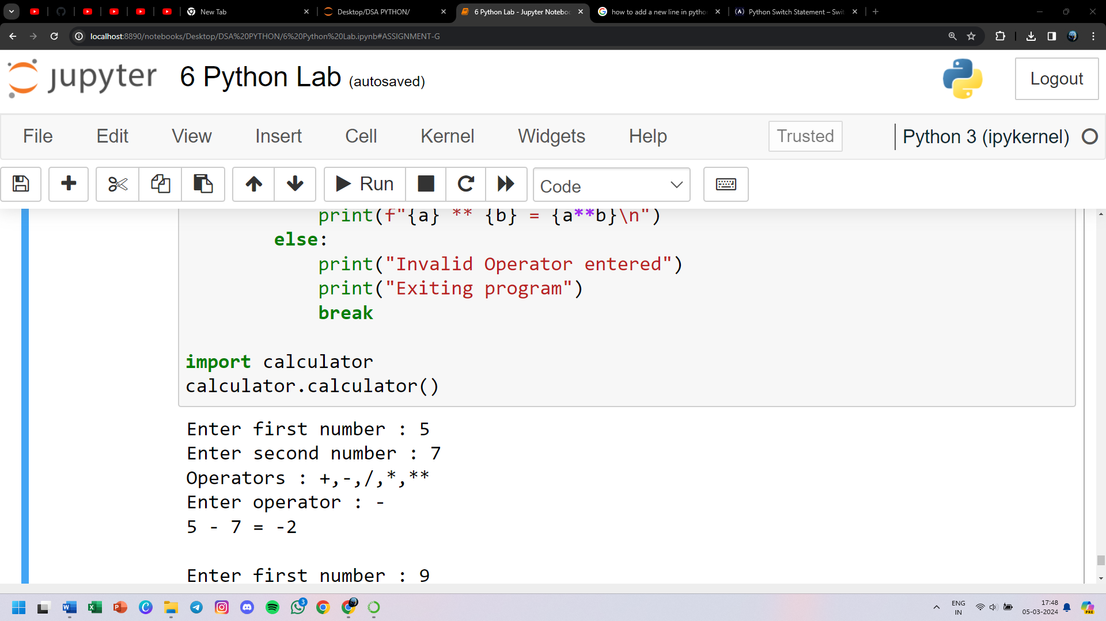

**33) Implement command line arguments (display all the arguments)**

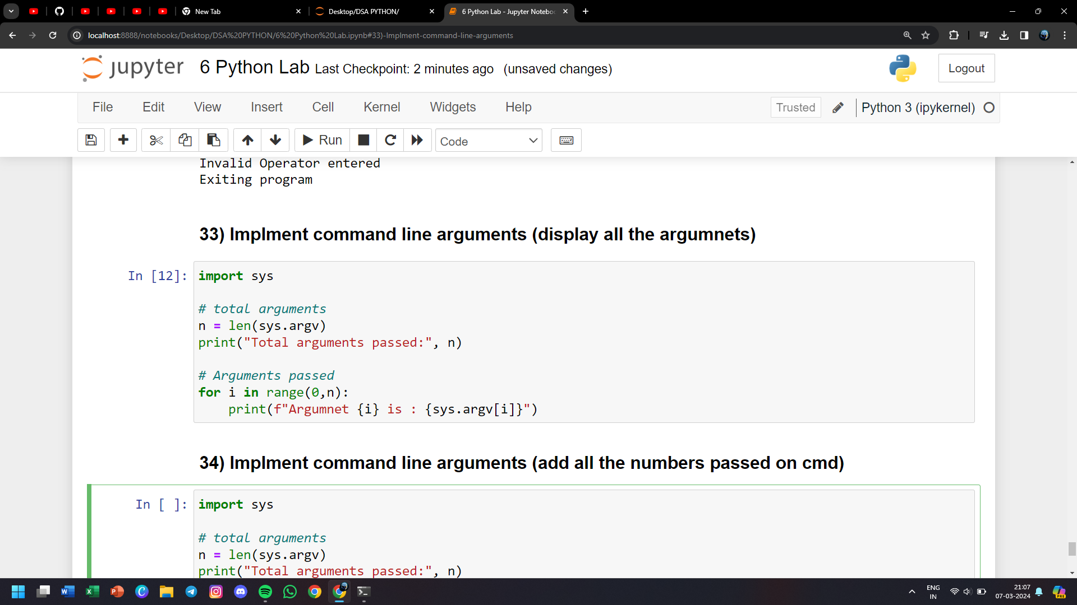

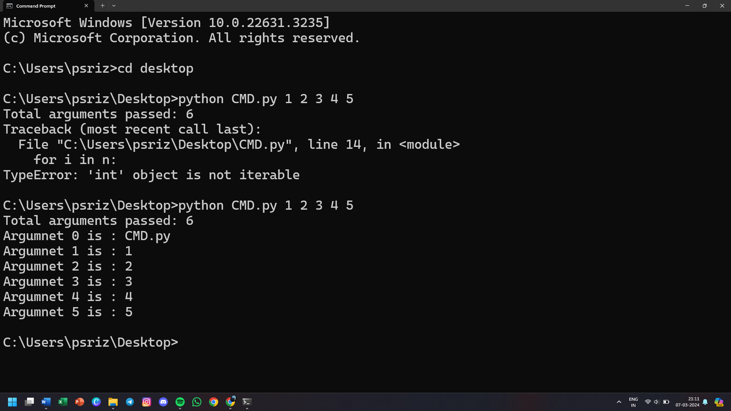

**34) Implement command line arguments (add all the numbers passed on command line)**

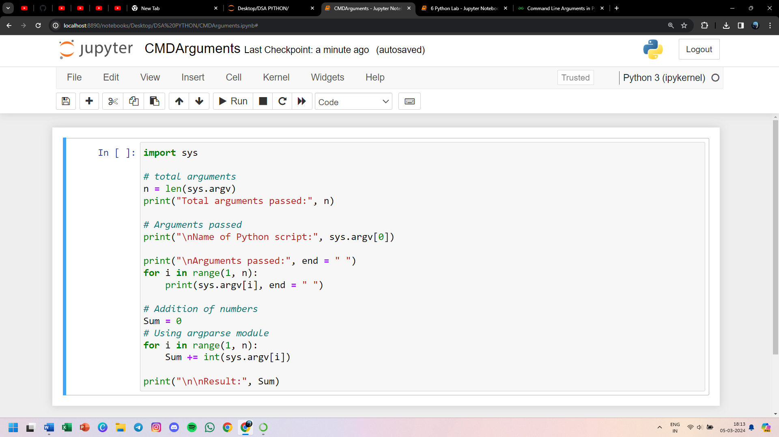

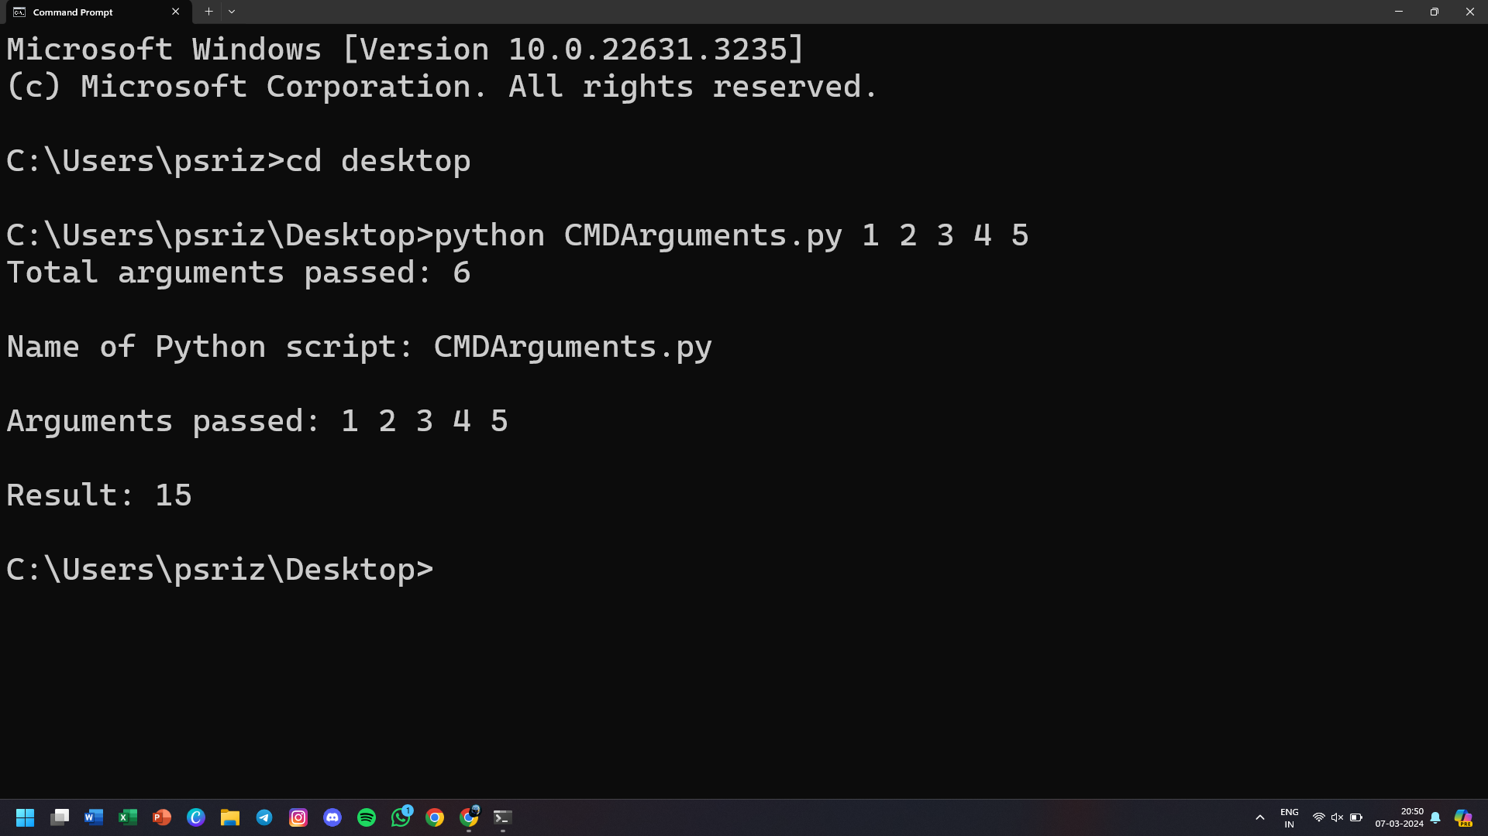

**36) From the string “Bamboozled”. WAP to obtain the following output**

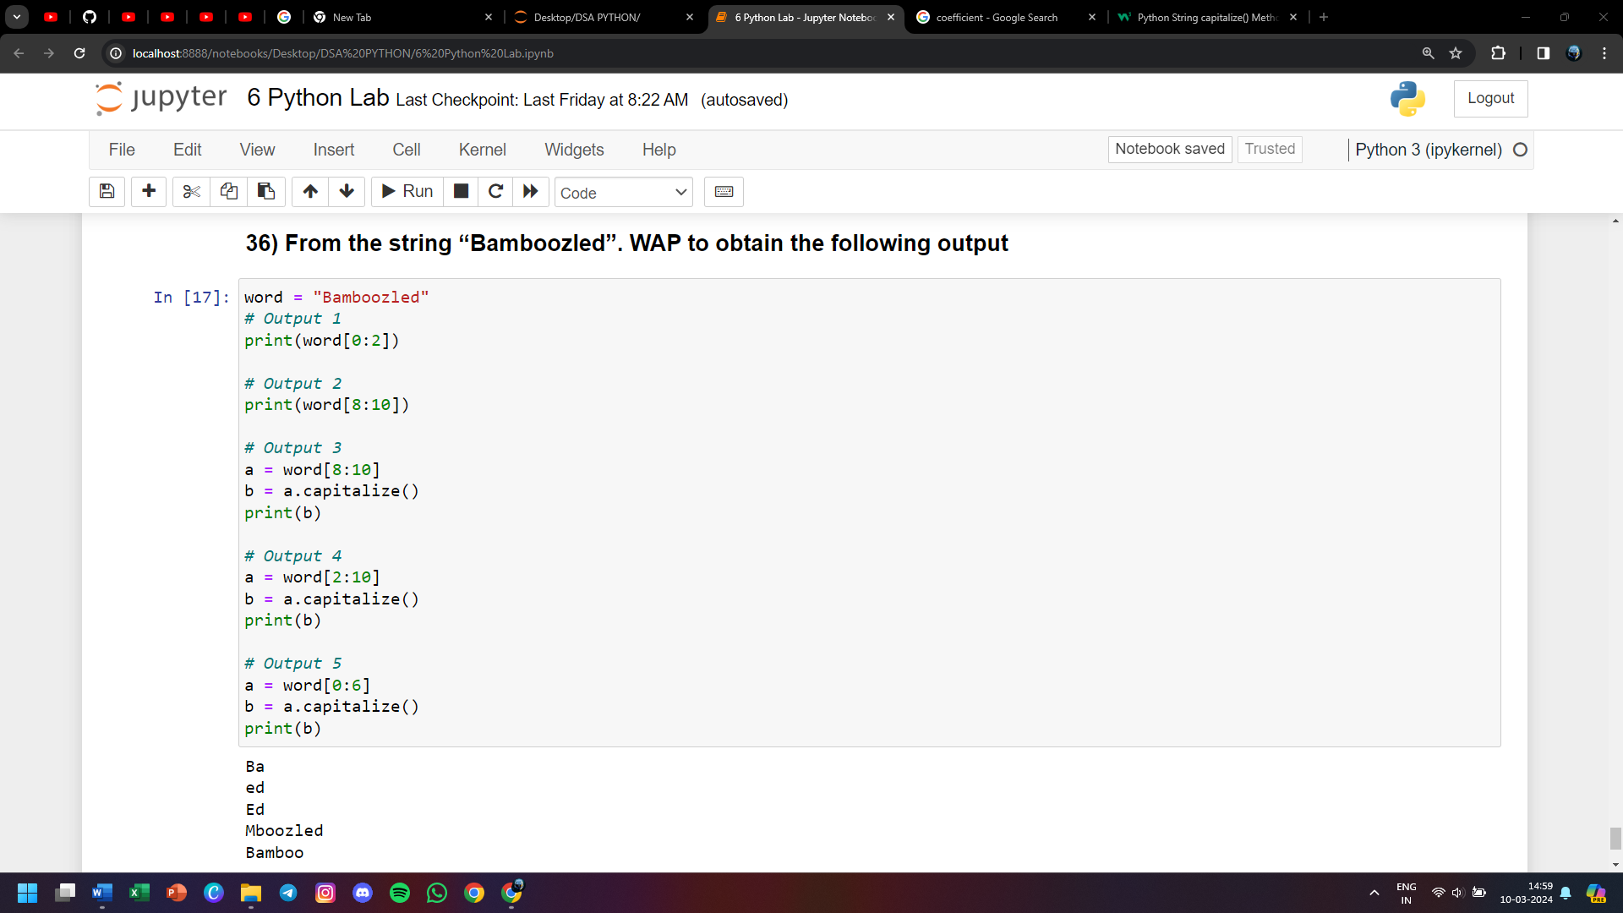

**37) Find all the occurrence of 'T' int the string 'The Terrible Tiger Tore The Towel'. Count them and print also replace them with 't'**

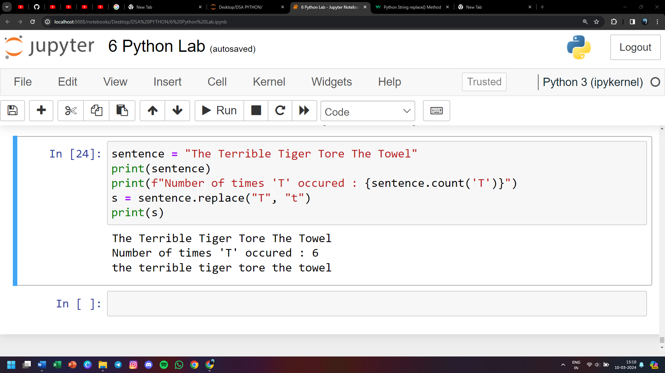

**38) WAP to reverse a string**

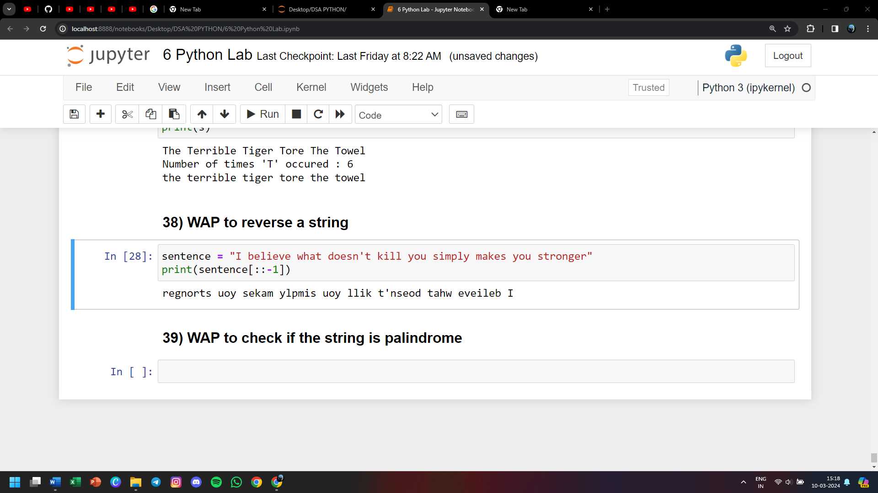

**39) WAP to check if the string is palindrome**

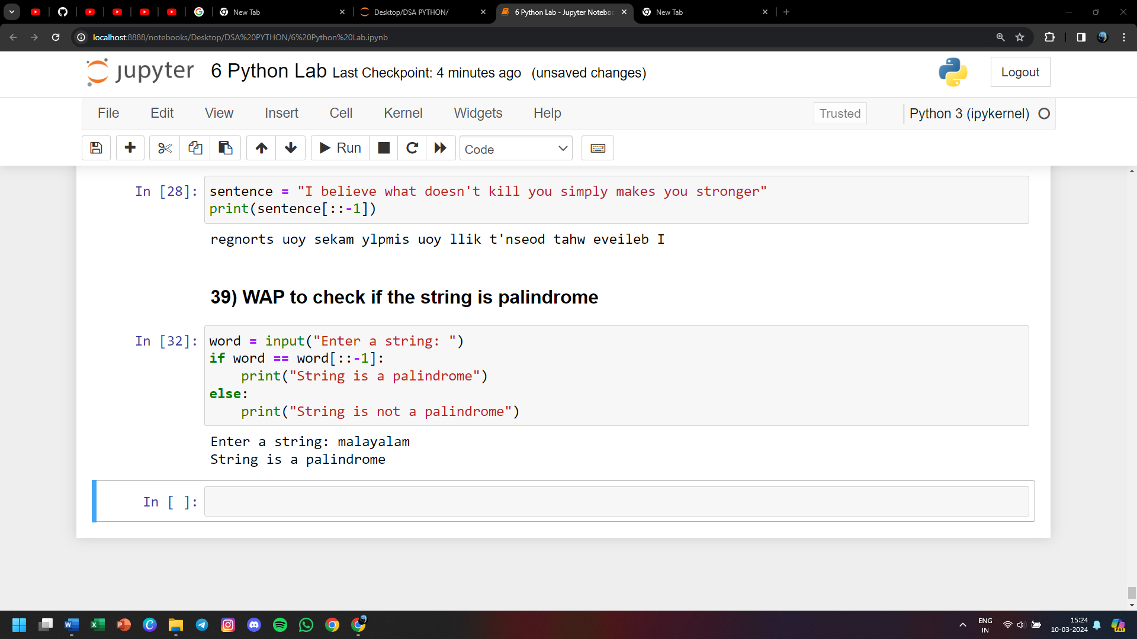

**40) WAP to calculate the length of the string**

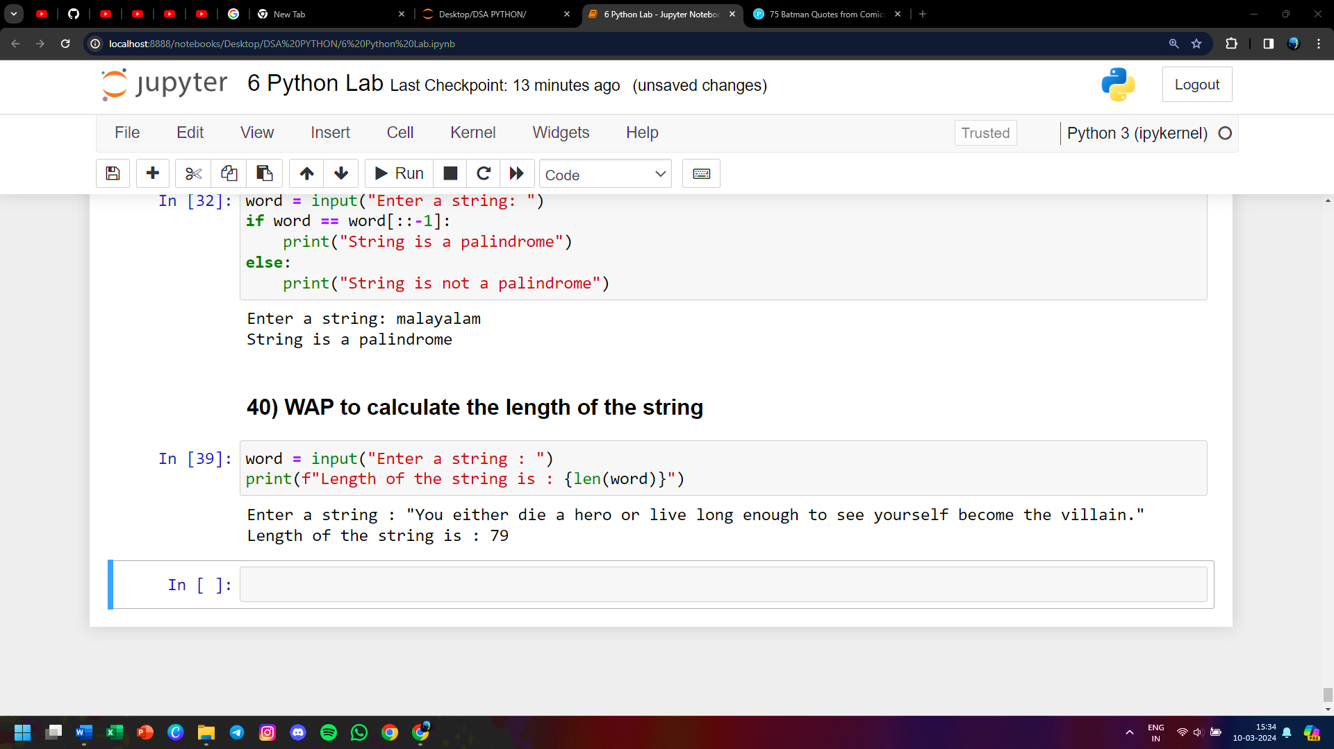

**41) WAP to count the number of characters (character frequency) in a string**

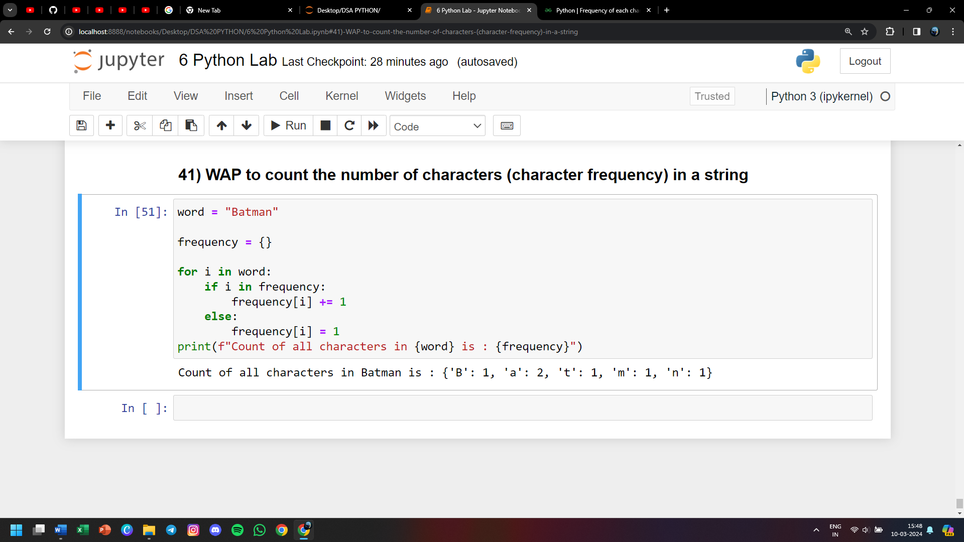

**42) WAP to get a single string from two strings separated by a space and swap the first two characters of each string**

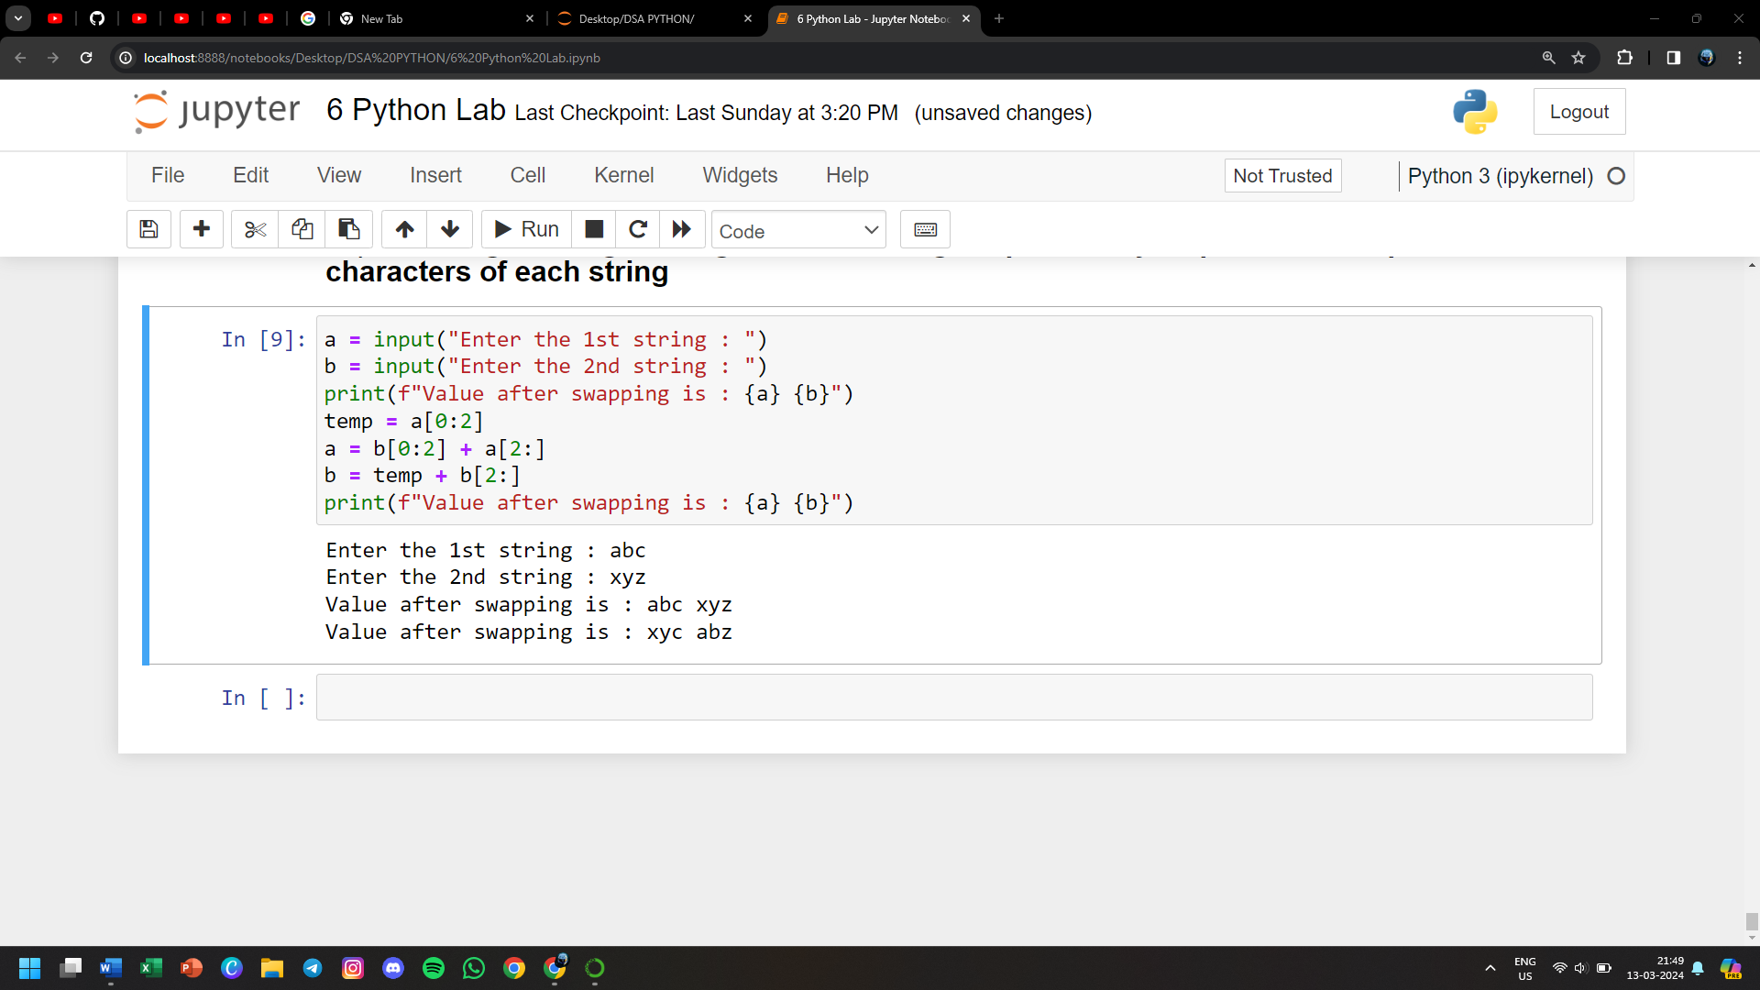

**43) WAP to accept a string and count the total number of vowels**

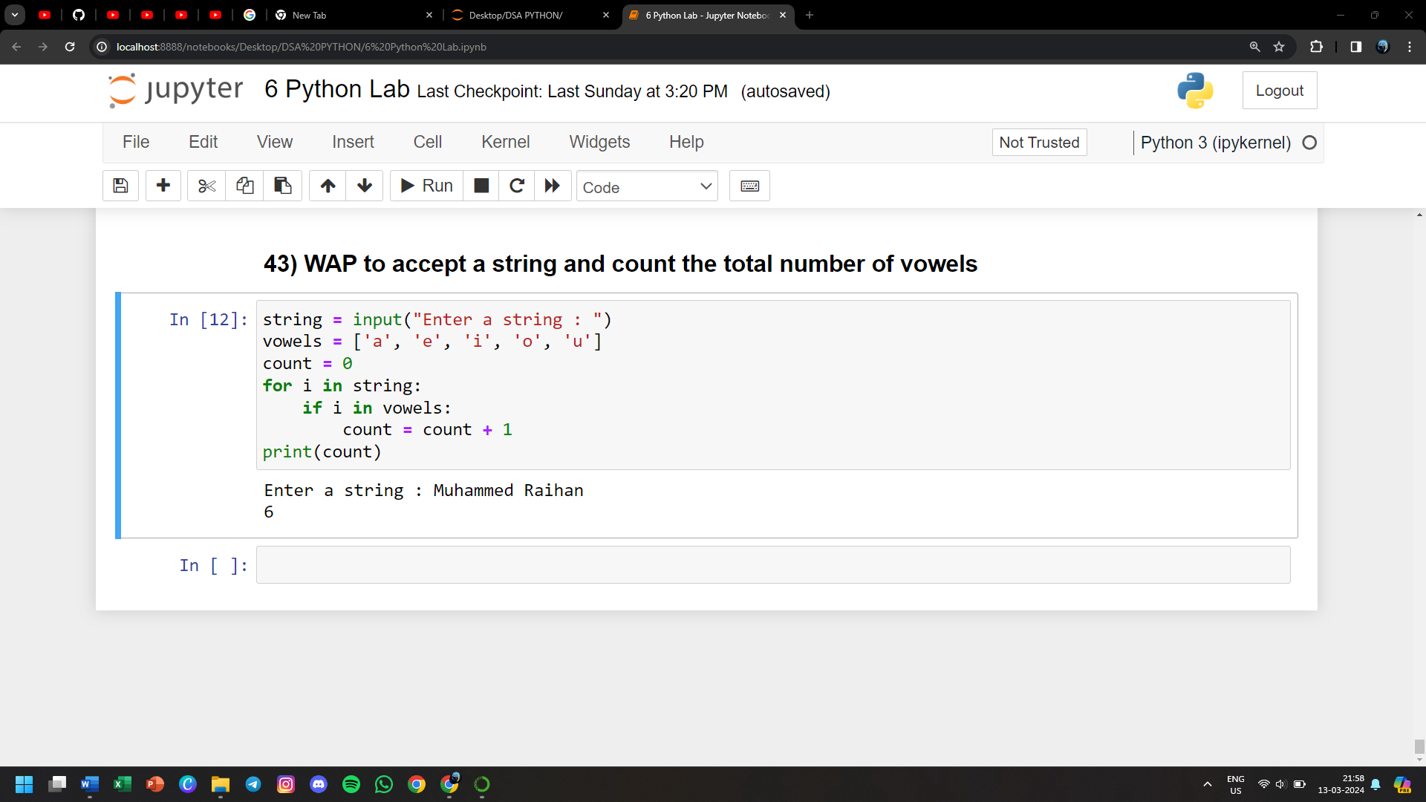

**44) WAP to search a character in the string**

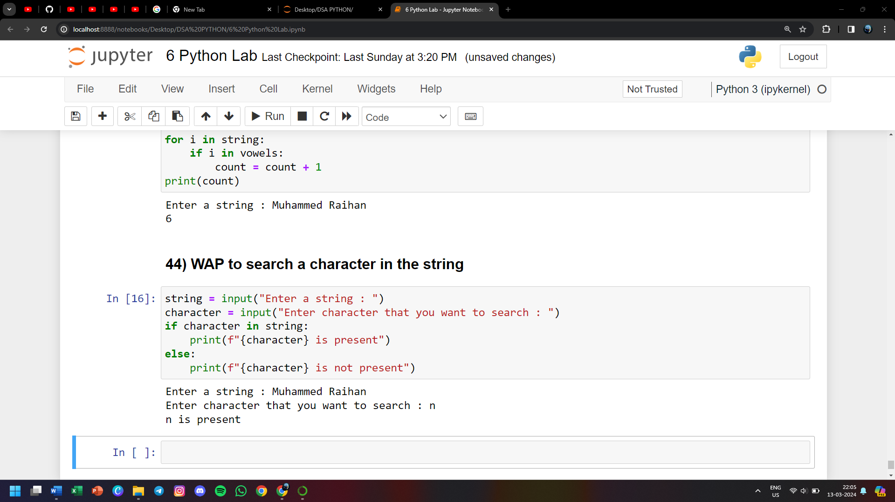

**45) WAP to read the email id of the person in the format expected**

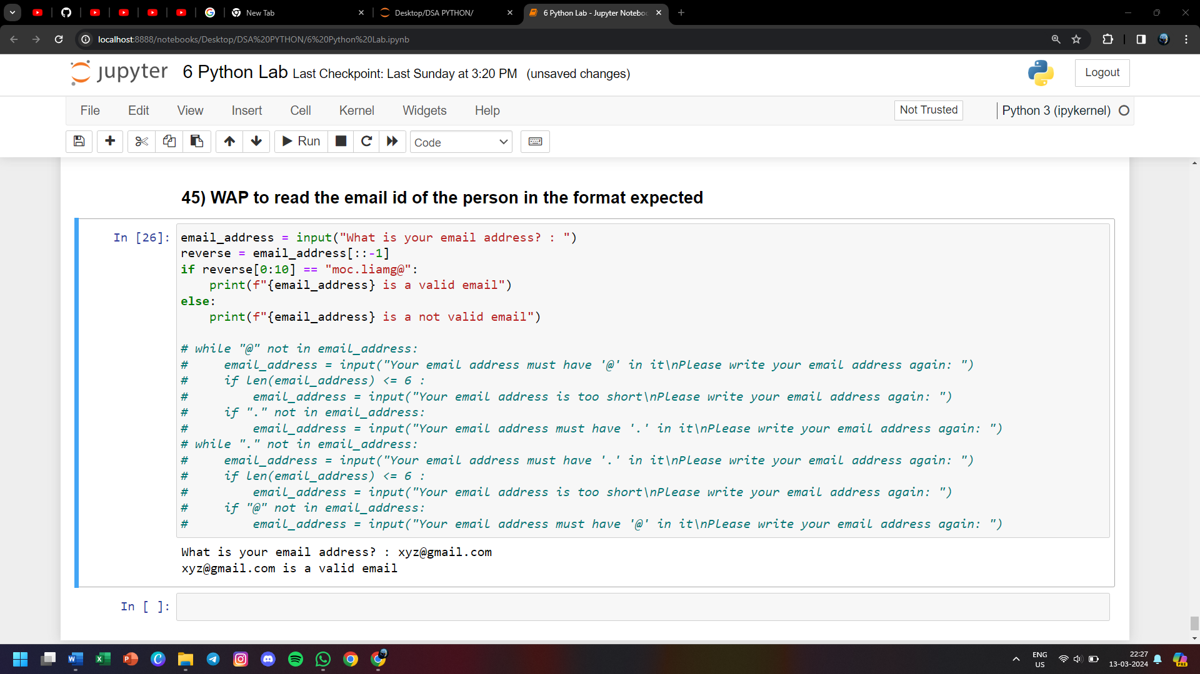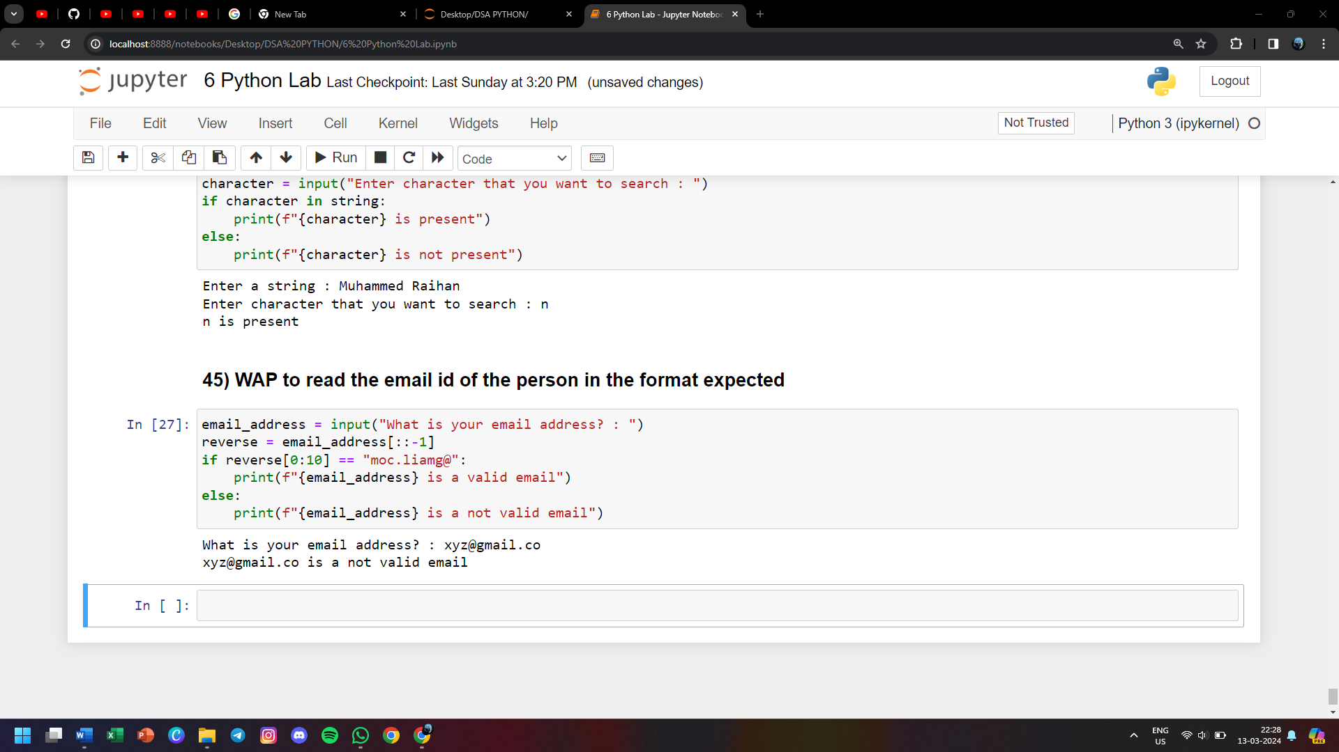

**46) WAP to perform following on the list**

**1) Create a list of 5 names**

**2) Insert a name Anuj before Aditya**

**3) Append a name Zulu**

**4) Delete Avi from the list**

**5) Replace Anil with Anil Kumar**

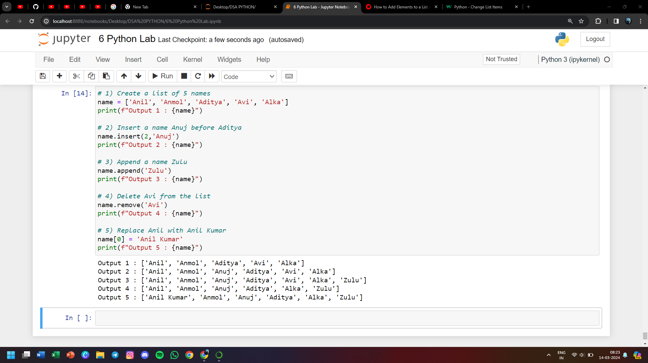

**47) WAP to implement stack data structure which is LIFO**

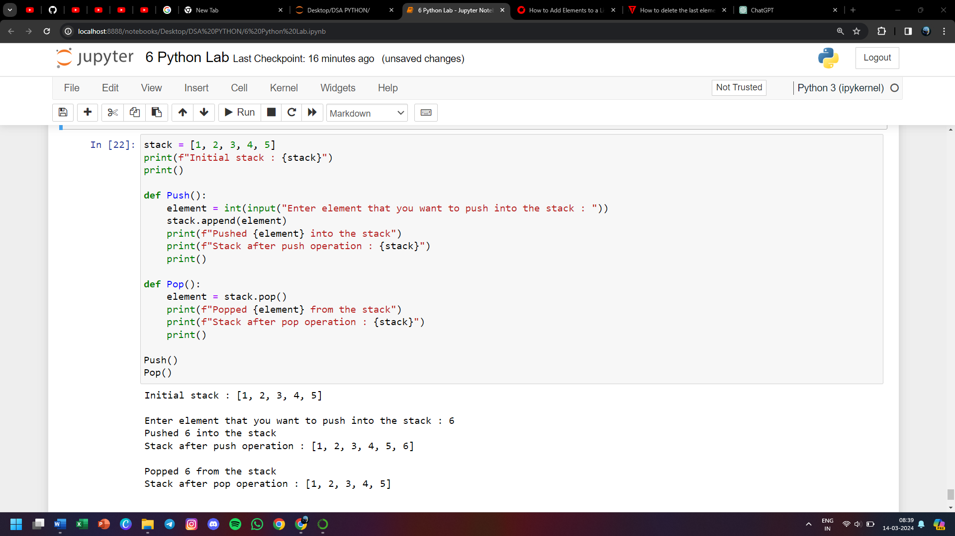

**48) Suppose a list has 20 numbers. WAP that removes all duplicates from the list**

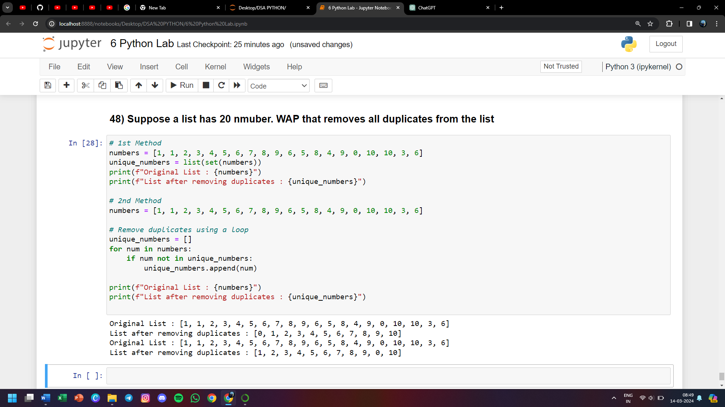

**49) WAP to obtain the median value of the list of numbers, without disturbing the order of numbers in the list**

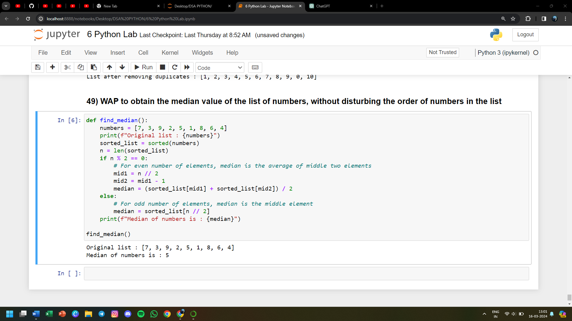

**50) WAP to count the occurrence of each character entered by the user and store them in a dictionary**

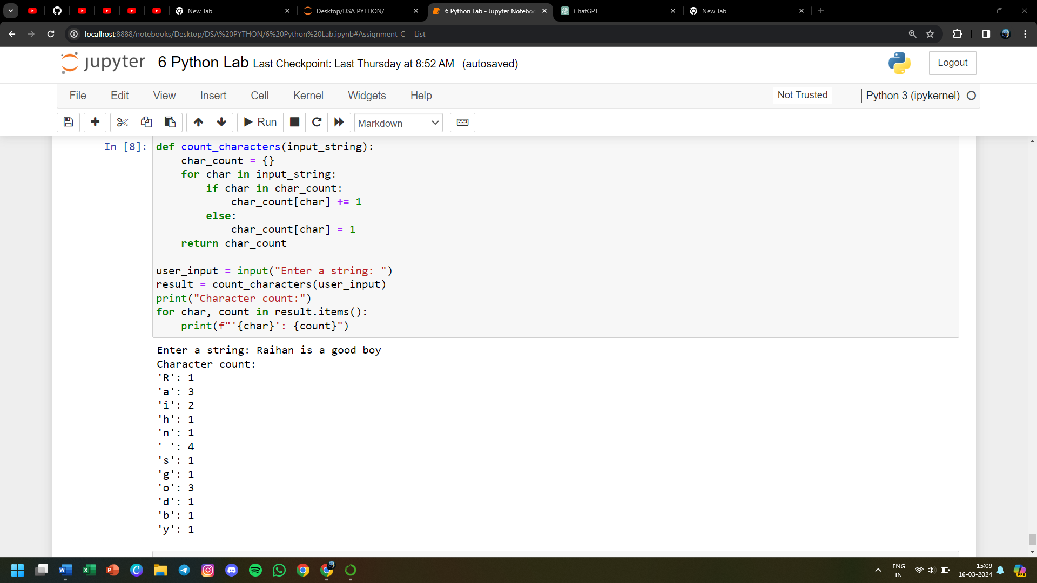

**51) WAP to create two dictionaries, concatenate them and create a third dictionary**

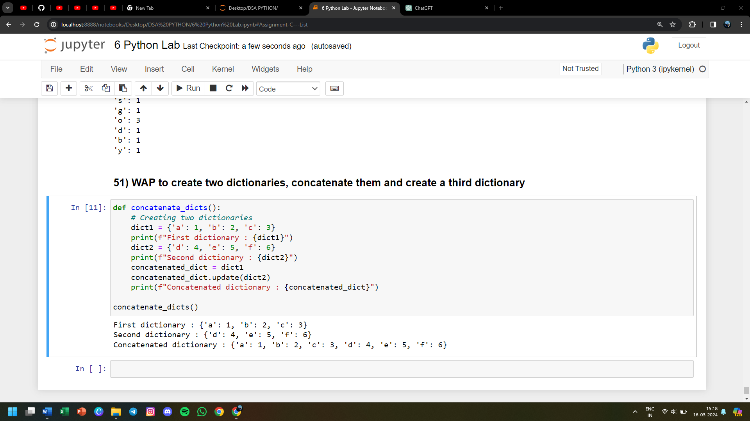

**52) WAP to check weather a given key exists in the dictionary**

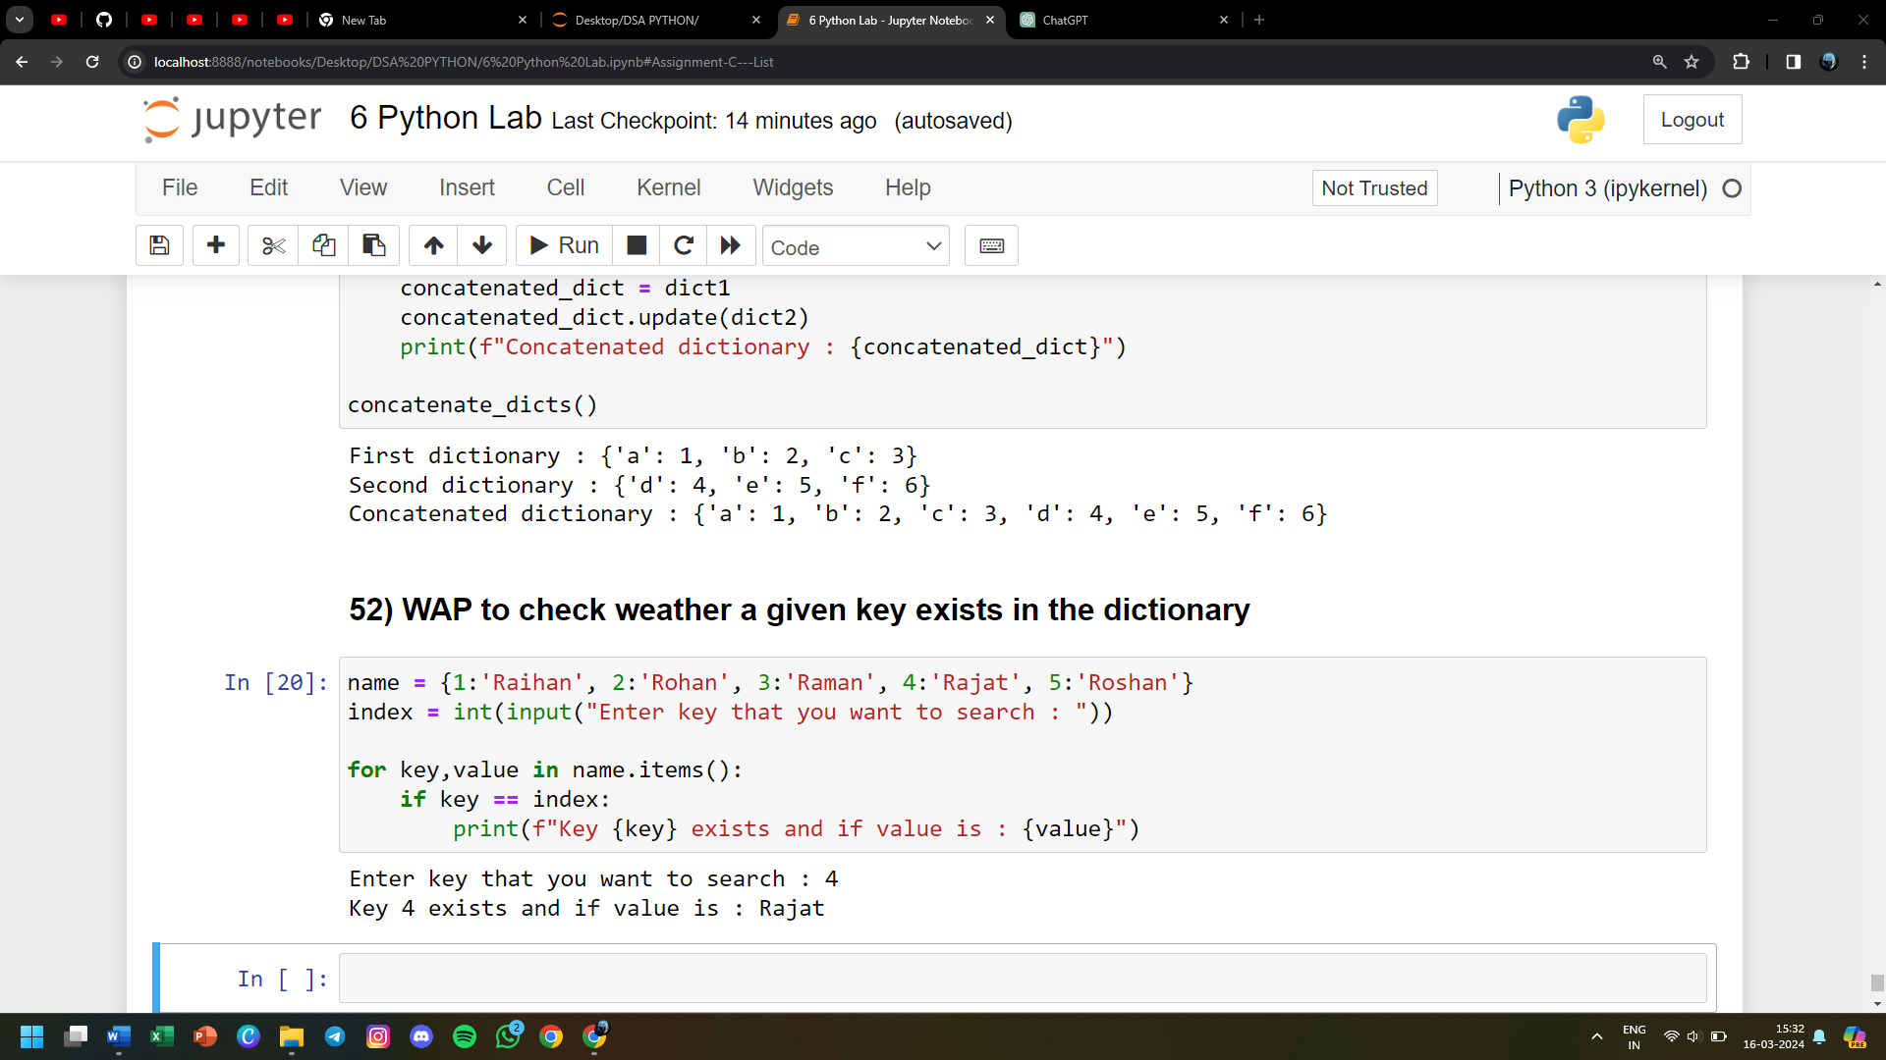

**53) WAP to remove a particular key from the dictionary**

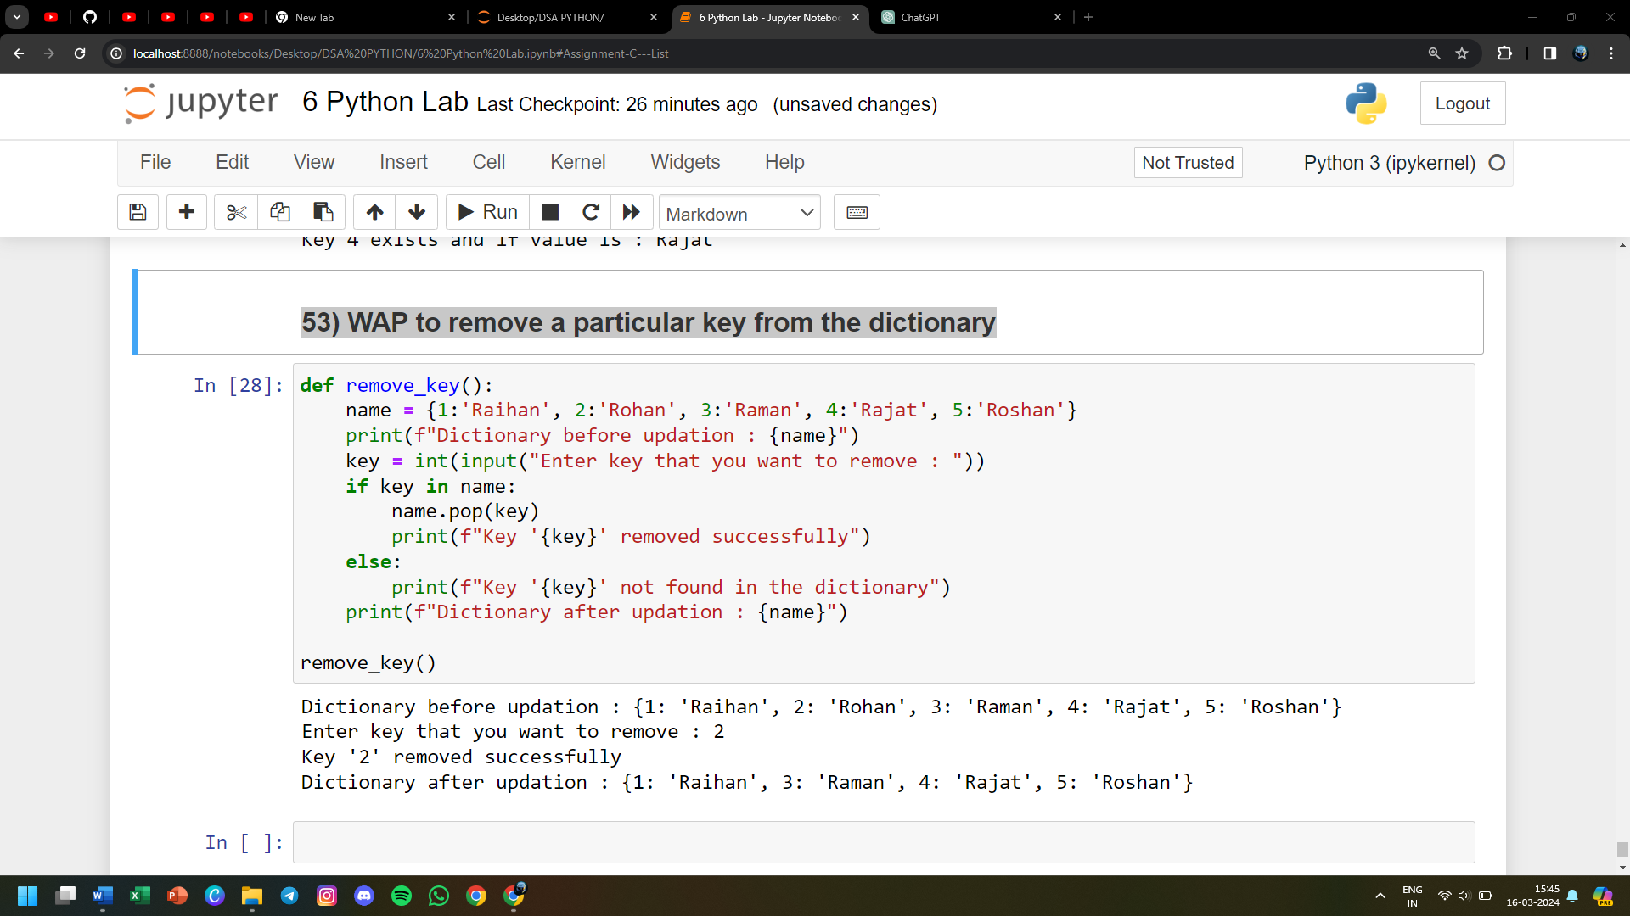

**54) WAP to display the minimum and maximum in a dictionary**

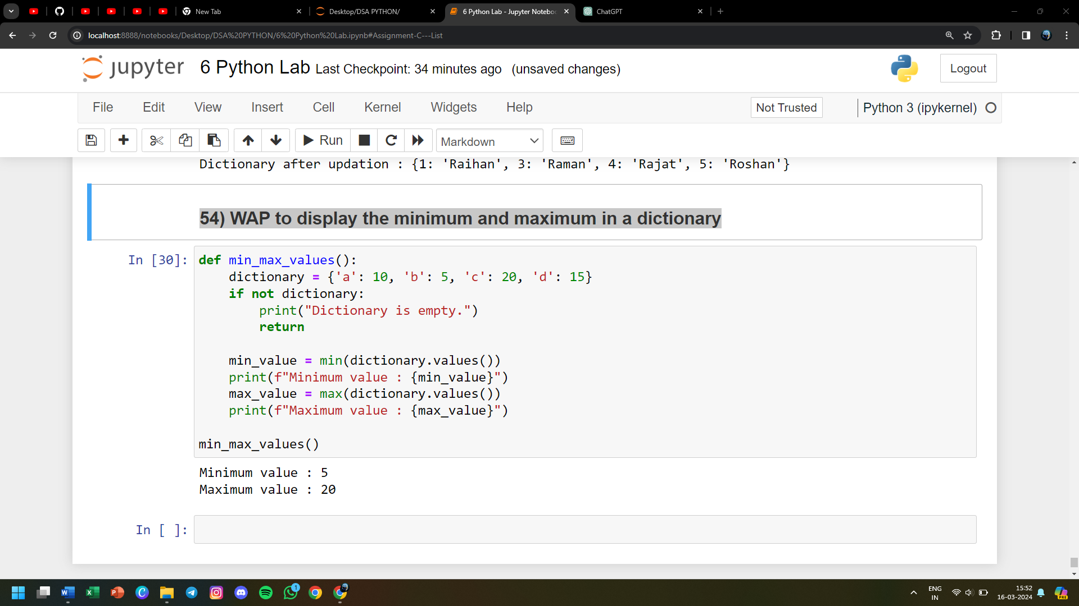

**55) WAP to reverse a tuple**

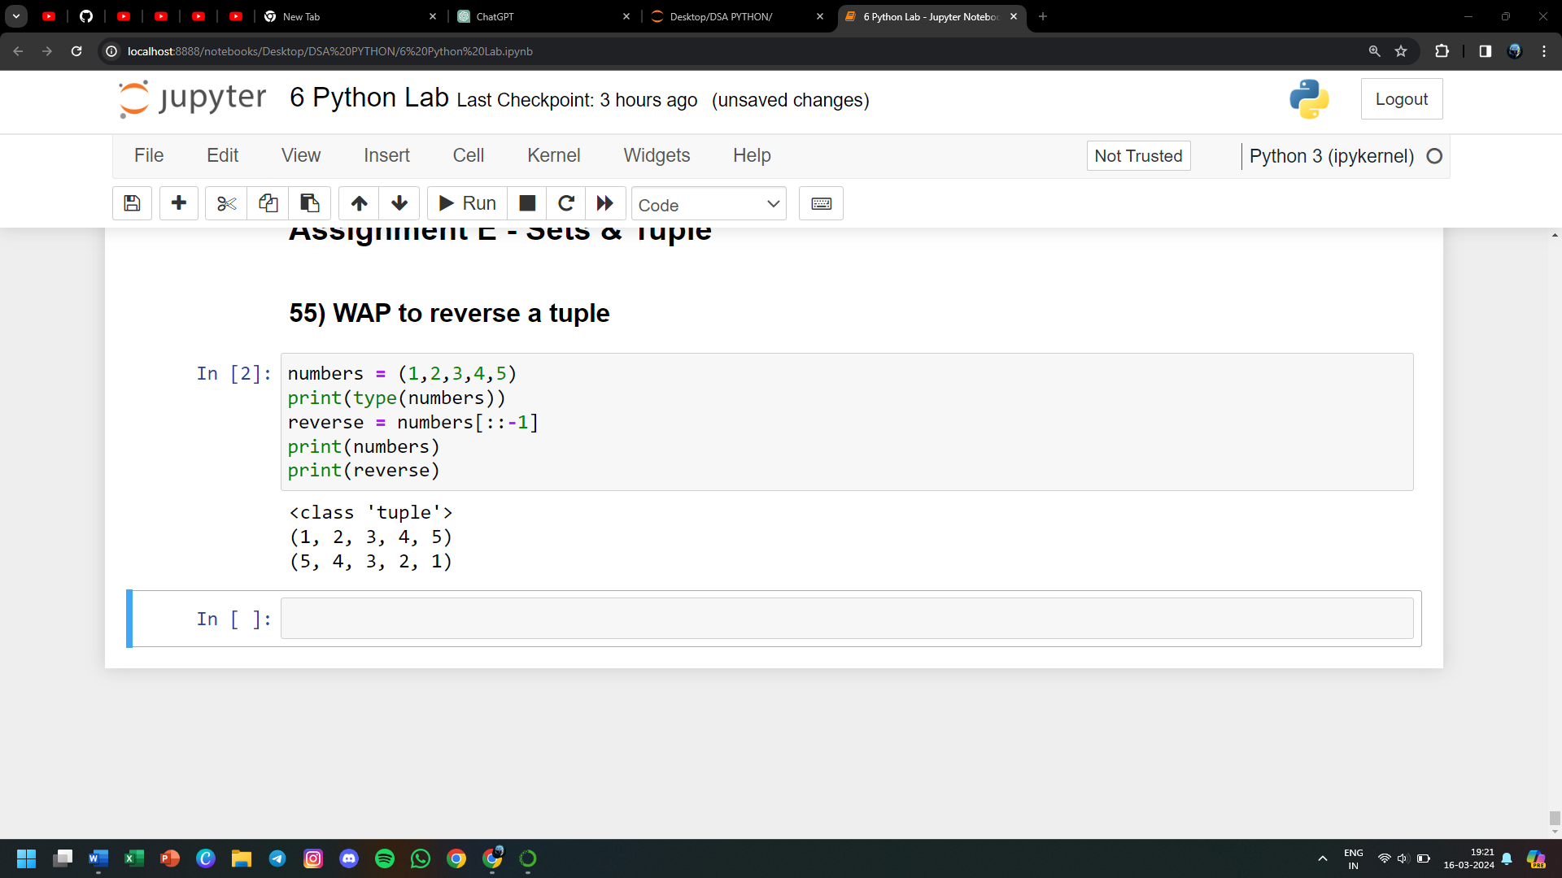

**56) WAP to calculate the product by multiplying all the numbers of a tuple**

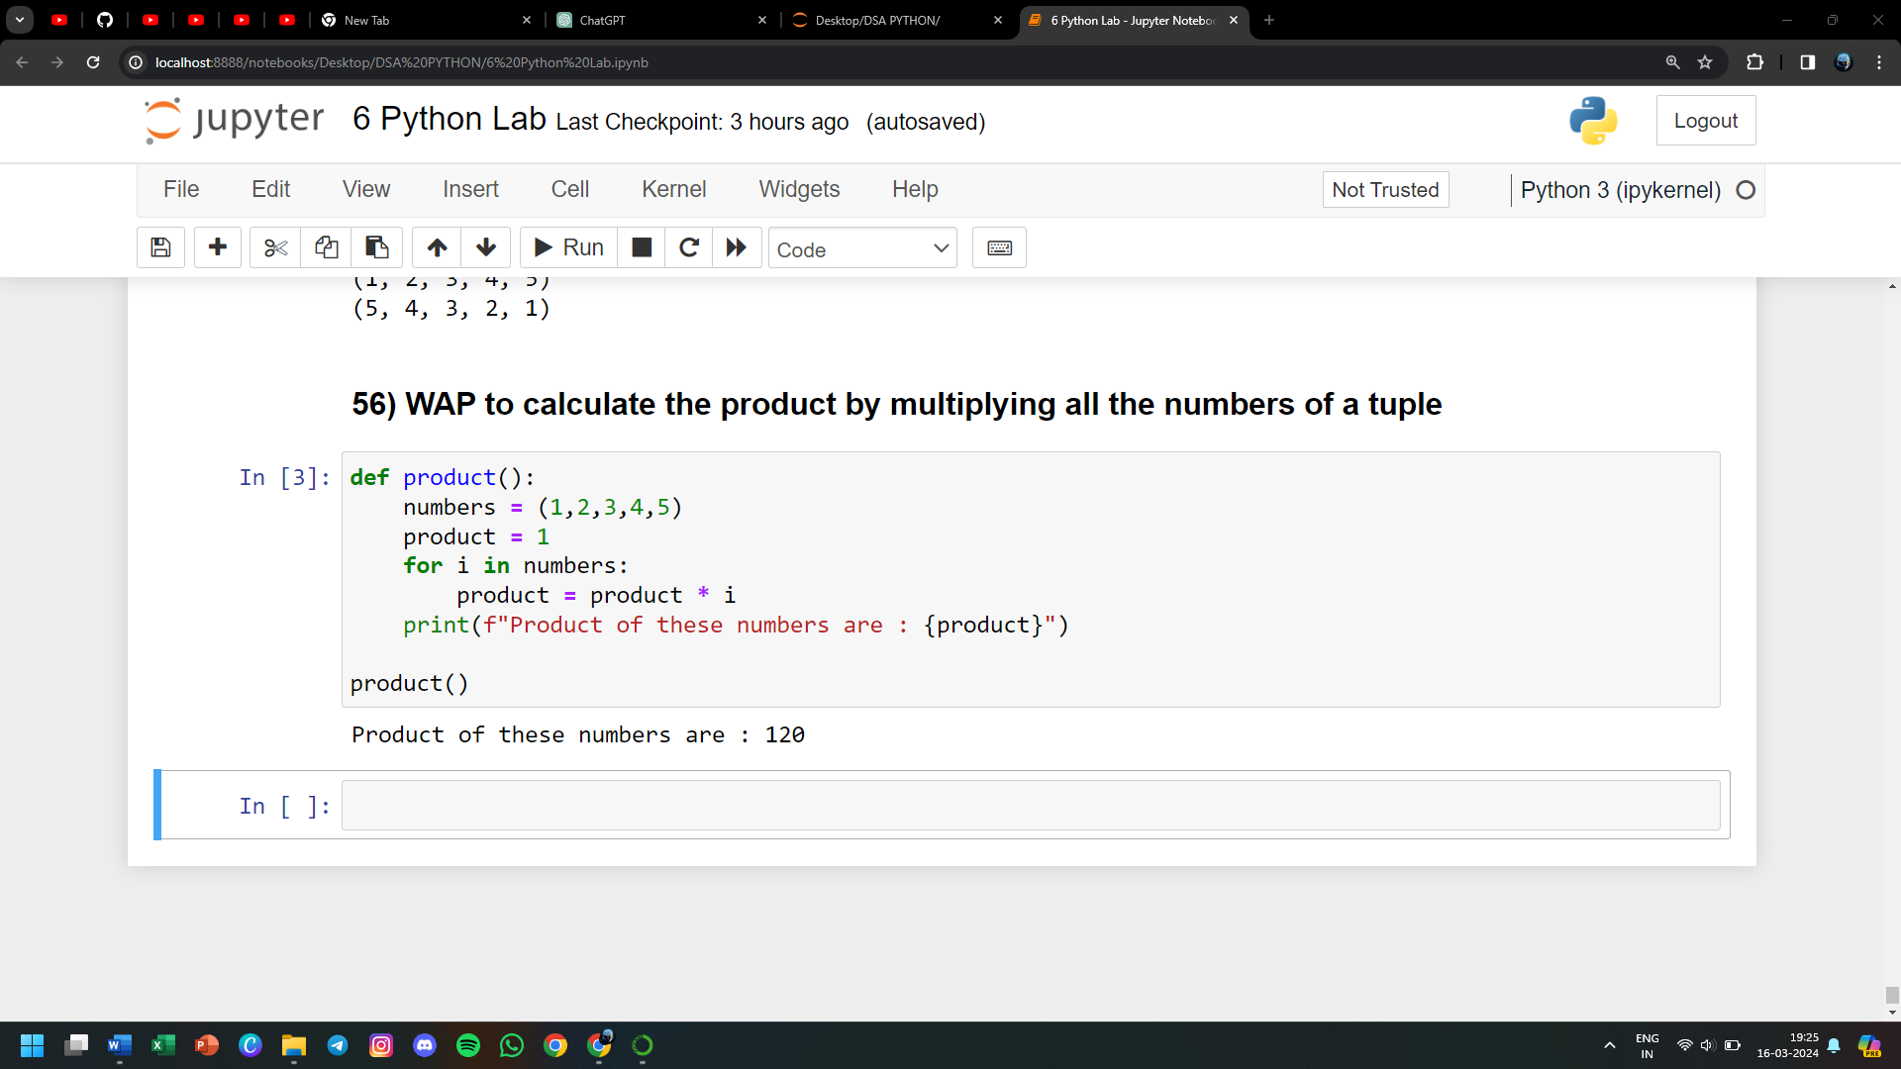

**57) WAP to check if the number exists in the tuple**

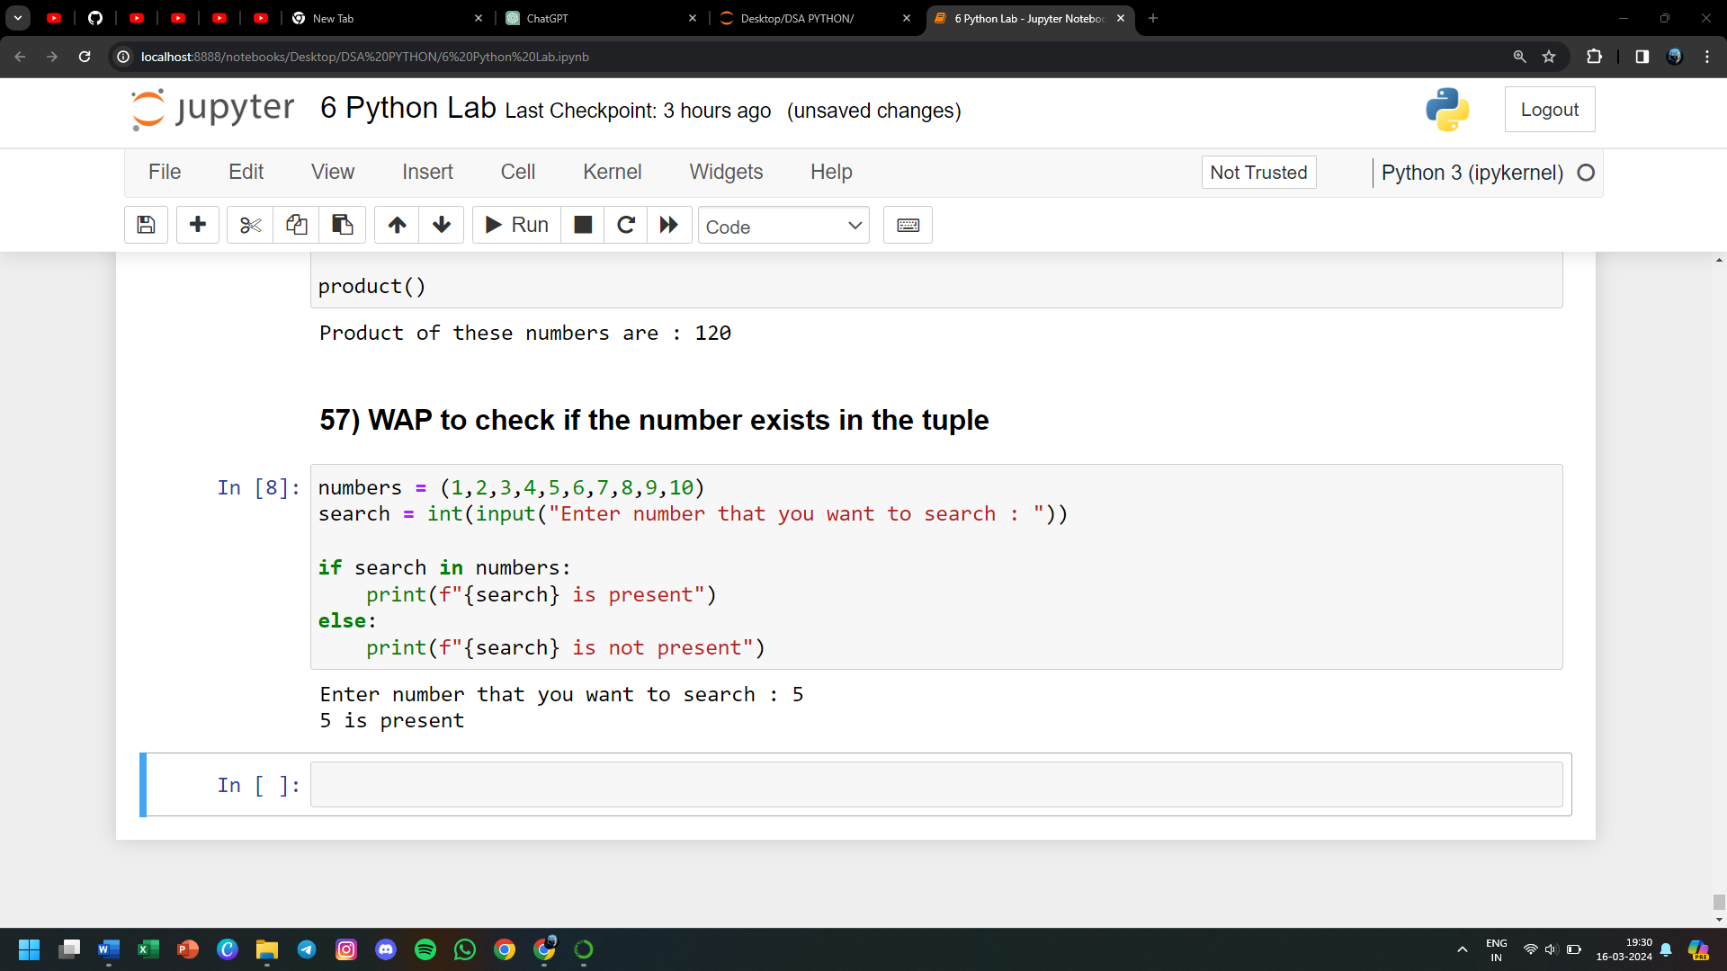

**58) WAP to check if two sets have any elements in common. if yes display the common elements**

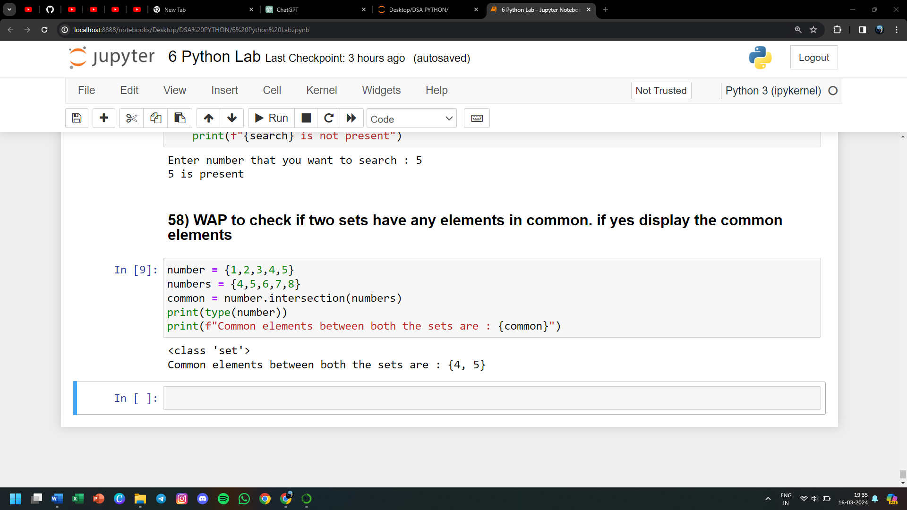

**59) Update set1 by adding items from set2, except common elements**

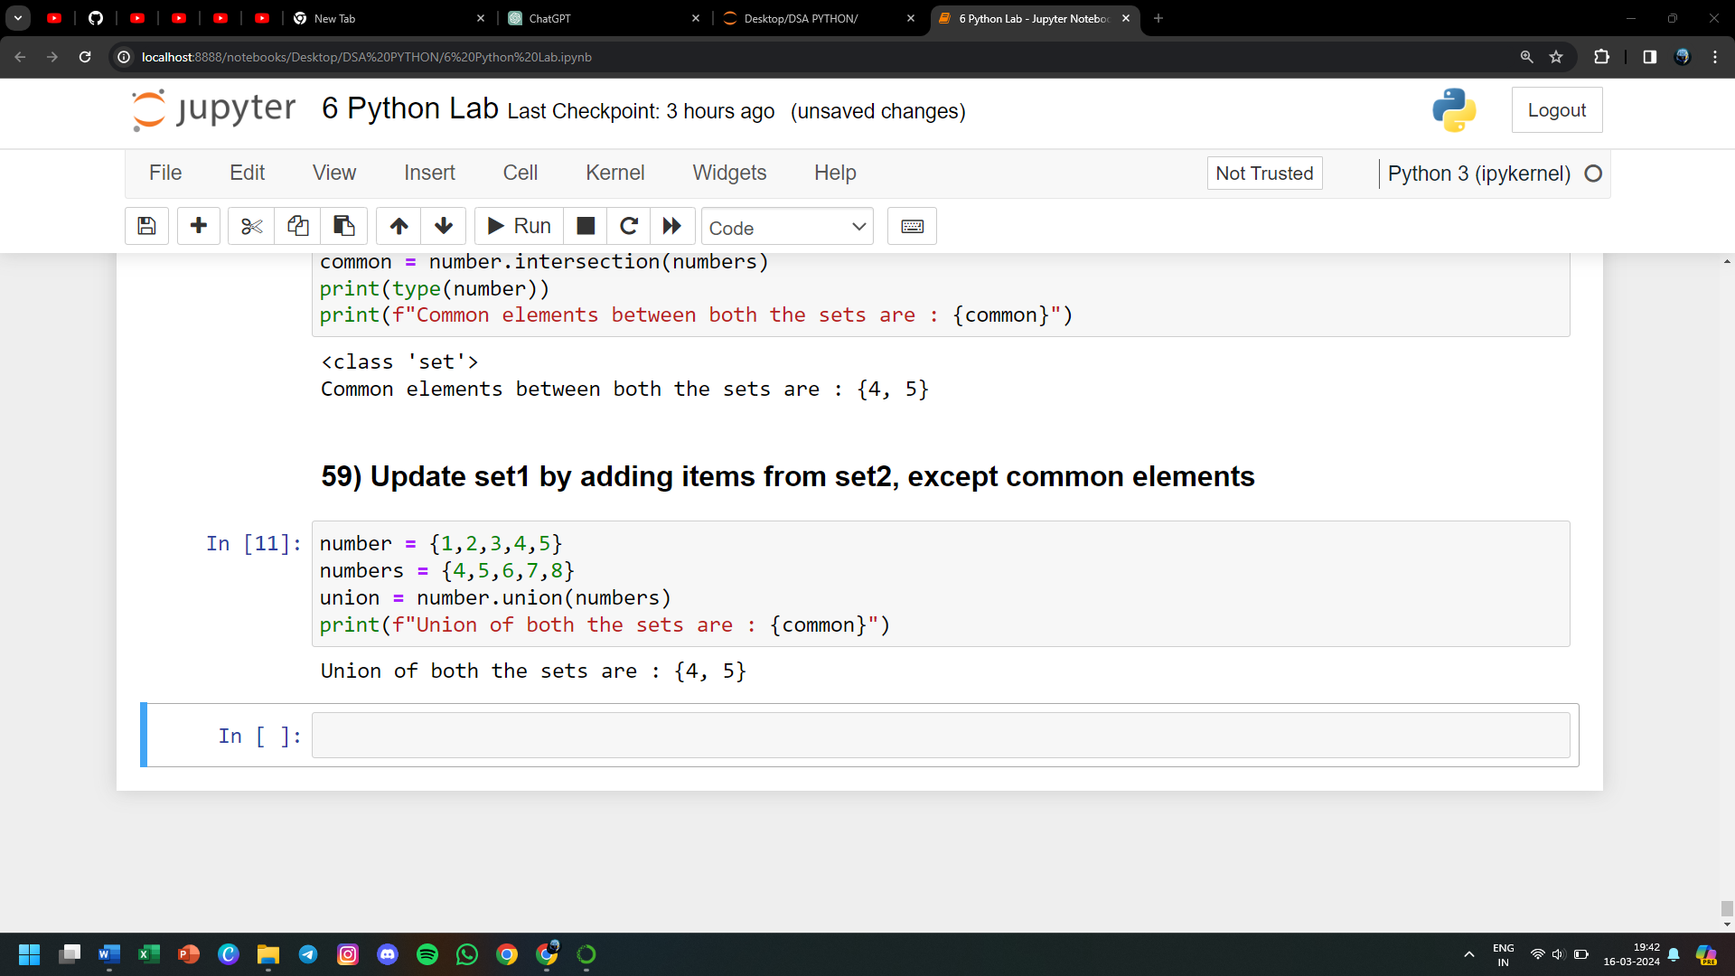

**60) Remove items from set1 that are not common to both set1 and set2**

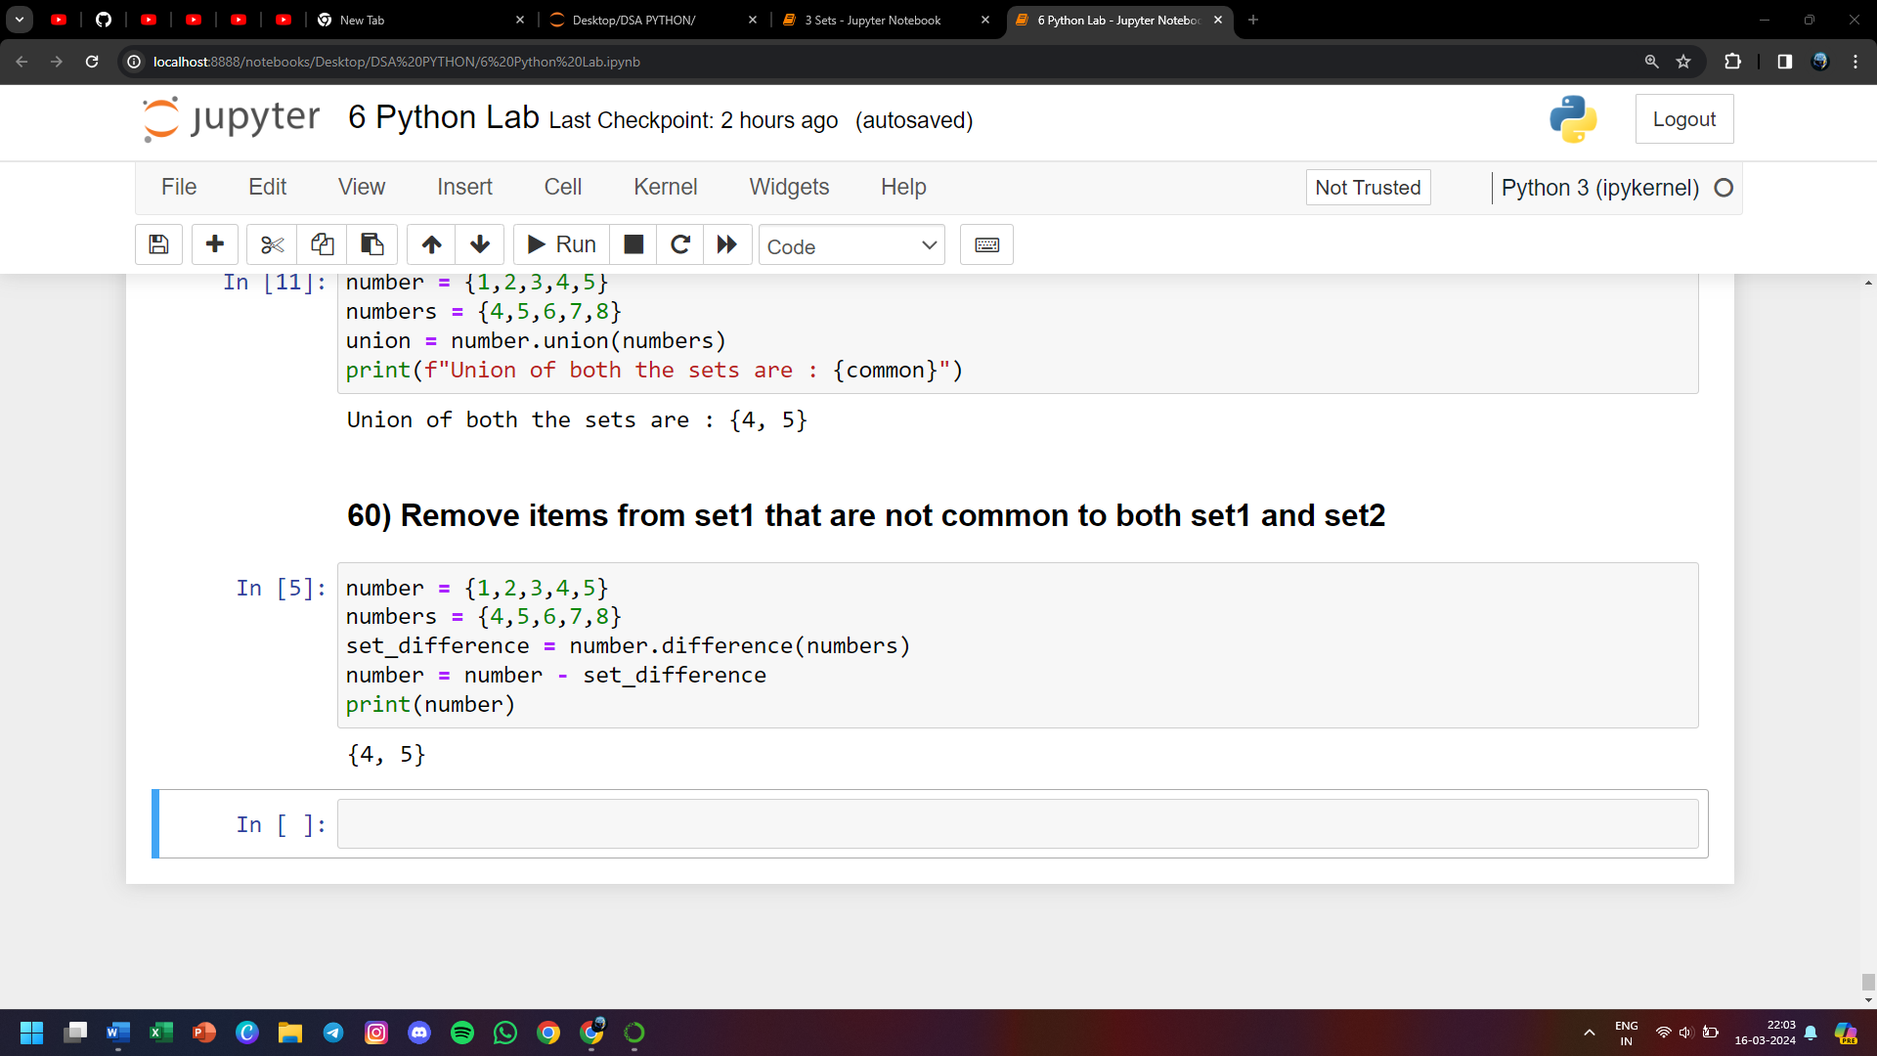

**61) WAP to print tuples which are not empty**

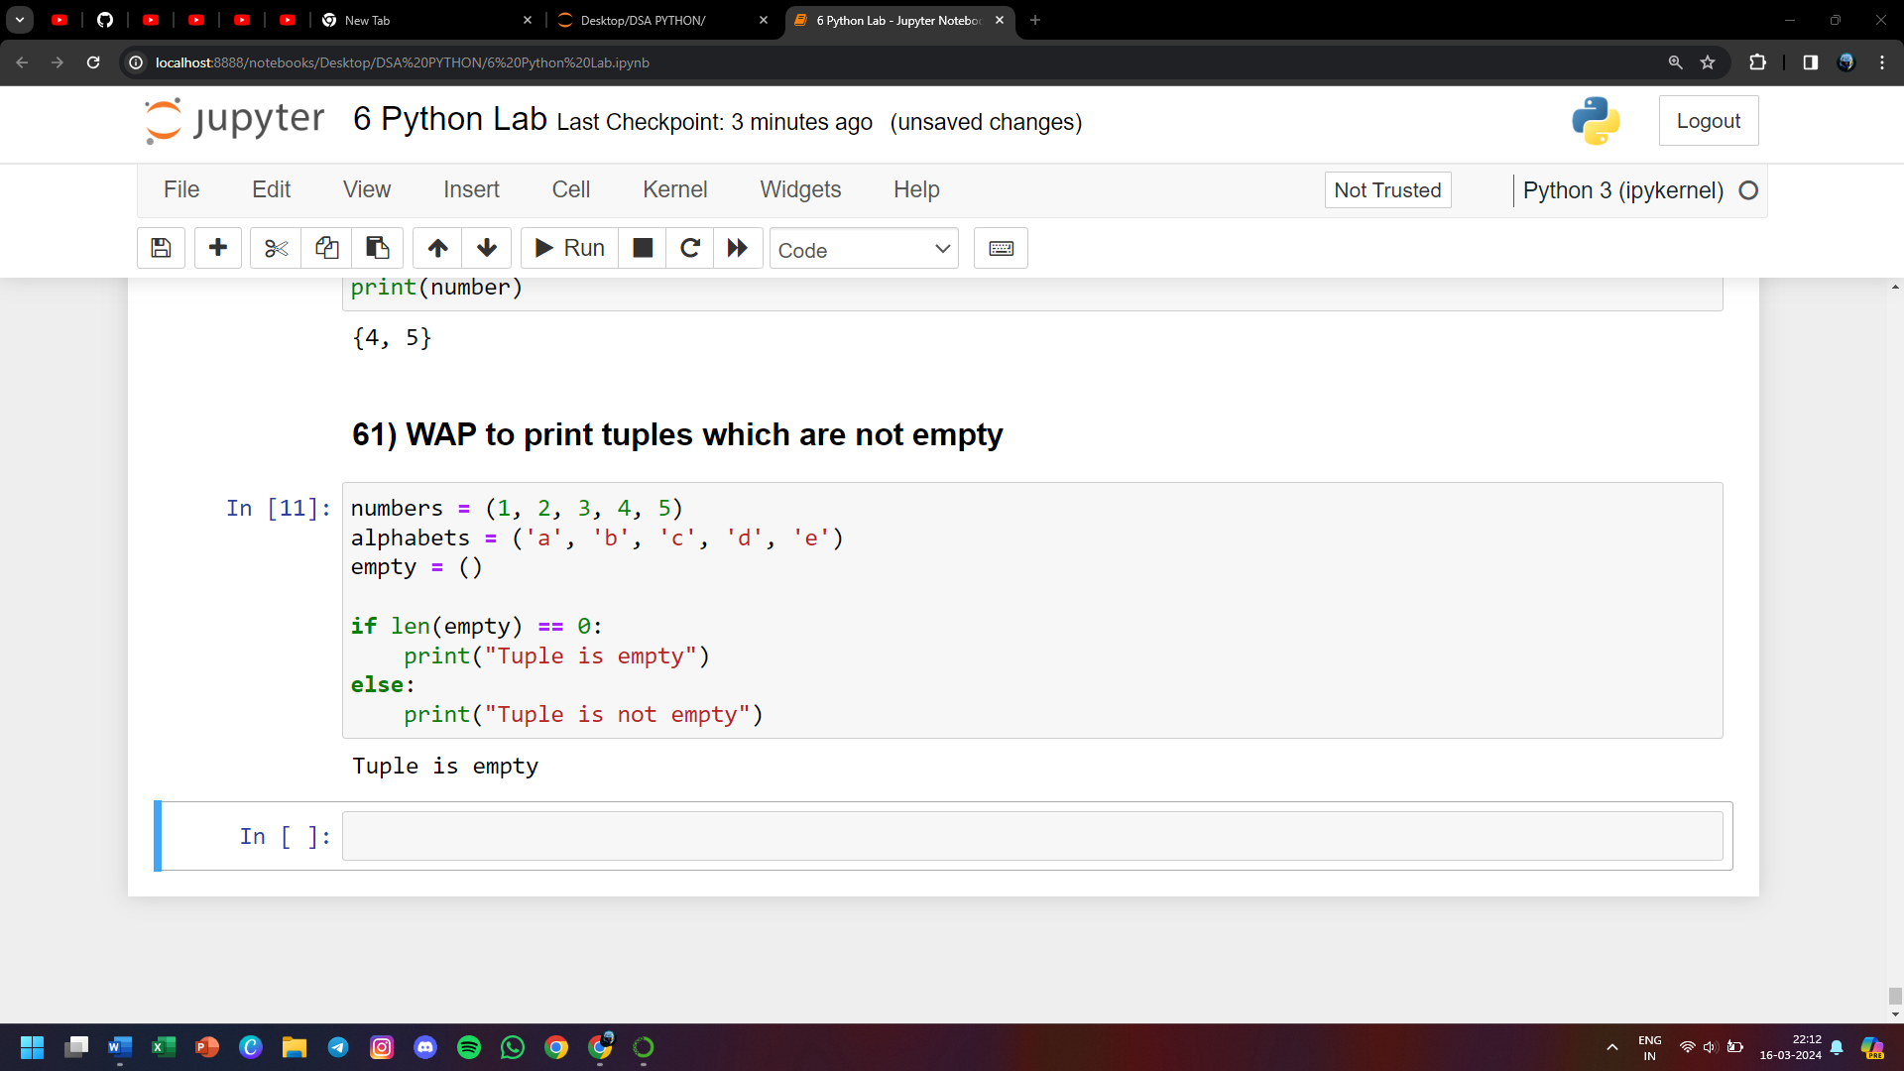

**62) WAP to open a file try.txt, add some text into it and close it**

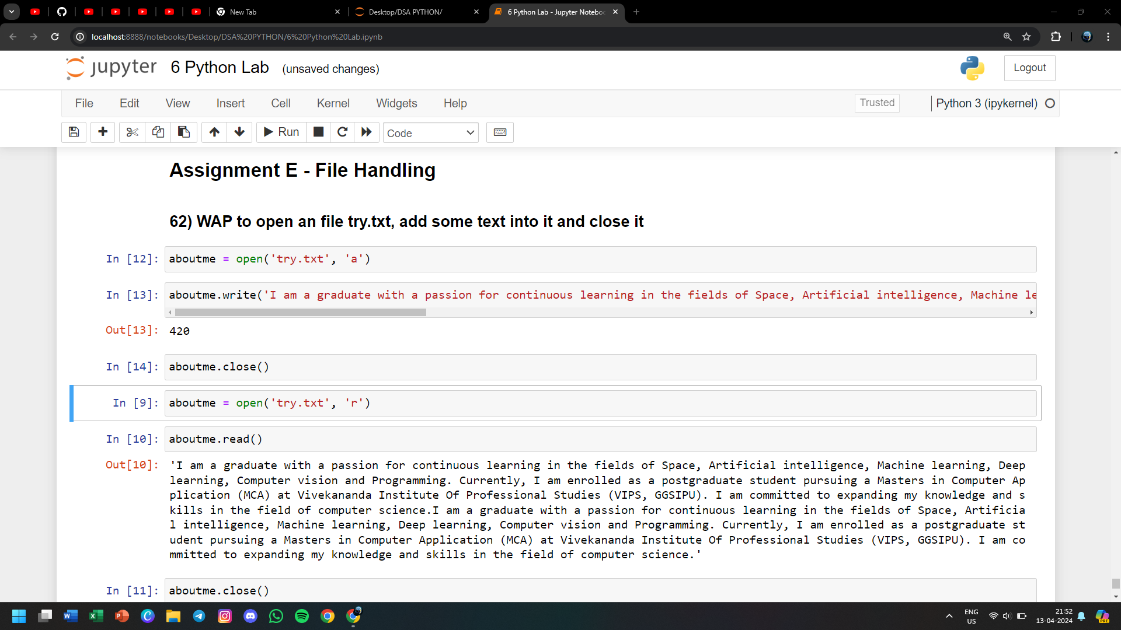

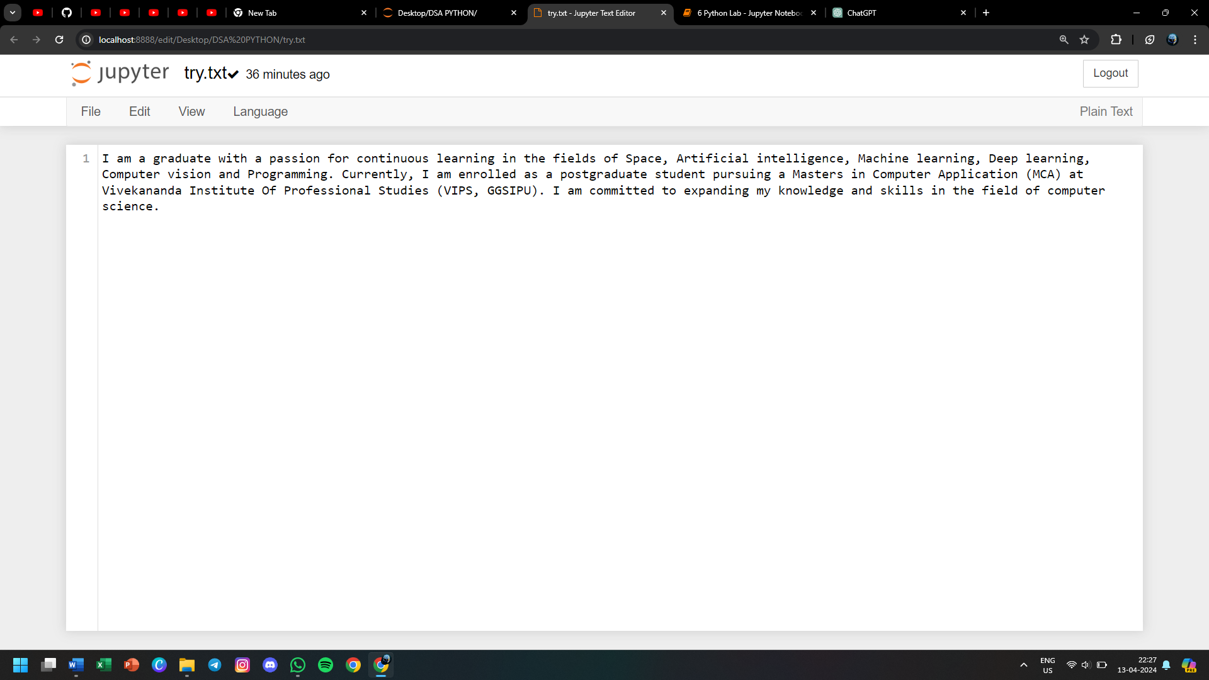

**63) WAP to read the above file and print that on the screen**

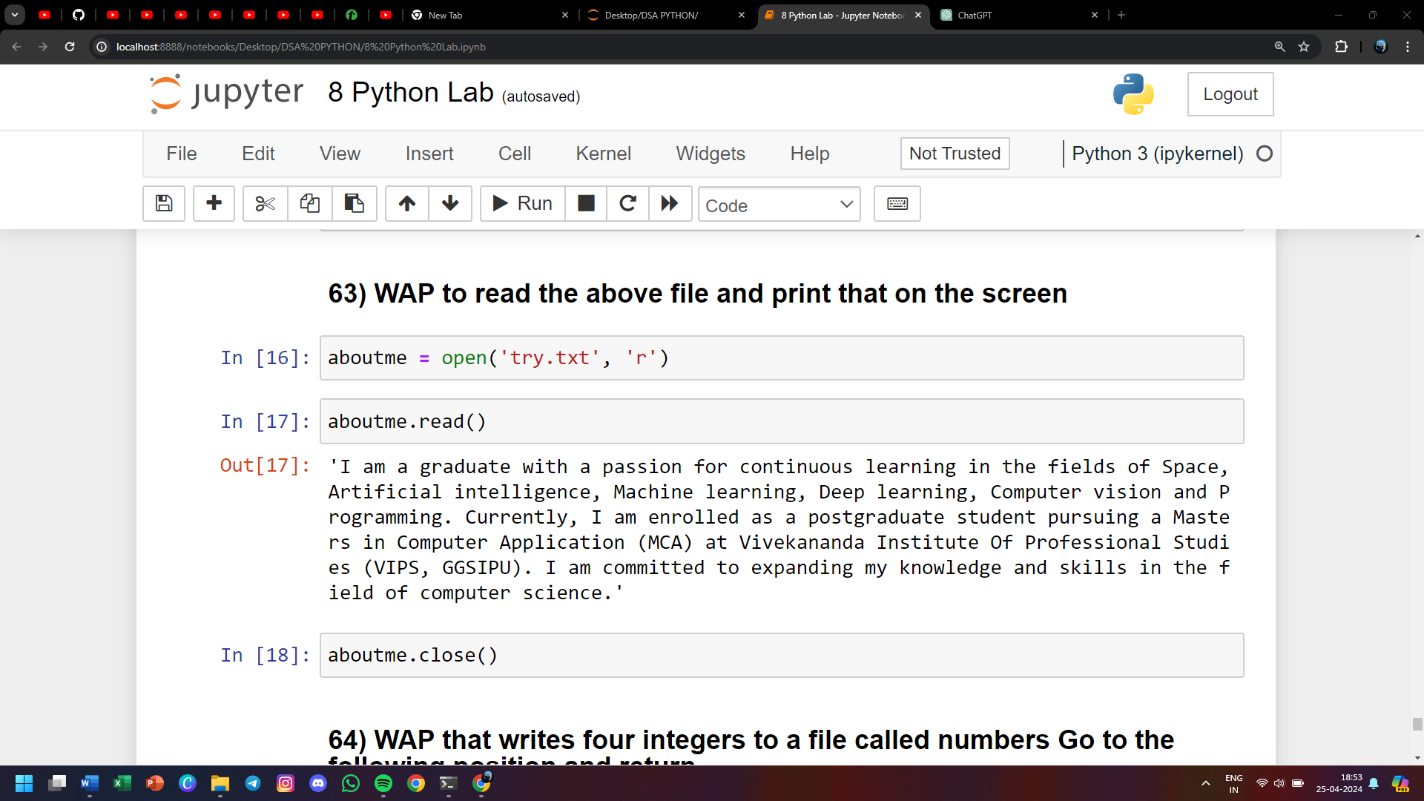



**64) WAP that writes four integers to a file called numbers Go to the following position and return**

**a) 10 positions from the beginning**

**b) 2 position to the right of current position**

**c) 10 position to the left from the end**

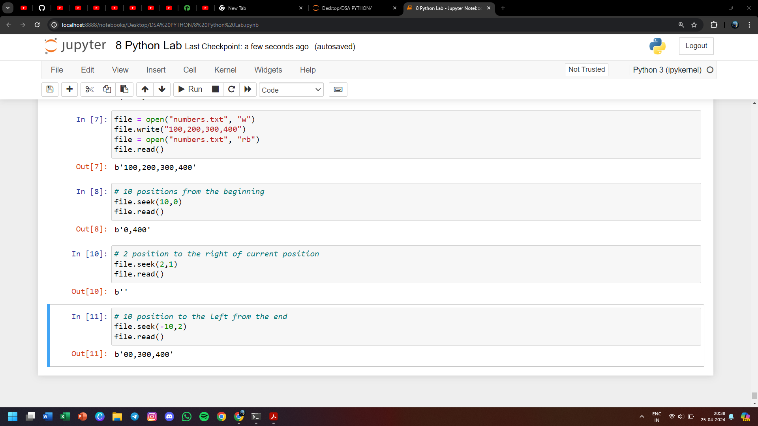

**65) WAP to implement inheritance using shape class and also make rectangle as a derived class. declare a function area to calculate the area of rectangle and also show the colour of the rectangle. Also make required constructor**

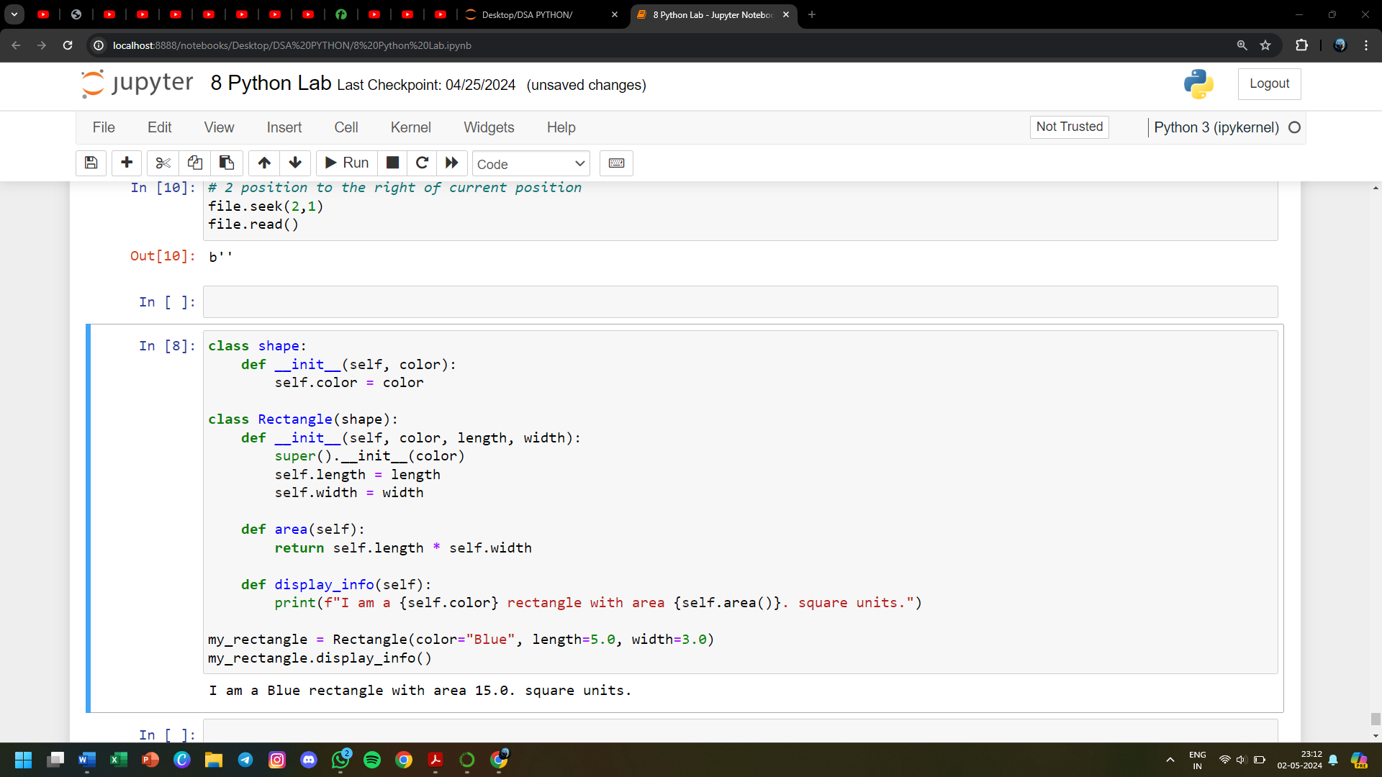

**66) WAP to implement Multiple Inheritance using the example of employee class, waged employee and salaried employee. Write Appropriate constructors and functions to calculate pay.**



**67) Implement operator overloading for + operator**

**68) Implement operator overloading for less than equal to operator for user defined class**

**69) Implement operator overloading for - operator**

**70) Implement operator overloading for unary operator ++ and -- operator**

**71) Implement exception handling for divide by 0 exception**

**72) Implement exception handling using raise statement**

**73) Implement threading**

**74) WAP to construct a 3d array of dimension 4x2x3. Initialize the array to some value. Find the maximum along each axis (k,413)**

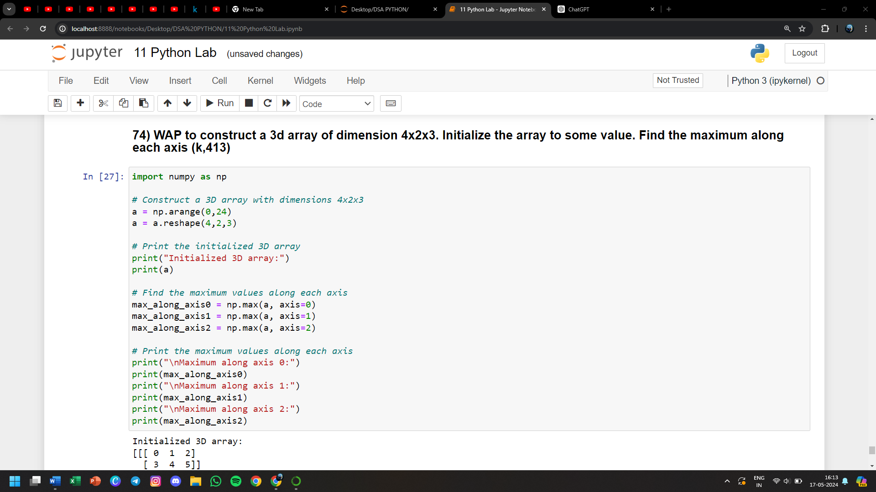

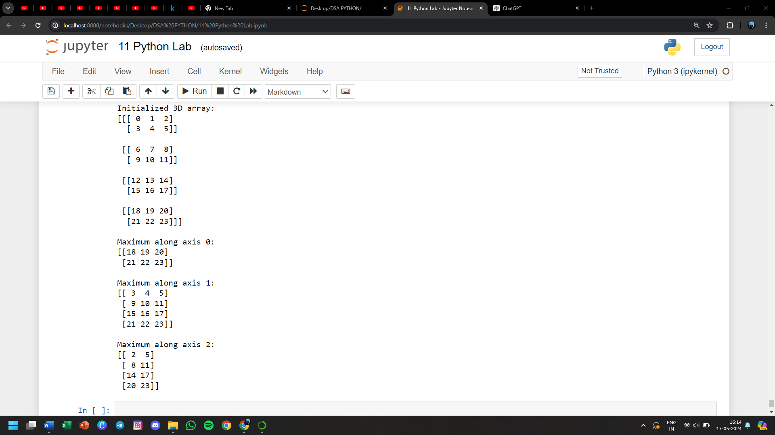

**75) Create a program to achieve the following**

* **Create an array of size 10 with each element of it set to a value 3**
* **Find the memory size of this array and its individual element**
* **Create an array b of size 10 with values ranging from 0 to 90 evenly spaced.**
* **Reverse elements of array b**
* **Add arrays a and b and store the result in c**

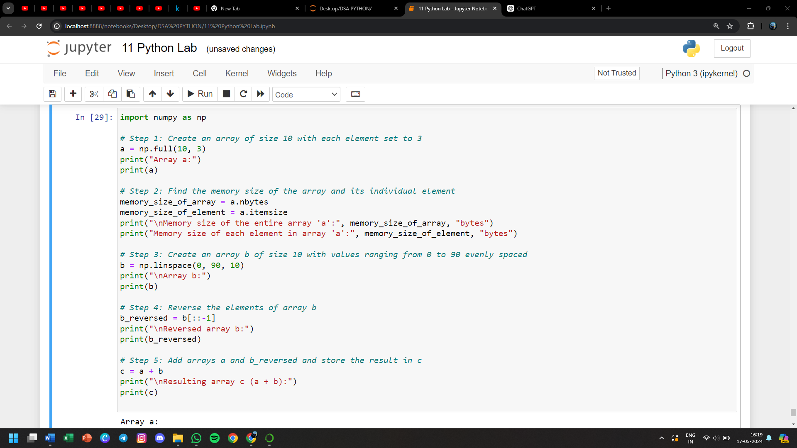

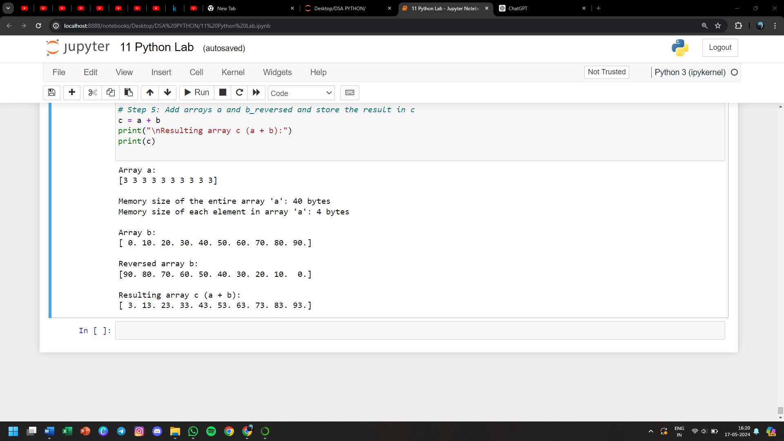

**76) Declare a matrix o 3x3 and calculate its transpose**

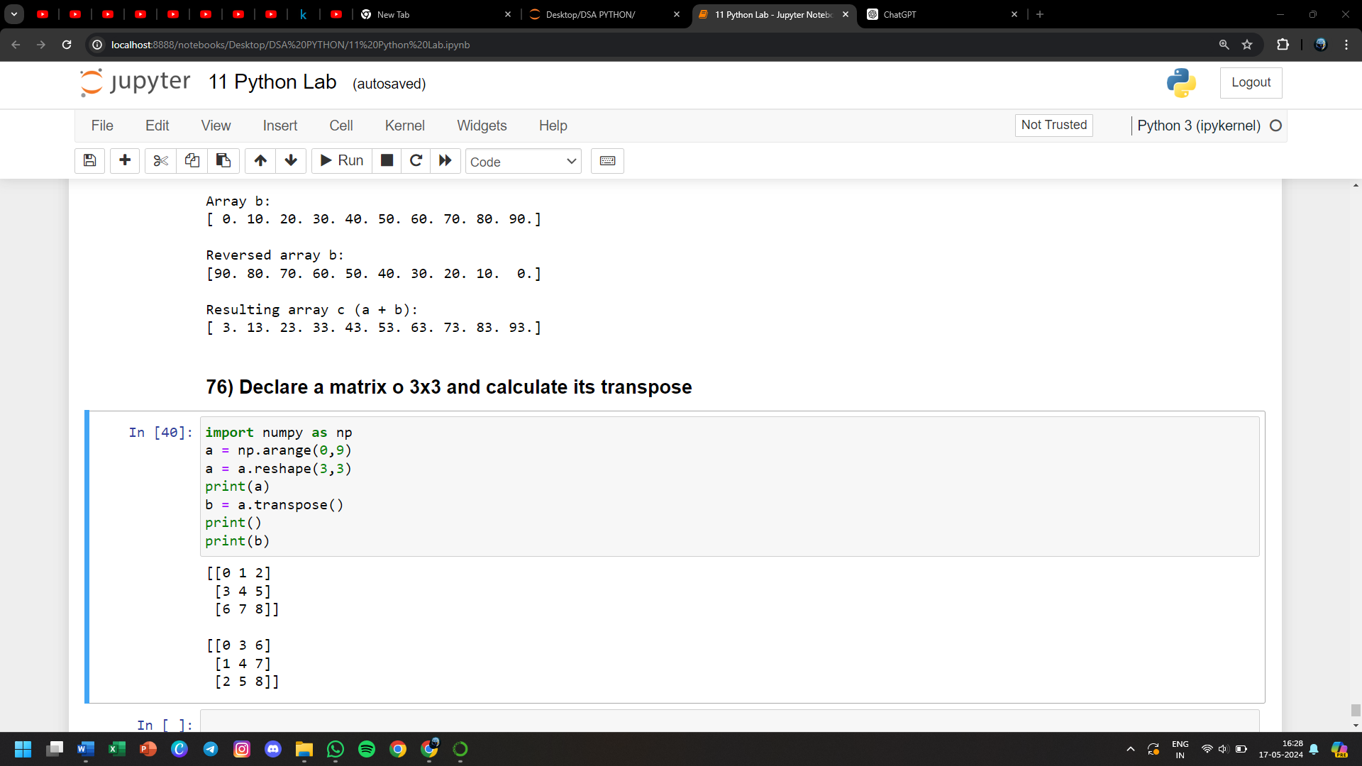

**77) Write a menu driven program to perform all the matrix operation**

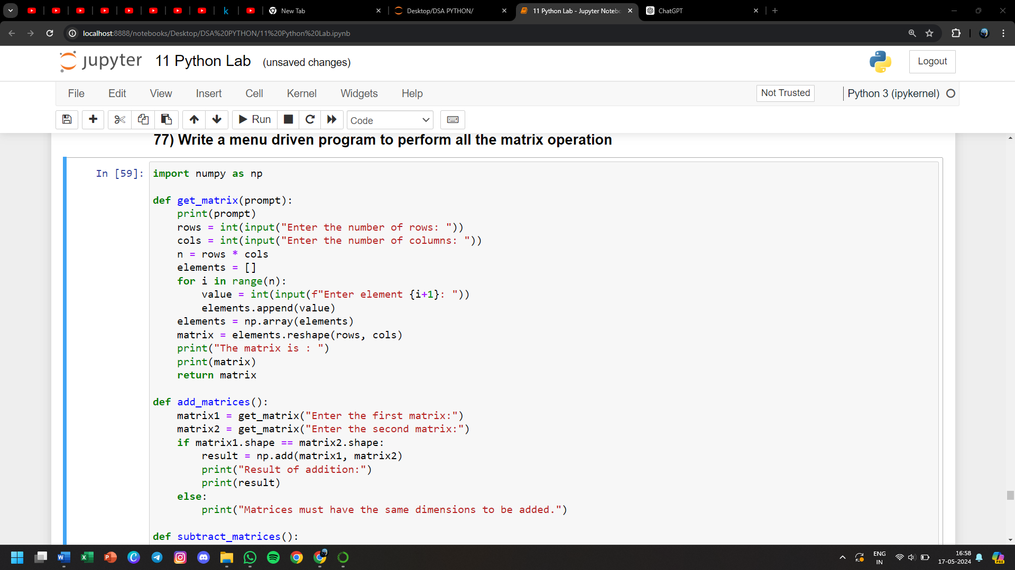

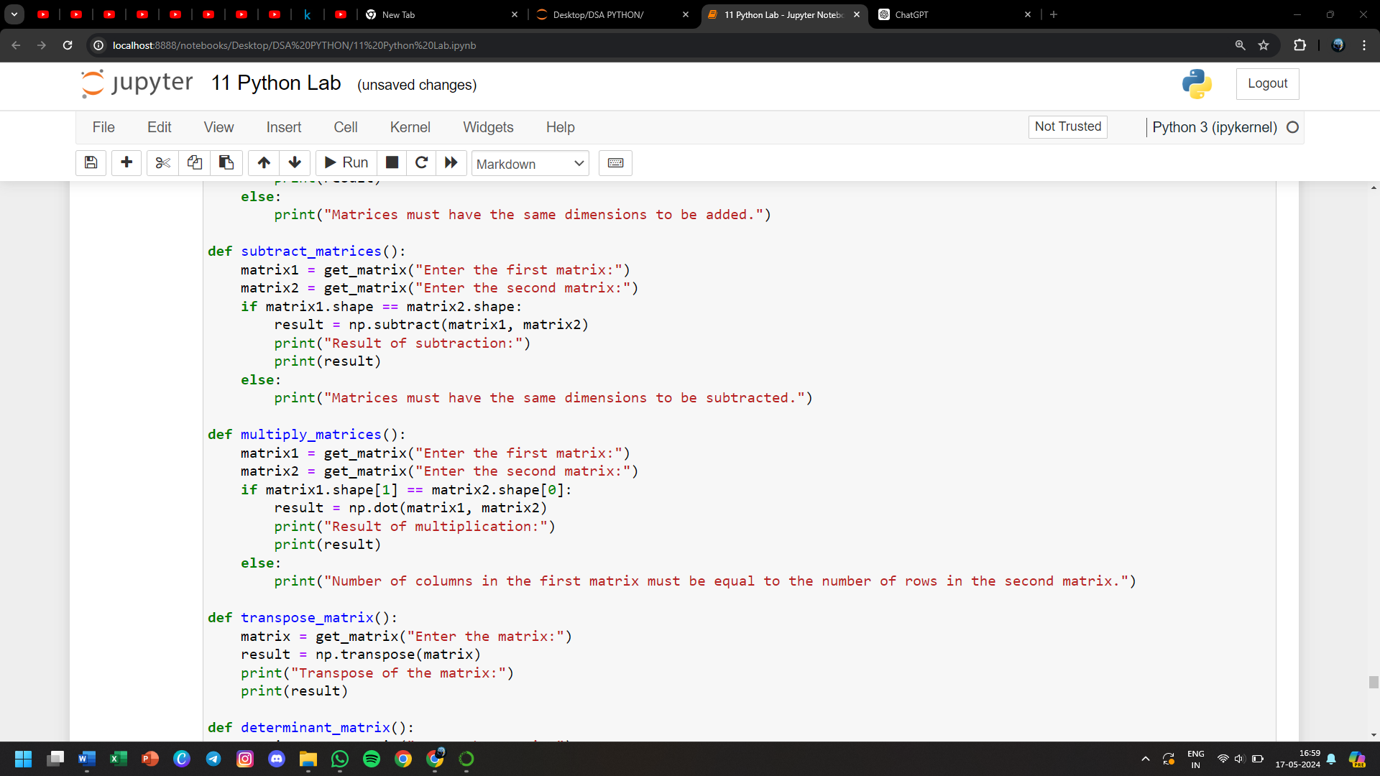

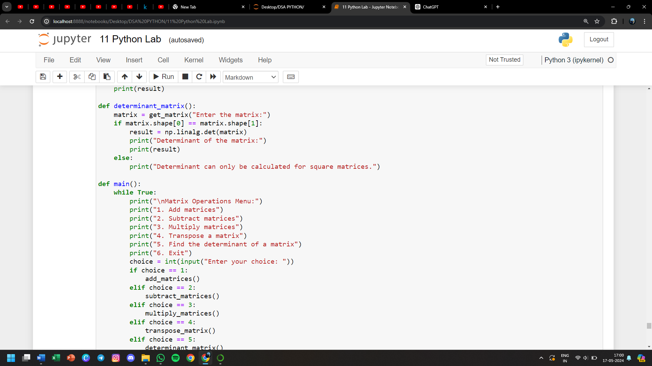

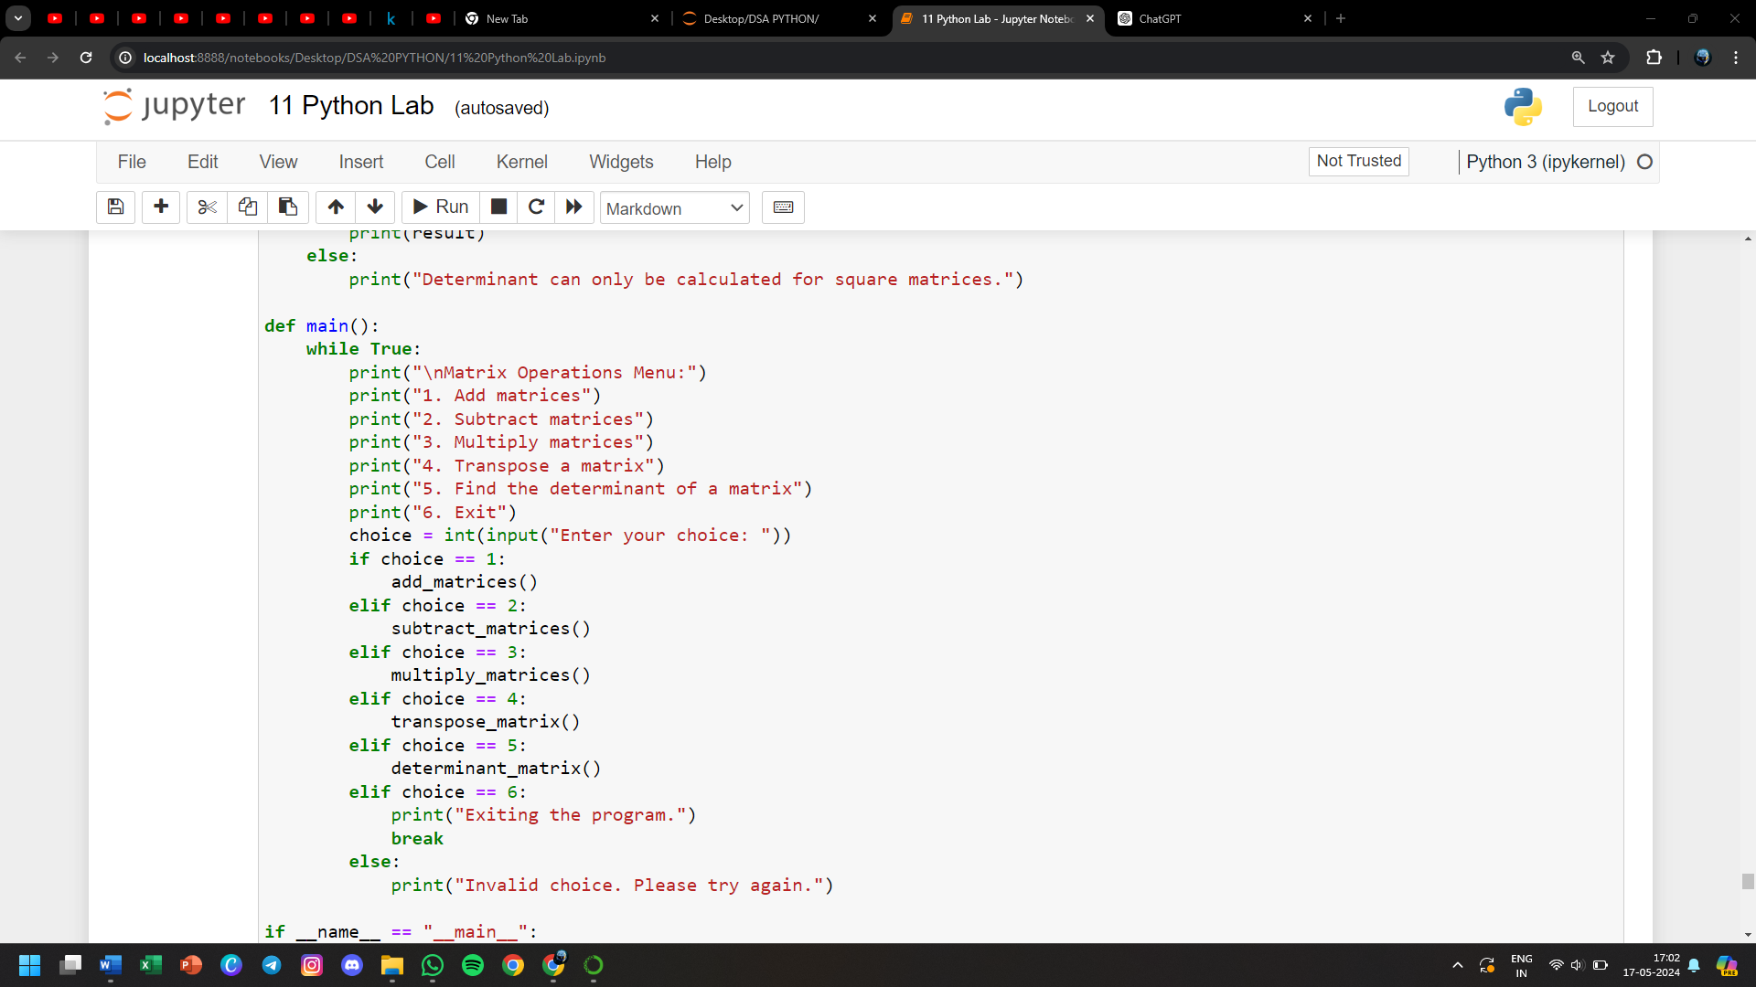

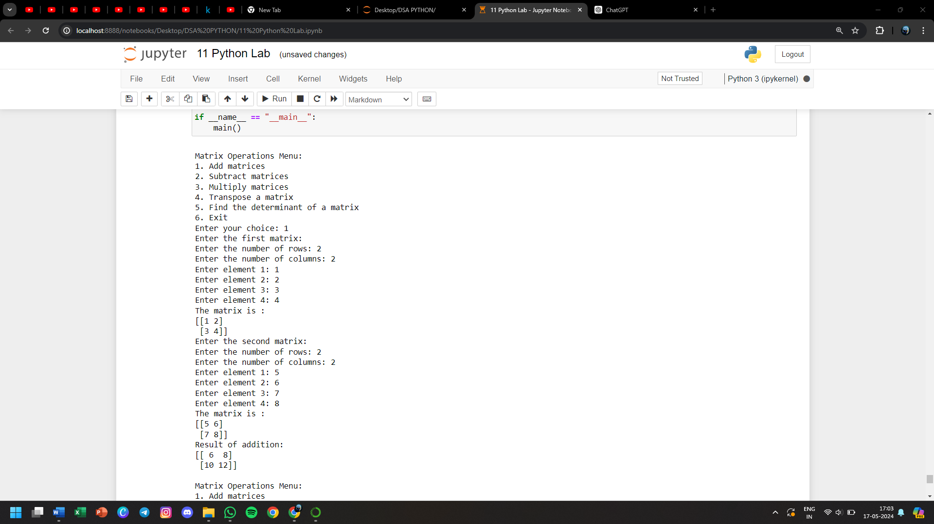

**78) WAP to count all the odd numbers in 1d array**

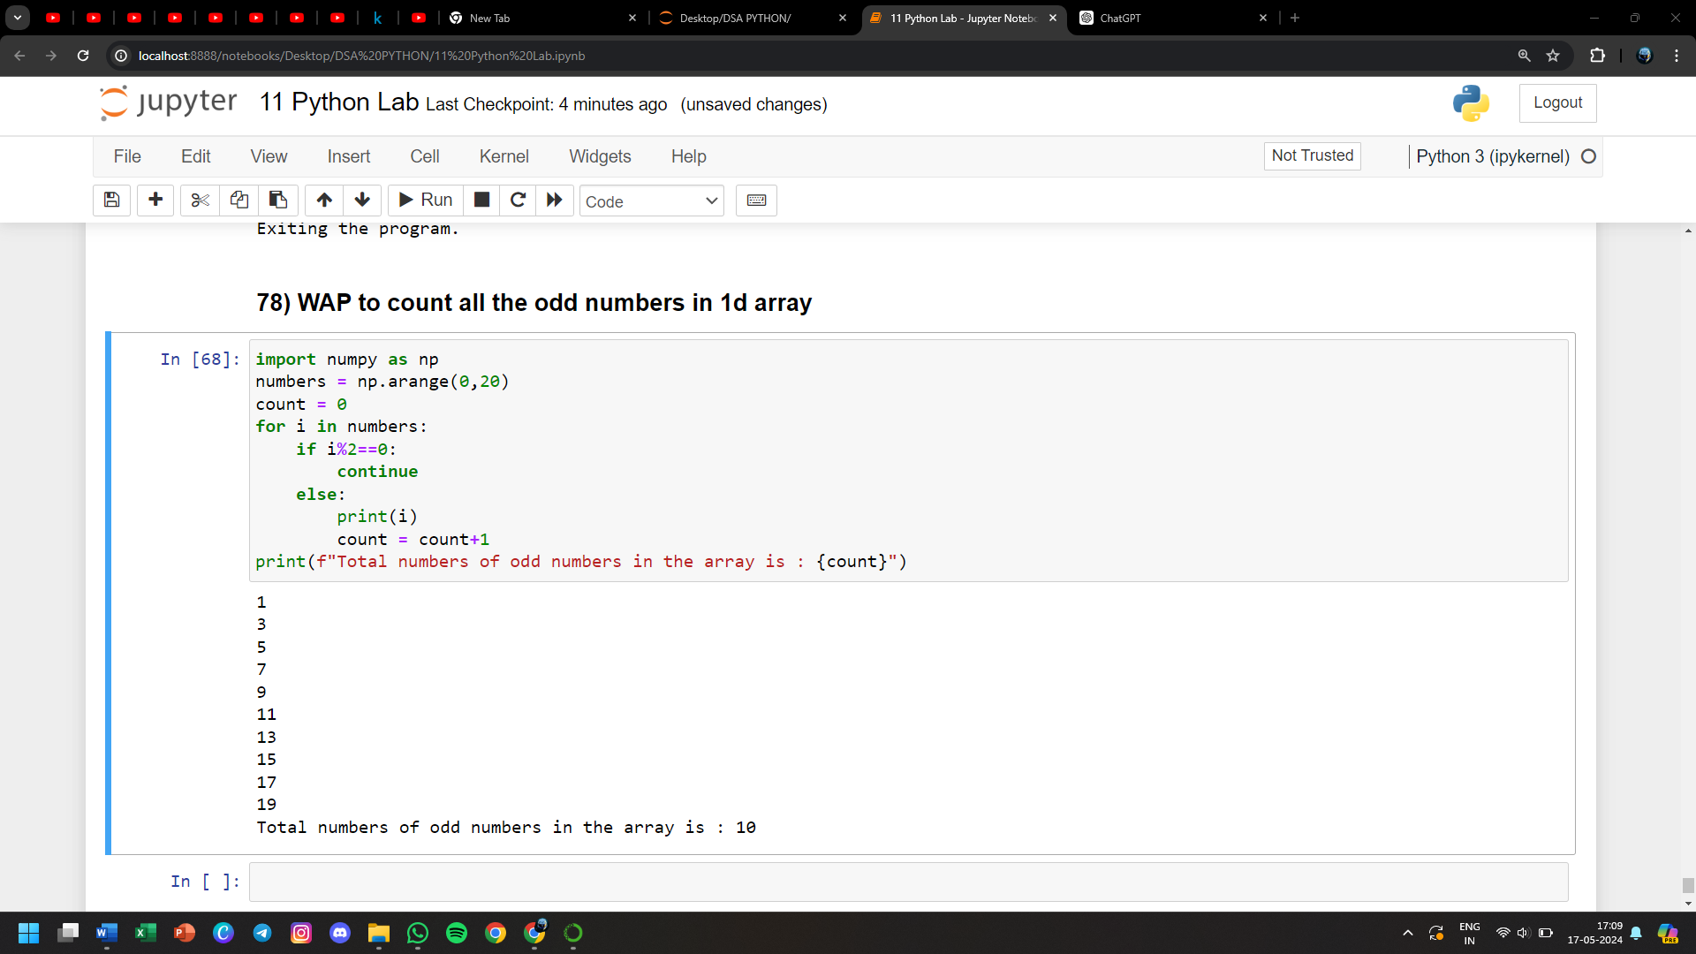

**79) WAP to check if none of the elements is zero in the array**

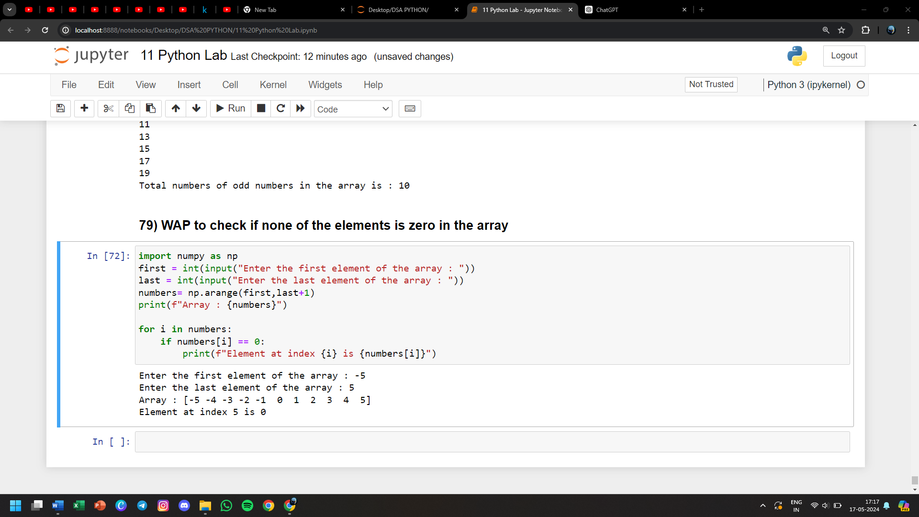

**80) WAP to extract all the prime numbers from an array**

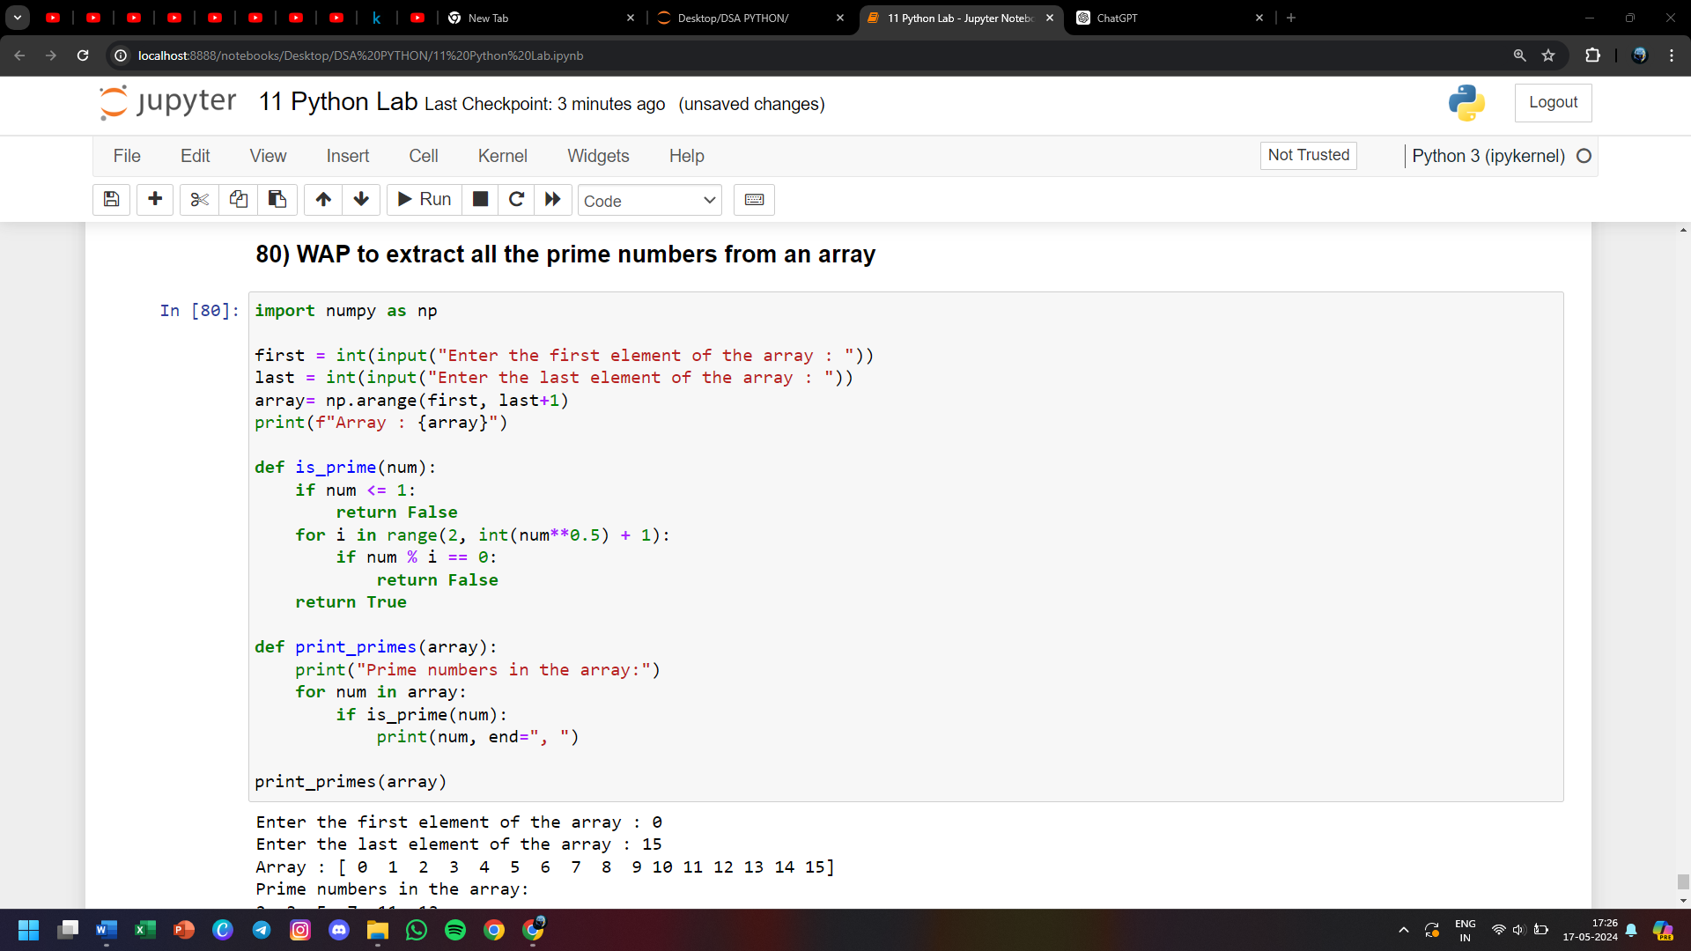

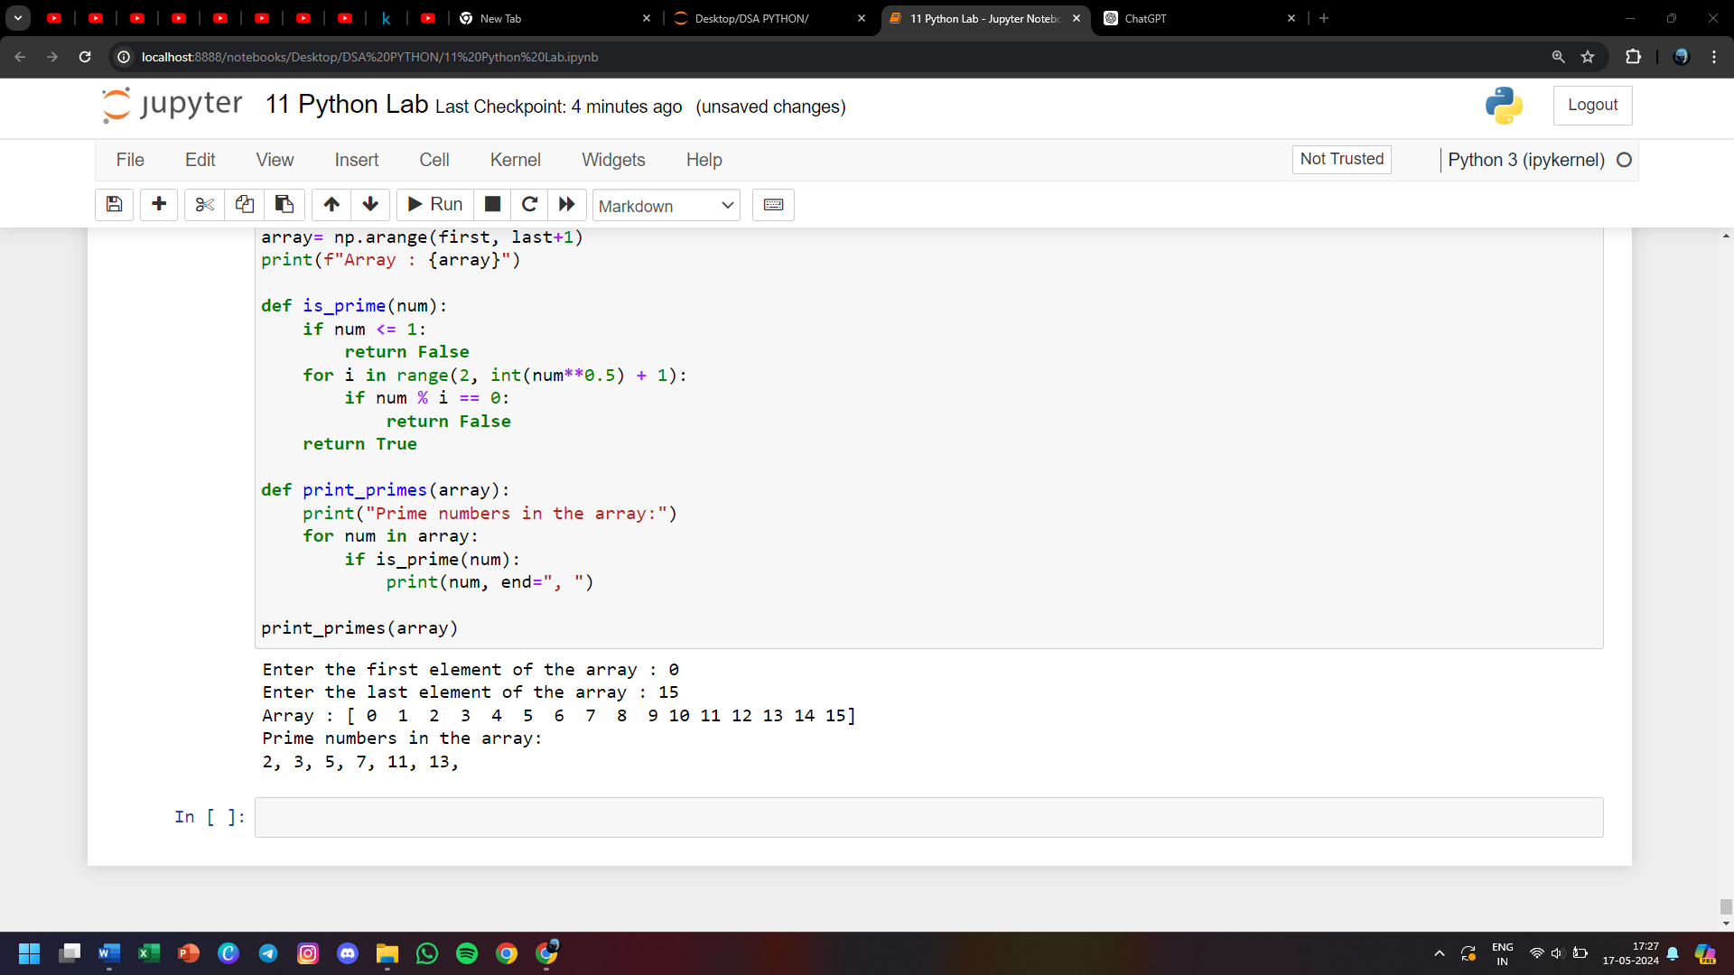

**81) Pre-process and perform different operations on data using Numpy and Pandas library**

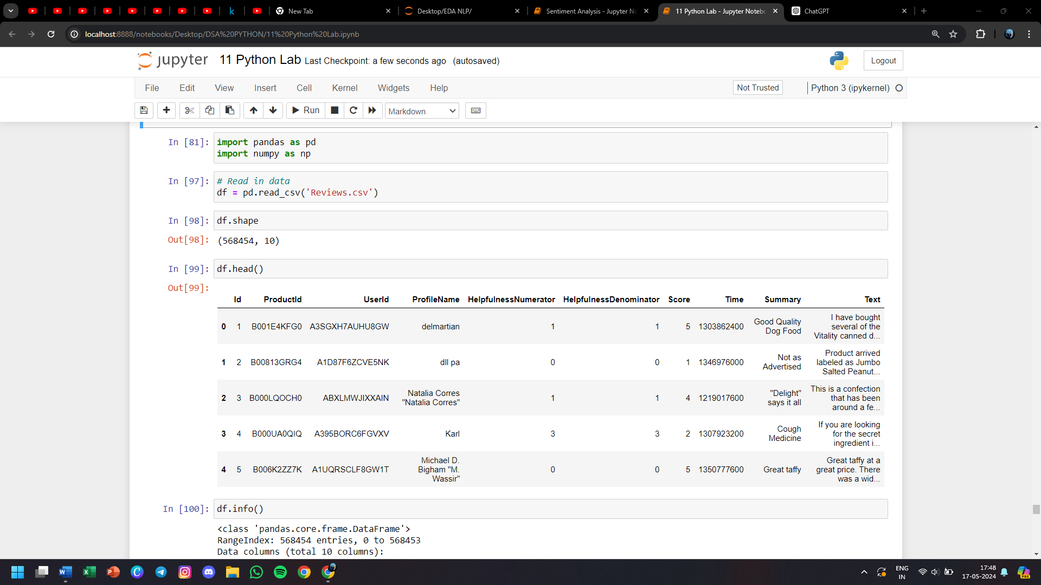

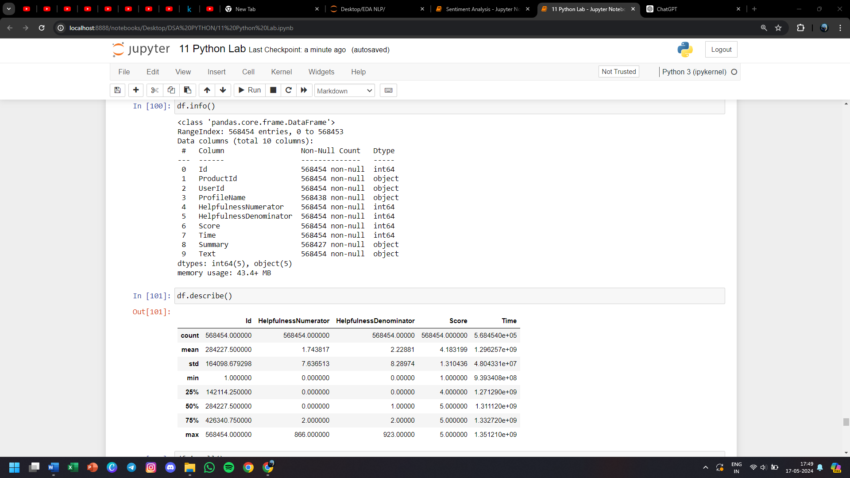

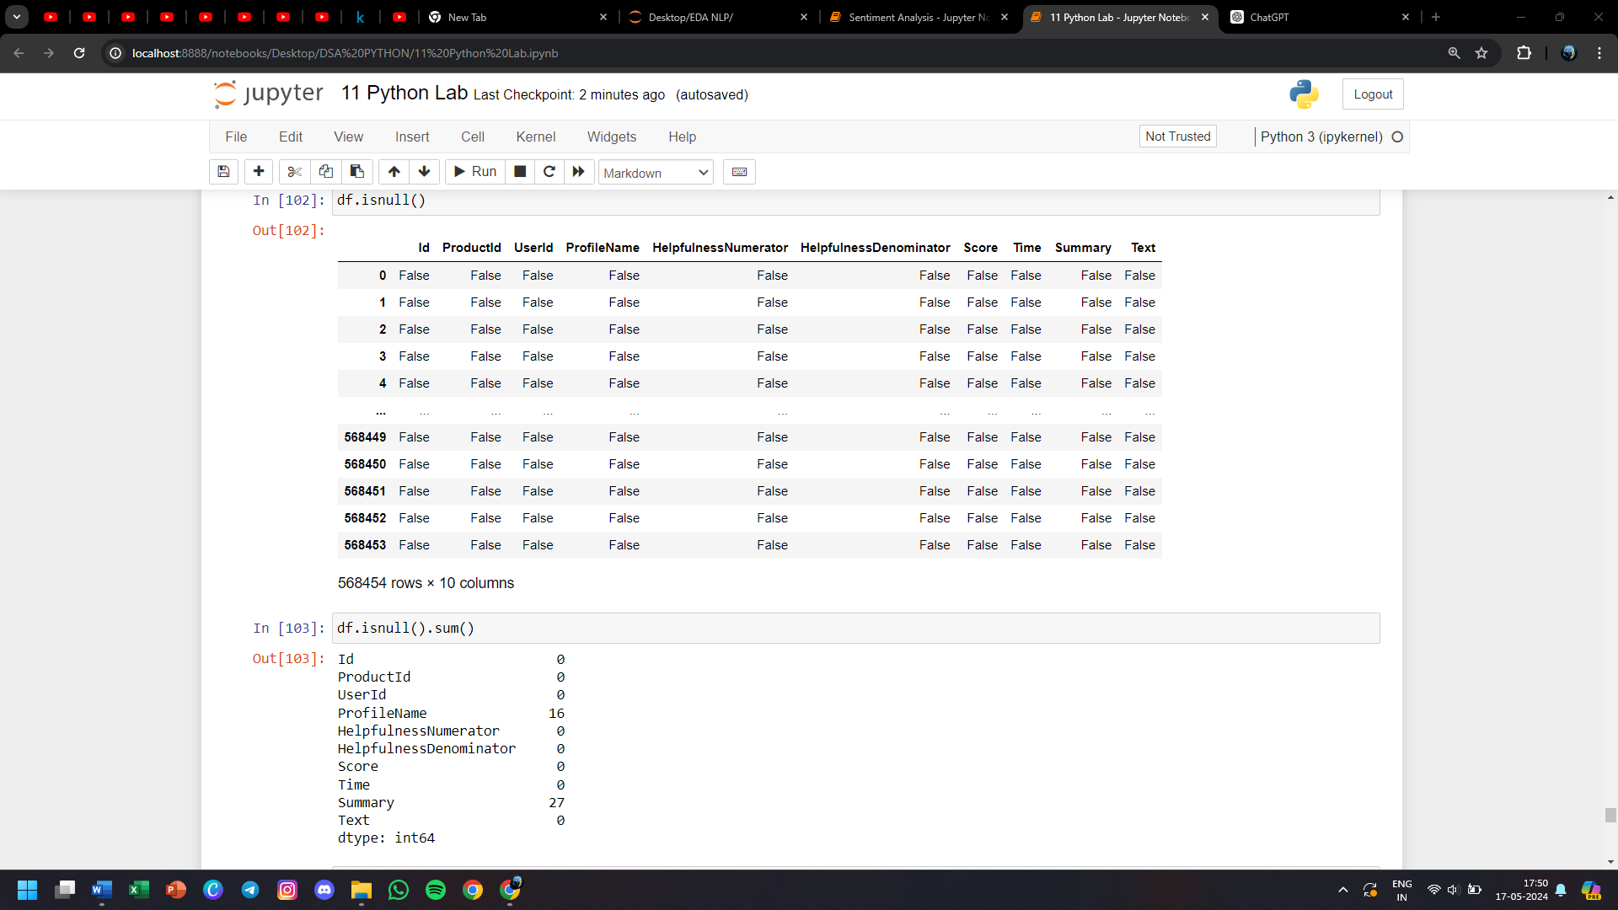

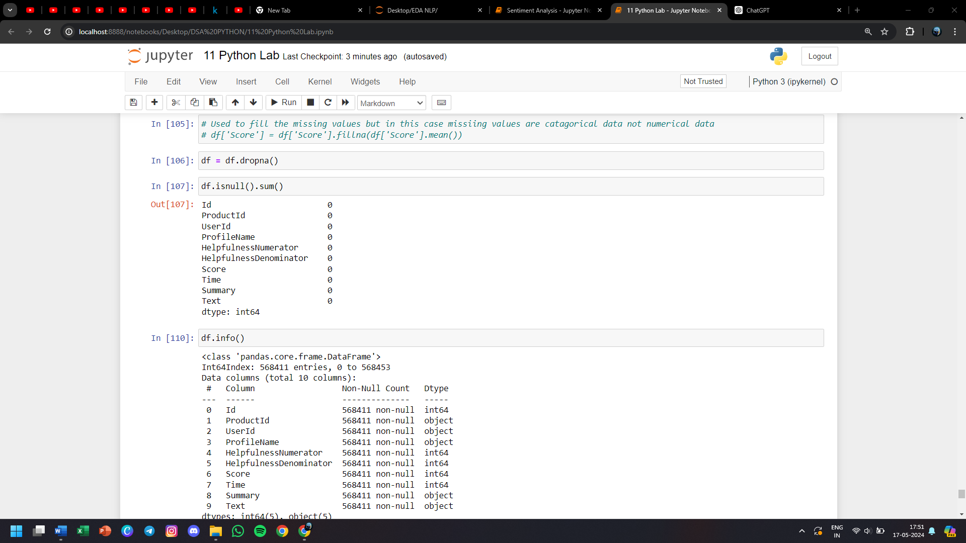

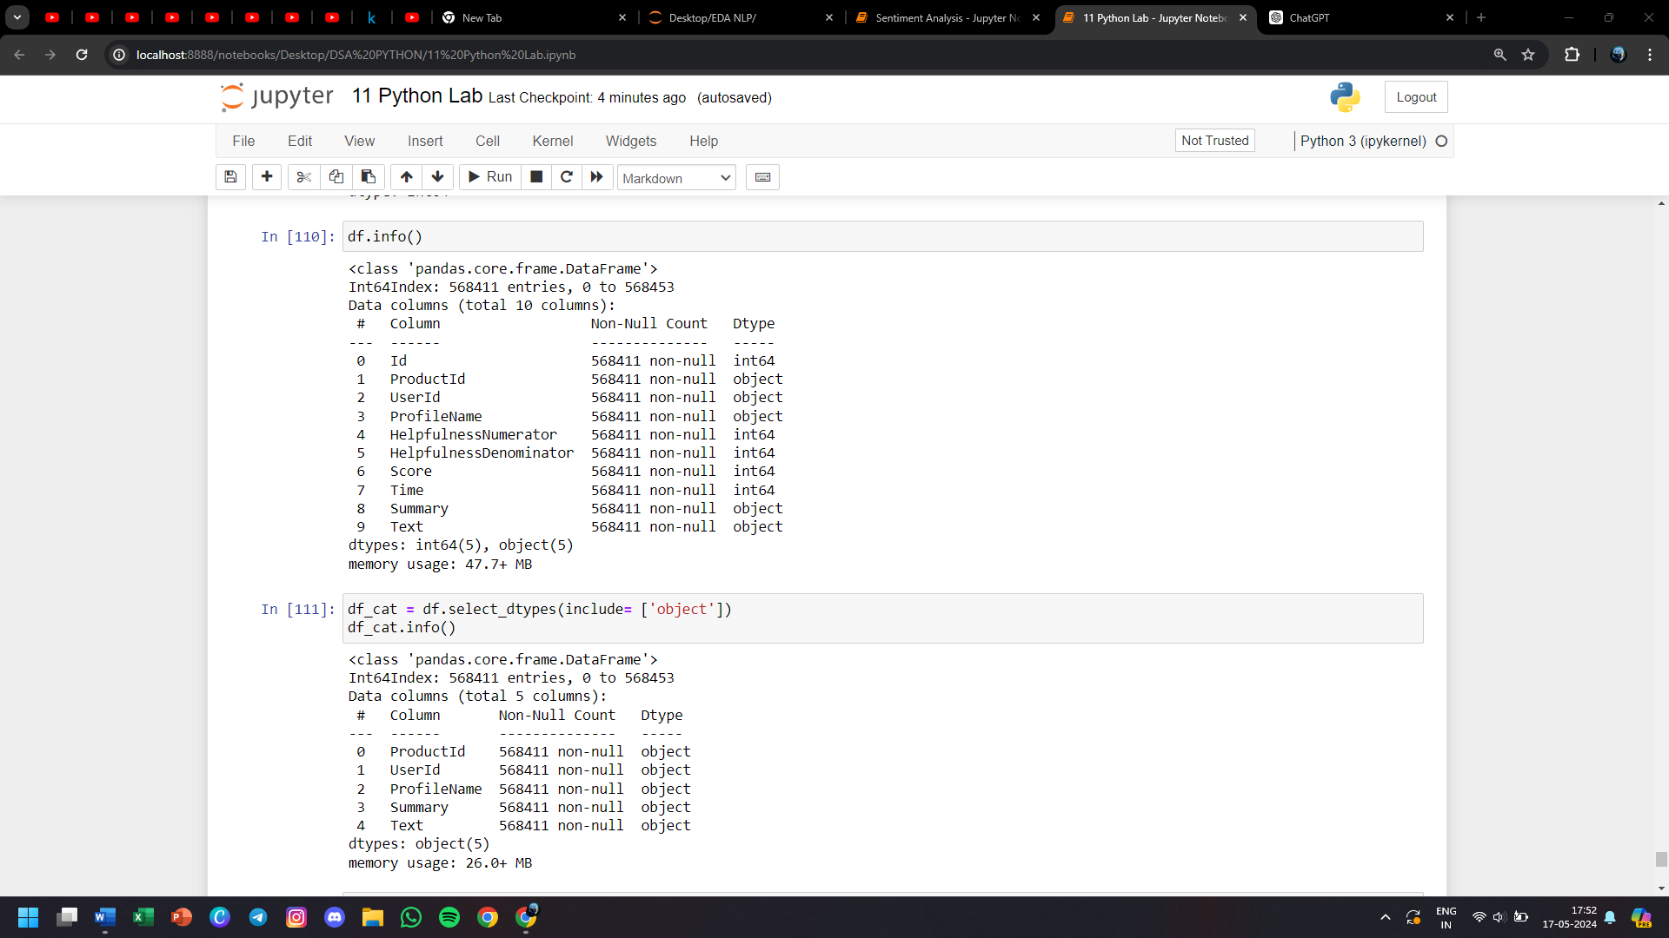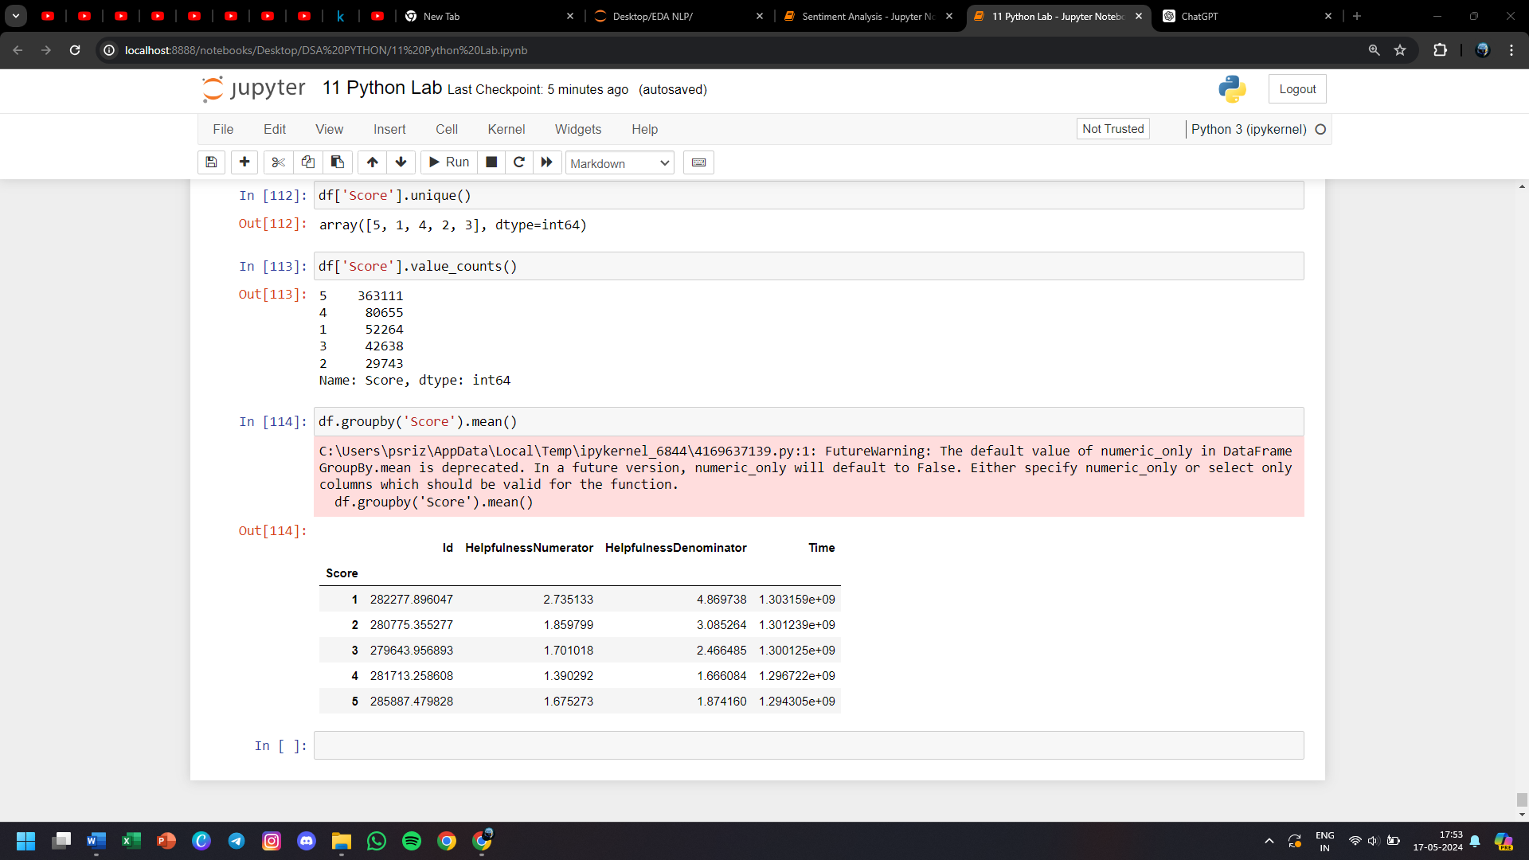

**82) Analyze the sales data and visualize it using different plots**

